Topology Optimization Through Computer Aided Software

Yardley Ordonez¹, Adrian Bituin¹, Krystal Kyain¹, Alec Maxwell², Wen Li Tang², Professor Zhaoshuo Jiang²

¹Cañada College, Redwood City, CA 94061
²School of Engineering, San Francisco State University, San Francisco, CA 94132

Abstract

Topology Optimization is a mathematical method used to reduce the structural weight, material, and layout of a design that many industries implement in their design process. The project goal was to use topology optimization on static structures through automated simulations to produce the most cost effective and structurally stable designs. The automated process will eliminate the cost of material used on a static structure and it will also eliminate extensive planning when picking a given design. This paper focuses on the work done in a 10-week research program by 3 community College students, led by civil engineering faculty at SFSU. The research behind this paper focuses on the use of topology optimization on static structures. With this knowledge we understand the design process it took in topology optimization with computer aided software. The research seeks to eliminate the need to use of the graphical user interface of ANSYS and AutoCAD completely to automate the simulation and structural analysis while optimizing a given geometry or design through the MATLAB environment by running a script file. The research presented is meant help build an automated platform that will eliminate many time consuming and rigorous steps. Our platform was able to analyze a static structure with a faster productivity rate and produce quantitative results that will help us further understand the topology optimization process.

- Introduction
Topology Optimization (TO) is a mathematical method used to reduce structural weight, material layout, or volume of a given design by adjusting design variables, set of constraints, and parameters. TO saves money and resources for any industry when it comes to designing and creating a final product. The financial benefits of implementing TO in business practices is more than enough to incorporate that in the design process, but it also beneficial to have a stable and efficient product without excess material. While topology optimization is very useful for design, often we see optimized results consist of complex geometries and poor material layouts which are not ideal to real-world problems due to expense and ease of manufacturing [1].
Besides in academia and structural engineering there are many engineering related industries that use TO such as aerospace, automobile, biological engineering, material engineering and so on. TO is not a modern method, as it can be traced back over a hundred years to Australian inventor Michell, who worked on some of the first truss solutions and derived optimality criteria for the least-weight-layout of trusses [2, 3]. Research on TO has advanced over the last several decades, by being focused on developing optimization algorithms [3].

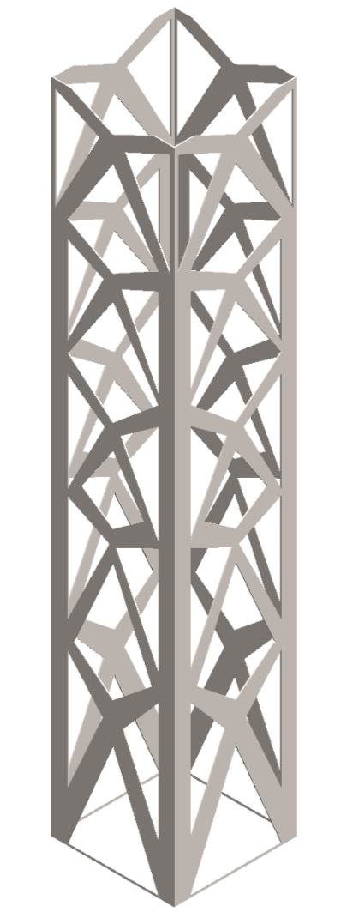
Figure 1: Optimized high-rise structure design
While topology optimization is an ideal solution for companies to save money, computer aided software run simulations through Graphical User Interface (GUI) that are not as timely efficient as we would like them to be. ANSYS is a software company that is known for running topology optimization simulations, and it can be a rigorous process when trying to optimize a design just like the example in Figure 1.

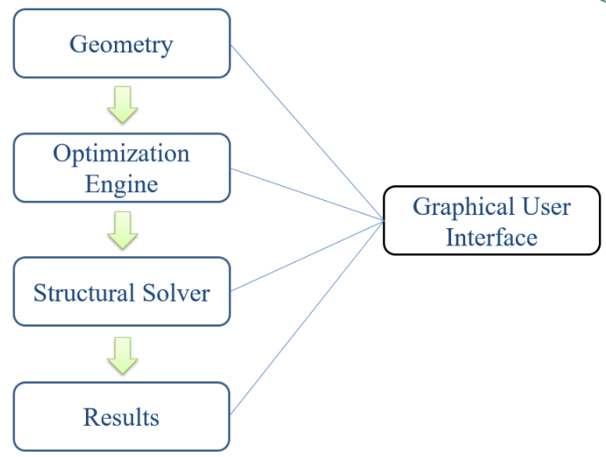
Figure 2: Flowchart sequence of optimization process through ANSYS GUI

In Figure 2, we can see that the ANSYS GUI, just like any other simulation software that run topology optimization simulations, has steps to completing an optimized shape. Our example in Figure 1 had to go through shape modifications after the optimization engine portion before we run a structural analysis on the optimized shape. These steps not only take time but can only process certain constraints one step at a time. Our group addressed the issue of lack of efficiency in the GUI of many of the simulation software that handle topology optimization, such as ANSYS. Not only did we see many rigorous steps to obtain an optimized design, but we also noticed the slow process that many of these simulations went through.
Our solution to this problem, was to create an automated software platform where we will be able to run multiple solutions on a model and produce quantitative results. Our group’s approach was to conduct research on topology optimization of static structures with computer aided software that would design, run simulations, and process data. The computer aided software we worked with were from commercial software vendors, such as AutoCAD, ANSYS, and MATLAB. The automation process that we chose to execute through MATLAB and ANSYS Parametric Design Language (APDL) that will help us create a fast and efficient platform that will further our understanding of topology optimization. Ultimately this platform can be modified to produce some of the most efficient optimized designs that architects and engineers use for high-rise structures
Our Research group is part of the ASPIRES program, which stands for ​Accelerated STEM Pathways through Internships, Research, Engagement, and Support, and it is an educational​ program that works in collaboration between Cañada College's Engineering Department, San Francisco State University School of Engineering, and UC Merced. Our group for the ASPIRES 2018 Summer group research program was led by SFSU civil engineering professor, Zhaoshuo Jiang with the help of civil engineer graduate student, Alec Maxwell.

- Static Structures
Static structures are rigid bodies such as beams and trusses that are at rest, and maintain static equilibrium when a force is exerted on them. These rigid bodies are important in framing, designing, building other structures such as high-rise structures, bridges, buildings, and other fixed structures.

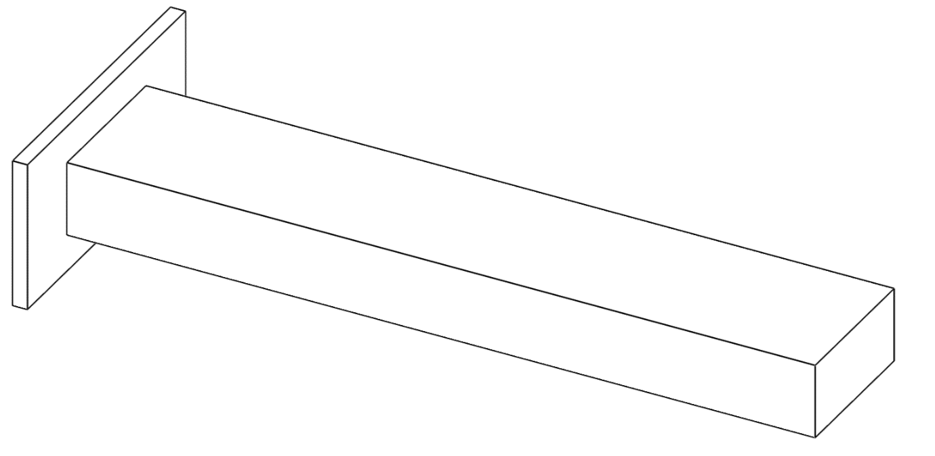
Figure 3: Isometric view of cantilever beam

The cantilever beam in Figure 3 is the rigid body that our group chose to work with in this research project. It is a simple structure that is used in research in topology optimization and static structure analysis. This rigid body consists of a plate and a beam that are connected as shown in the figure. Our cantilever beam has a predetermined steel material, since most beams are made out of steel.
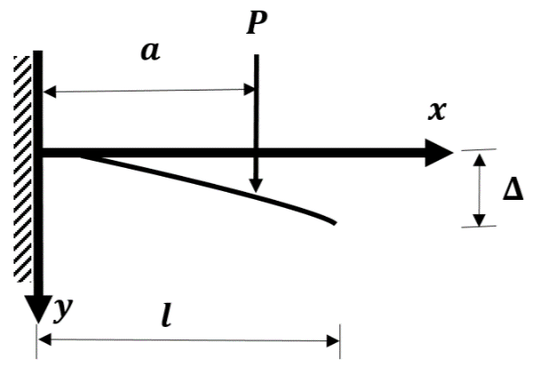
Figure 4: Cantilever beam with a concentrated load at any point

A point load is one in which an equivalent load or force applied to a single point, because we have a concentrated load over a small area, we can put into consideration that a load is acting on a point. We also have a fixed support that can resist forces and moments, also known as a rigid support. Having a fixed support and point load on our design was an important feature we had to consider when running a structural analysis through ANSYS.
Now to further understand point loads, we will refer to Figure 4 as visual representation to understand the behavior of a point load and the displacement. In most mathematical representation we see the vertical force denoted as 'P' followed with a symbol of an arrow symbol heading downward on a concentrated area. We applied this loading method into our cantilever beam which will be represented in our optimization process

- Finite Element Analysis, FEA
In ANSYS we obtained TO data and results through Finite Element Analysis (FEA), which is a computerized method that predicts how a product reacts to real world forces, vibration, fluid flow, and other physical effects. In many simulation software that use FEA, the cycle of finite element analysis continues until an objective volume is reached and the change in the objective is reached to a desired tolerance, steady state. [2, 4] For our purpose, we use FEA to analyze a static structure to find how applied forces will affect the material of the design. FEA is derived from Finite Element Method (FEM), which is a numerical method for solving engineering or mathematical problems. The process of solving a given problem involves breakdown or division of a large problem into smaller parts that are named finite elements
Before applying a force or a fixed point on a static structure, we first need to apply a mesh on our design that will be analyzed. mesh is a collection of vertices, edges and faces that defines the shape of the object going through a structural analysis in computer aided software.

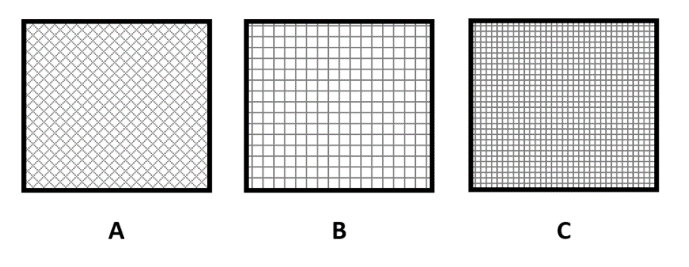
Figure 5: Examples of mesh sizes and patterns on 2-d blocks

In Figure 5 we can see a 2-d visual representation of different mesh sizes and patterns applied to 2-d blocks. On block A, the small diamond pattern can be categorized as a fine mesh and in block B and C we observe a more uniform mesh pattern with a big and small mesh size, respectively. Usually a finer mesh will entail smaller spaces and more triangular shape pattern.

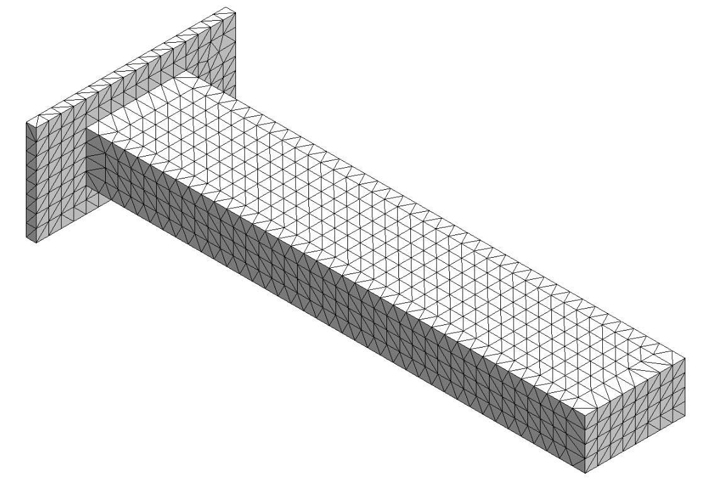
Figure 6: Isometric view of cantilever beam with a fine mesh applied
In Figure 6, this is a 3-d representation of our cantilever with a fine mesh size just like block A in figure 4. We can see that all around the cantilever beam, we have triangular shapes that form a mesh pattern.

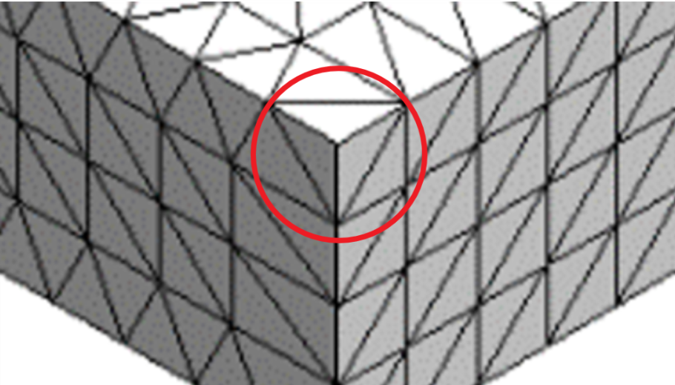
Figure 7: Cross sectional area of meshed corner

In Figure 7, we can observe that there is a tetrahedral shape occurring in the corner of the cantilever beam form figure 5. The tetrahedral shape is similar to a building block that our design is being broken down to since we use the concept of FEA, which means breaking down a big problem into smaller parts.

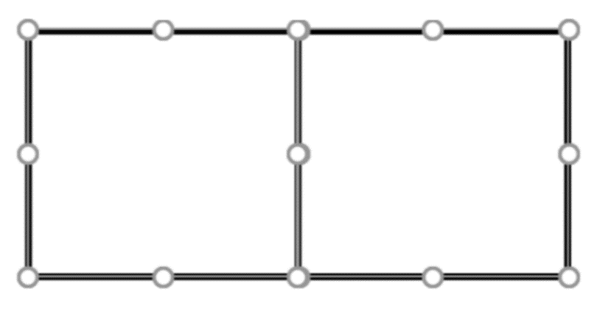
Figure 8: Cross sectional area of mesh and nodes applied

A mesh helps accomplish fulfilling the Finite Element Method. The Finite Element Method, as mentioned earlier, is a process in which a model will be broken down into smaller elements, that are connected by nodes. In our case study, our mesh breaks down the model into elements and a load is applied at a particular node. Figure 8 can illustrate how a simple design can be broken down and connected by a simple series of nodes.

- Automation Platform
In the platform our group created, we sought out to eliminate the need to use the GUI of ANSYS for simulations and AutoCAD for designing. Our Platform fit the need of cutting down time when running multiple simulations on a single model and also produce quantitative results through MATLAB. This Platform fits the need to promote a more productive rate by cutting out rigorous steps and time delays by attaining an optimized solution all through an automated process.

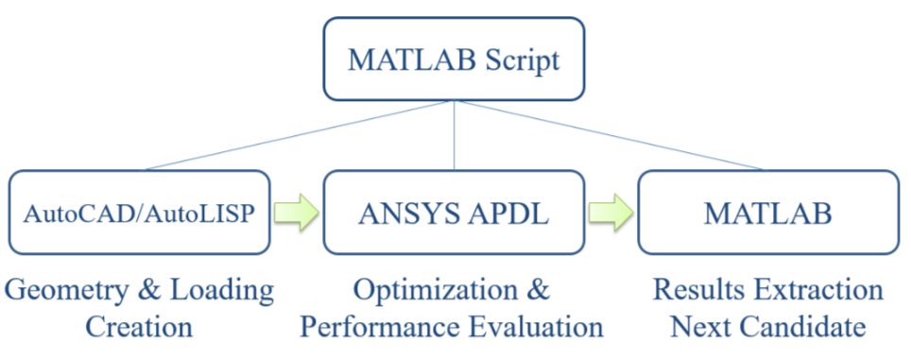
Figure 9: Flowchart of our group’s automated platform

In Figure 9 we have a flowchart that represents our automated platform sequence that we will further explain. We used the AutoCAD environment by using AutoLISP commands for parametric modeling and designing a static structure that would be exported into ANSYS. ANSYS has two Graphical User Interfaces (GUI) that we used to run simulations on our cantilever beam, but our objective for our platform was to process successful and efficient simulations.
In the ANSYS Workbench environment we ran simulations that would take more than an hour executed by manually clicking on buttons, tools, and features. The APDL environment worked in a similar way to Workbench, but had a command prompt to help us interact with GUI through modified Fortran based commands.
The focus was on using the APDL environment in which we are able to import an AutoCAD geometry and set parameters with loading features before running it through a topology optimization simulation. Once the optimization process was complete, we extracted the results and processed data through MATLAB. Our results give a better understanding on how we will be able to optimize our design through the displacements presented from the simulations we set up.

- Geometry & Loading Creation
Modeling and designing a cantilever beam was the initial part of our TO process, and we chose to use AutoCAD for this step. ANSYS has a parametric modeling feature that is not as user friendly as AutoCAD. In the AutoCAD environment we were able to create a 500 mm x 100 mm x 50 mm beam.

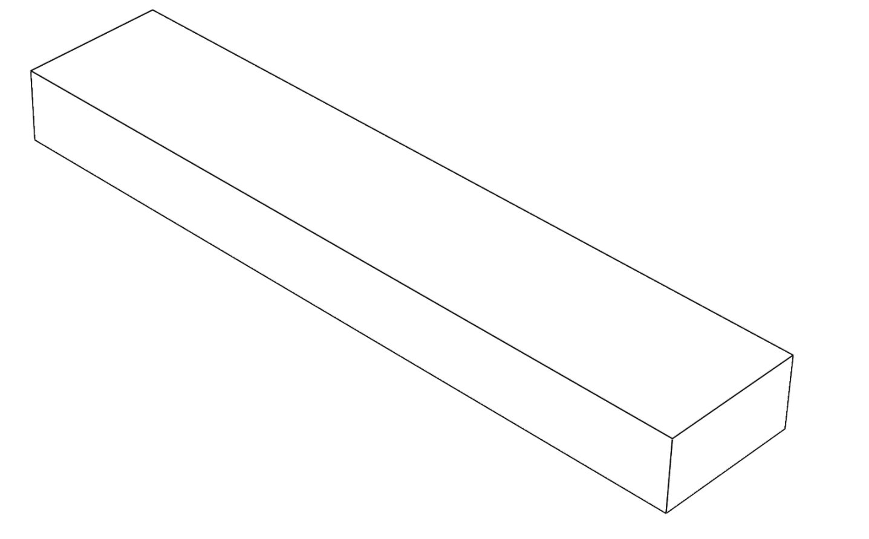
Figure 10: Trimetric view of beam

Since most of the focus was on the actual beam of the cantilever beam, we decided to use the portion represented in figure 5. In order for the APDL environment to read any geometry built in AutoCAD, we saved the design as an IGES (Initial Graphics Exchange Specification) file. IGES is a neutral file format designed to transfer data between CAD systems such as AutoCAD and ANSYS. To automate the process of geometry creation, we used AutoCAD’s programming language, AutoLISP. AutoLISP does not only allow for the geometry to be created, but also save and export into IGES format.
In order to reach an automated state for our process, we had to save the IGES file in a selected directory. Our selected directory were usually folders on our desktop to save as much progress along the research process. Since we were using the APDL environment, we had to use APDL commands that were used as a scripting language that had Fortran syntax similarities. The commands we used were all saved under the same directory where the IGES file was stored. We used the import command in our script file to import our geometry within our set directory. After the IGES file was successfully imported, we then began to go through our toplogy optimization process.
- Optimization & Performance Evaluation
For the simulation process we initially used Workbench to start the optimization process, but most of this process was to familiarize ourselves with what tools Workbench had to offer. Both Workbench and APDL had a GUI that was very user friendly but we had to learn the commands implemented in the APDL environment

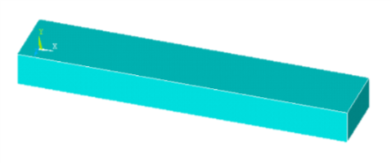
Figure 11: Cantilever Beam uploaded in APDL

In the APDL environment, the use APDL commands were needed to store our commands in a script file with a given directory. The commands we used were all saved under the same directory where the IGES file was stored. We used the import command in our script file to import our geometry. After the IGES file was successfully imported as we can see in the figure above, our commands began to set our geometry as a Static Structure before running an optimization process.

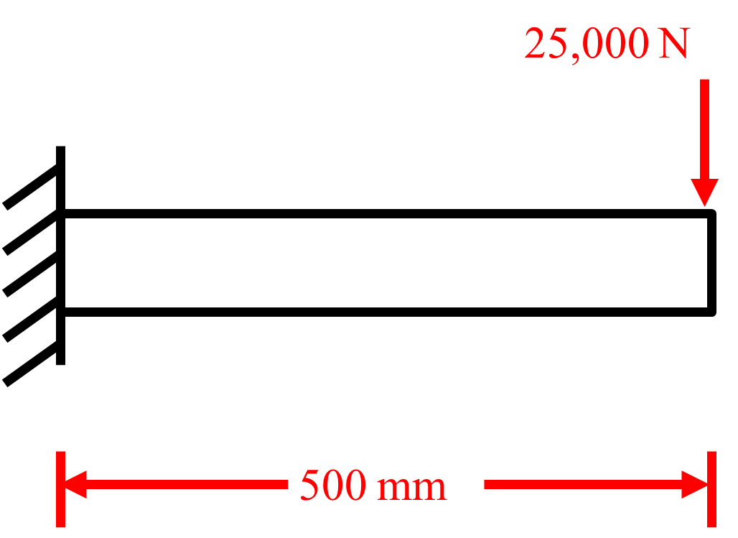
Figure 12: Case study of our model

In Figure 12, we had to validate our automation platform by performing a case study of our cantilever beam. Since we are running an optimization process, we retained 50% of the volume on our model. Our mesh size was varied from 10 mm to 50 mm by 10 mm increments. We also had a point load that would change locations by 50 mm increments from the end of the beam and stops at 50mm location from the beginning part of the beam. These different point load locations would occur for each varied mesh size and were ran in loop functions that were part of our APDL commands in our script file. We also had an export function for each mesh size that MATLAB compiled from our script file to quantitative results.

- Results and Discussion
In our script file we were able to create loop functions that would identify different force locations on our cantilever beam and also apply different mesh sizes. Once the forces and their respective mesh sizes were processed when running ANSYS in the background of the MATLAB environment, we were able to extract data from exported data made by the APDL command functions in our script file.

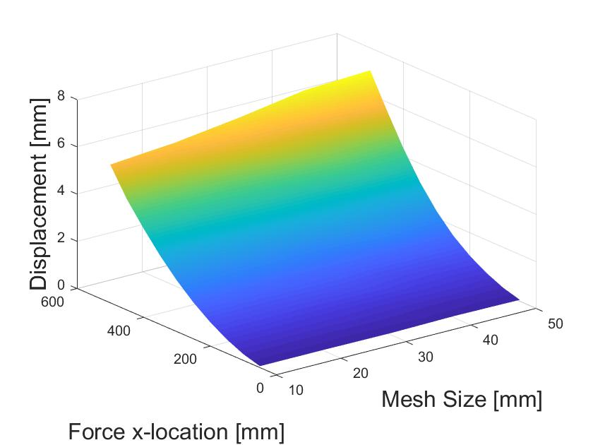
Figure 13: Graph of our force location, mesh size, and beam displacement results

In the graph above of our results from our case study, we can observe that large mesh sizes overestimate the beam’s displacement. We can also see a convergence to an equal value as the mesh size gets smaller.

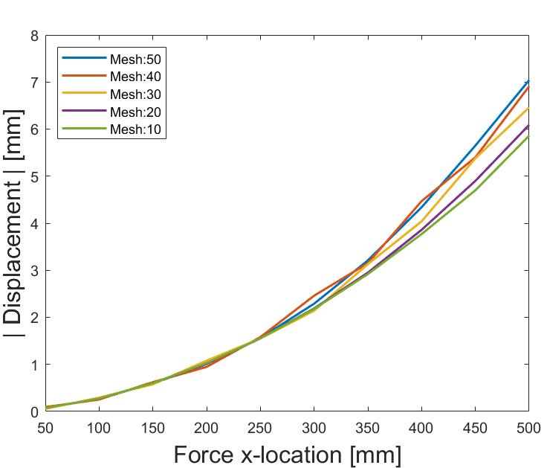
Figure 14: Graph of force location and beam displacement location

In Figure 14, observing the relationship between the force location and the displacement location, we can get a better perspective on how the mesh size plays a huge part of how accurate our data can be. If we observe the 10 mm and 20 mm results, we can see a small difference in the displacement locations towards the end of the beam.

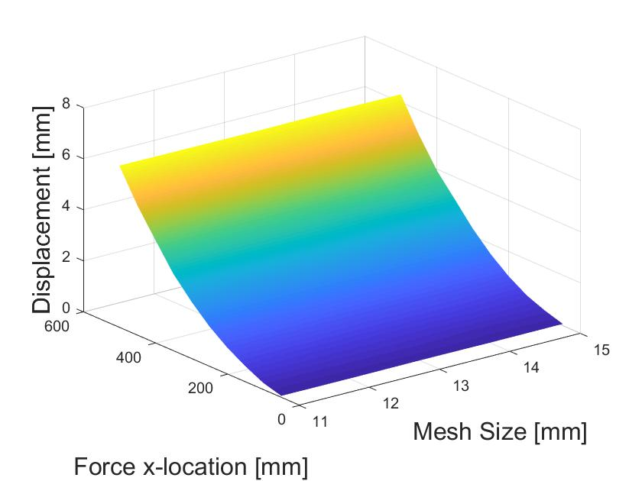
Figure 15: Graph of mesh range from 11 mm to 15 mm
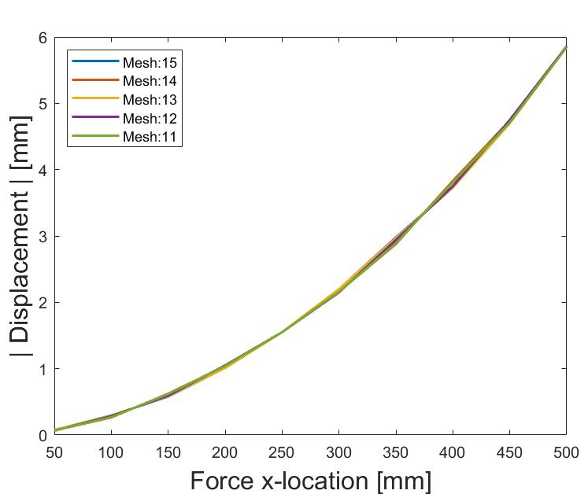
Figure 16: Force location and Displacement Results graph from mesh range 11 mm – 15 mm

We can see that in the two graphs above, the range we are observing in our chosen mesh sizes show displacements not visibly observable between small increments of sizes. Our assumption would be that any mesh size that is smaller would have the same results since we are reaching convergence around 10mm. We can relate this to FEM, since the purpose is to break down a problem into smaller parts and we can see that the lower we break down our geometry with a smaller mesh size, then the more accurate our graphs will be. We may conclude that as the mesh size gets smaller, the displacement converges to a more accurate result.
Our results at the end give us some perspective on the behavior of our beam going through an optimized process. The behavior of our converging results is a great way of showing that our platform is working but we still need to look into more theory in why it is a reliable platform.

$Δ=\frac{Pa^{2}}{6EI}\left(3l-a\right)$ (Eqn 1)
$I=\frac{bh^{3}}{12}$ (Eqn 2)

We will now analyze the behavior of our model with the displacement equation (Eqn 1) where our point load was applied at location a. We observe that that there is a single acting force P, in Newtons (N), on a concentrated area of the beam as shown in Figure 4 and 12. In the first equation our $Δ$ is the displacement max, l is the length of the beam, and E is Young’s modulus number. Young’s modulus E is a mechanical property that measures the stiffness of a solid material and this is a value we can look up, since we already have it as steel. The moment of inertia I is a calculation (Eqn 2) that we have to determine since the shape of our beam is rectangular, so b and h are height and thickness of the beam.

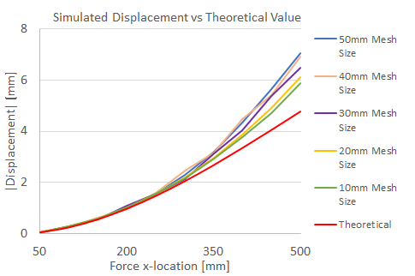
Figure 15: Experimental results with theoretical values graph comparison

In the above graph we can see that the theoretical values and our 10 mm mesh sizes are in the same ball park range. This result comparison was something our group wanted to accomplish since our model only retained 50% of its initial volume when going through the optimization process. We can also observe that our results are accurate when applying a smaller mesh size.

- Conclusion
In our platform, we currently have a reliable automated routine that performs a much productive analysis on a cantilever beam then an analysis done in the GUI. We were able to produce quantitative results by extracting displacement locations on our beam respective to its respective direction and vector component. The theory behind FEM proved that we were able break down our model and produce accurate results through small mesh sizes. We were also to create displacement results that were in a reasonable range, since we only analyzed 50% of the volume retained in our model.

- Future Work
After running successful simulations in MATLAB while running a script file with command functions, we were able to have a reliable platform. In this platform, we are able to import an IGES file in the APDL environment where we can run multiple simulations with different mesh sizes and point load locations and the extract quantitative data that we can interpret in the MATLAB environment. We still have three prospective modifications in our platforms that we would like to see in the future. Our first modification we would like to see is being able to have a shape optimization process where we can modify our deformed shape to make it more manufactural. Our second prospective is to analyze complex models such as high-rise structures and our third prospective would be to include more commands export different forms of quantitative data to further understand the behavior of our models under the topology optimization process.

- Acknowledgment
This project is supported by the US Department of Education through the Minority Science and Engineering Improvement Program (MSEIP, Award No. P120A150014); and through the Hispanic-Serving Institution Science, Technology, Engineering, and Mathematics (HSI STEM) Program, Award No. P031C110159.
We would like to express our appreciation to several people that have made this program a success and wonderful experience. We want to thank Dr. Amelito Enriquez from Cañada College for the opportunity to participate in this internship. Also, we want to thank Professor Zhaoshuo Jiang from San Francisco State University, our faculty advisor, and our graduate mentor, Alec Maxwell from San Francisco State University. We also want to thank San Francisco State University graduate student Wen Li Tang, for participating in this program to further understand the software behind our research.

References
1.Stromberg, Lauren L., et al. “Application of Layout and Topology Optimization Using Pattern Gradation for the Conceptual Design of Buildings.” Structural and Multidisciplinary Optimization, vol. 43, no. 2, 2010, pp. 165–180., doi:10.1007/s00158-010-0563-1.
2. Xia, Liang, et al. “Bi-Directional Evolutionary Structural Optimization on Advanced Structures and Materials: A Comprehensive Review.” Archives of Computational Methods in Engineering, vol. 25, no. 2, 2016, pp. 437–478., doi:10.1007/s11831-016-9203-2.
3. Wu, Yue, et al. “Size and Topology Optimization for Trusses with Discrete Design Variables by Improved Firefly Algorithm.” Mathematical Problems in Engineering, vol. 2017, 2017, pp. 1–12., doi:10.1155/2017/1457297.
4. Tang, Jiwu, et al. “Conceptual Design of Buildings Subjected to Wind Load by Using Topology Optimization.” Wind and Structures, vol. 18, no. 1, 2014, pp. 21–35., doi:10.12989/was.2014.18.1.021.

