Comparison of 200kN Magneto-Rheological Dampers for Determination of Parameters by Probabilistic Means

Christopher Amaro, Priscila Silva, Adam Davies, Juvenal Marin, Jesus Caballero
Mentors: Jun Jian Liang, Dr. Chen
Cañada College / San Francisco State University

Abstract:

The state of California has many fault lines throughout the San Francisco Bay Area and other densely populated areas that are prone to earthquakes, and past research and data seem to conclude that there is a probability that an earthquake of at least 6.7 magnitude will occur in the next 30 years. An example earthquake of comparable magnitude, would be the 1989 Loma Prieta earthquake, caused around 6 billions dollars in damages. In order to prevent a huge disaster to our infrastructure MR (Magneto-Rheological) dampers are being previously designed to dissipate energy from earthquakes. By analyzing different numerical model for the dampers, we are able to monitor their behavior and response to optimize their performance. Using software like MATLAB and UQ Lab we have been able to conduct various experiments, and collect data that has been gathered to see how the dampers will react in a real-world application. Our results also alerted us to any errors that happened in real-world applications and see if there needs to be adjustments within formulas, and parameters. Our goals helped us determine model parameters with probabilistic methods, and also compare/contrast models and respective parameters.

1. Introduction
Structural engineering addresses safety and failure prevention of structures. This concern is important in the state of California, which is prone to experiencing strong earthquakes. In the next 30 years there is a 99.7% chance of a 6.7 or larger earthquake will hit California. In order to potentially reduce vibrations that a structure experiences during a seismic event, several models of Magneto-Rheological (MR) dampers have been researched. Magneto-Rheological dampers are promising due to the temperature range in which they are functional , size, simple mechanical design, low power needs, and smart Magneto-Rheological fluid ¹. MR dampers are also known as “Smart Dampers” because of the MR fluids beneficial physical properties. The viscosity of MR fluid can be influenced by an external magnetic field; by increasing the strength of a magnetic field surrounding the fluid, the viscosity of the MR fluid increases as well ². Since the 1990’s Lord Corporation has been developing large-scale MR dampers that can be used in structures ². With continued research surrounding MR dampers, models can perform effectively and ultimately allow structural safety to increase.
The work described in this paper represents the results of the research done by a group of community college students during a ten-week summer internship program. The students were part of the Accelerated STEM Pathways through Internships, Research, Engagement and Support (ASPIRES) program at San Francisco State University in partnership with Cañada College. The ASPIRES program serves to expose community college students to summer research projects that will help students advance in their academic and professional career. The students involved in this project conducted research that contributes to the mechanical and civil engineering communities by conducting simulations and acquiring data on MR dampers.
Our work involved the comparison and analysis of parameters of five different MR damper models that have been previously studied by deterministic means ⁵. MR damper models are represented by a set of differential equations, and each of the five damper models has its own set of equations ⁵. The five models we worked with are the Bouc-Wen model, Hyperbolic Tangent model, Viscous Plus Dahl model, Non-Parametric Algebraic model, and the Maxwell Non-linear Slider model ⁵. The parameters of an MR damper correspond to the set of differential equations that describe that model.
2. Approach
The goal is to compare and analyze the models of MR dampers that has been presented through previous research. This will be done by using the add-ons UQ lab and Simulink. Both of these plugins will be used in MATLAB. We will also use the graphic user interface in MATLAB to create a tool that will help us conduct our research. The graphic user interface (GUI) we created allows easy comparison of all the damper models. Analysis of the parameters was conducted using MATLAB and UQ Lab. Damper models were created in MATLAB’s Simulink feature and simulations were run to obtain hysteresis and velocity curves. UQ Lab was used to run simulations that analyzed the sensitivity of each model parameter within MATLAB. Some models perform better at low currents while other models function better at higher currents. The models will also function differently depending on the time allotted. We are going to compare all of the different models and optimize the parameters of each model to investigate these patterns in more depth.
Ultimately the task set forth for the group was to determine probabilistic parameters of each MR damper model through use of the Metropolis-Hasting Algorithm, allowing for further comparisons between all the current damper models to be made. As seen in the appendix, tables one through six display deterministic parameters previously found for each model studied in this paper.

2.1 Developing a GUI
Comparing the different models graphically is an efficient way of conducting comparisons. For this to happen we made our own specific application, using MATLAB to create our GUI. Using MATLAB’s built in GUI tools, we created a GUI that allows a user to easily compare and interact with all the different MR damper models. The graphic user interface is a better alternative to text-based user commands. One of the main advantages is an easy interface that can easily be learned and used efficiently. In other words creating a GUI for our research allows us to easily conduct by visually comparing the models and collecting the data. The GUI we created is illustrated below and is easily operated. The way it works is the user first enter in a IV value into the text box in the left window, after that he presses the green button to enter it. Finally the user will select one of the models that is listed on the left side of the other window. Finally to plot the graphs the user select either a displacement or velocity graph. The plots will overlay each other for easy comparison. They can also be be deleted by pressing the ‘’clear’ bottom. The GUI is a easy and effective way of comparing the models graphically.

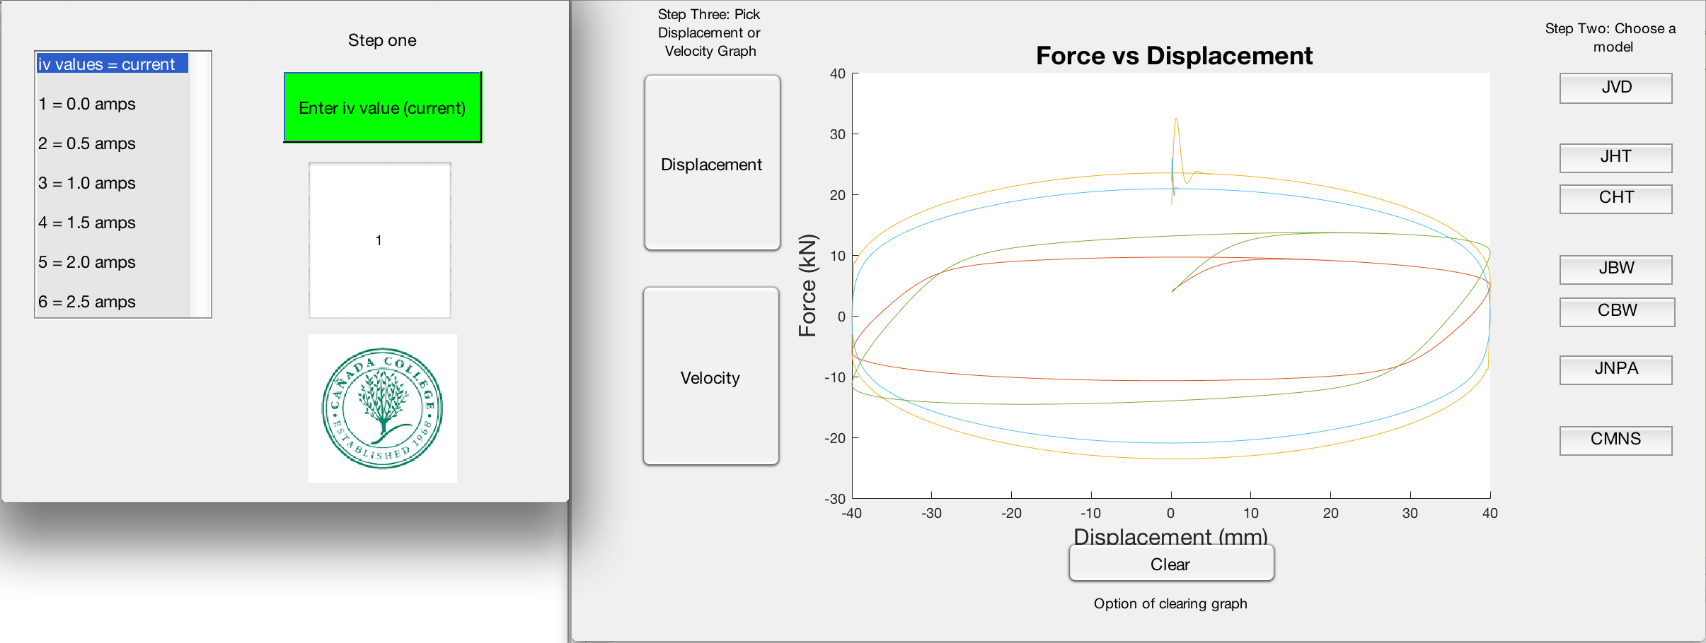
Figure 1. Functioning GUI

2.2 Simulating MR models responses using Simulink
Another tool we were exposed to was Simulink, a program that allows users to generate complicated codes by using diagrams and symbolic icons. Simulink allowed us to efficiently create multiple models within MATLAB. By using symbolic blocks and diagrams, we were able to design and simplify the different computational models that we were given from previous research. Each mathematical model has different parameters and equations meaning that no two models will be equivalent. In this case Simulink allowed us to be more time effective, since programming differential equations in MATLAB is complicated and time consuming. Following the simulations, we gathered data that showed us how the damper would react to certain currents that go from 0A to 2.5A in increments of 0.5A. The ground motion is simulated using a sin wave. The data and results allowed us to see if we were in the correct path by generating similar graphs to the ones of past research. As described below there is a brief summary of what the results mean and how they will helps us further this research.

2.3 Uncertainty Quantification using UQ Lab
Uncertainty quantification is a process used to determine how likely certain outcomes are to occur depending on aspects of the system that are unknown. UQ lab is a MATLAB-based program that allows us to run these simulations and scenarios for the purpose of quantifying said uncertainties. We are going to use uncertainty quantification for the sensitivity analysis of the MR dampers models. The purpose of sensitivity analysis is to analyze each of the MR damper model to determine how much each parameter affects the output of the model. In other words, we are looking at the sensitivity of the models to parameters. After we are done with this we will have an estimate of how the parameters affect the different models.

2.4 Metropolis-Hastings Algorithm

The Metropolis-Hastings Algorithm, also known as MHA, is a realistic mathematical modeling approach that helps generalize experimental results. Although some models used in the research paper, by Jiang, require validation of their parameters with experiment, others can have parameters directly measured ³ . Using a probabilistic approach means treating the model’s parameters as random variables, which is how it is analyzed in the Metropolis-Hastings Algorithm. MHA generates sample parameter sets and can show potential correlations between parameters, which may further provide insight to the uncertainty in the algorithms used for control applications. Having a probabilistic characterization of model parameters, which includes extreme and unlikely parameter values, provides information that could anticipate or improve model predictions and controller response. This will aid us when providing estimates of the relative impact of individual parameters and comparing the models. The probabilistic model developed in this work was updated using four records drawn from large-scale test performed on a full-size MR damper in the University of Colorado at Boulder.

3. Results

3.1 Simulink

After creating files that consisted of differential equations in Simulink for each model, two plots were obtained from the data Simulink generated. Each data set in Simulink was generated with a sine wave that represented assumed ground motions experienced by a structure. Plots of force vs displacement and force vs velocity were generated to represent the behavior of our five different damper models. Figures 2 - 14 depict the plots obtained by the simulations ran in Simulink.

The force vs displacement plots represent the displacement of the piston in the MR damper as it experiences seismic loads. As mentioned previously, MR dampers are also called smart dampers because they can dissipate different amounts of energy depending on the size of the current that runs through them. Thus each closed curve in the displacement curve represent a different current value and the area contained within each closed curve represents the amount of energy dissipated by an MR damper. The values of current that run through the damper range from 0.0A to 2.5A and increase in increments of 0.5A. When the MR damper experiences larger forces from the ground, a higher current is supplied through the coil in the MR damper and thus the amount of energy dissipated by the damper is larger. In our simulations, the dampers models were ran through all six current values, allowing for the analysis of all the values of current to be analyzed.

The force vs velocity plots represent the velocity of the damper piston as it is displaced when subjected to assumed ground motions. As the velocity of the piston increases, so does the force in the damper. There are a total of six curves, each curve representing a different current value experienced by the respective damper model. The curve depicts a point where both the damper velocity and force reach a maximum. After this point, both the velocity and force in the damper begin to decrease back to the initial state. The force vs velocity plot exhibits a hysteresis curve, due to the Magneto-Rheological fluids ferromagnetic properties.

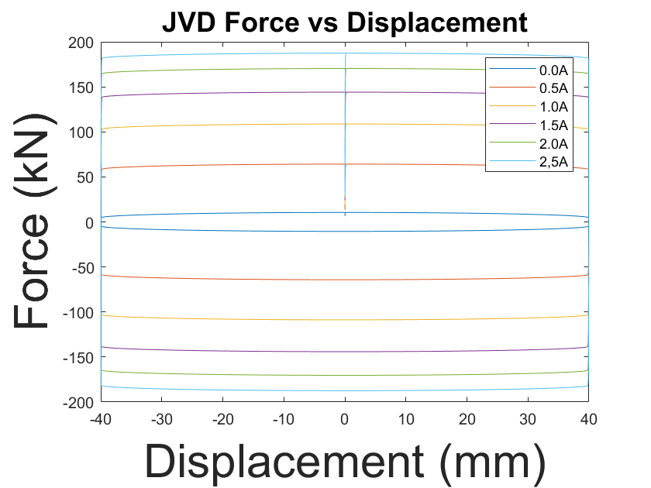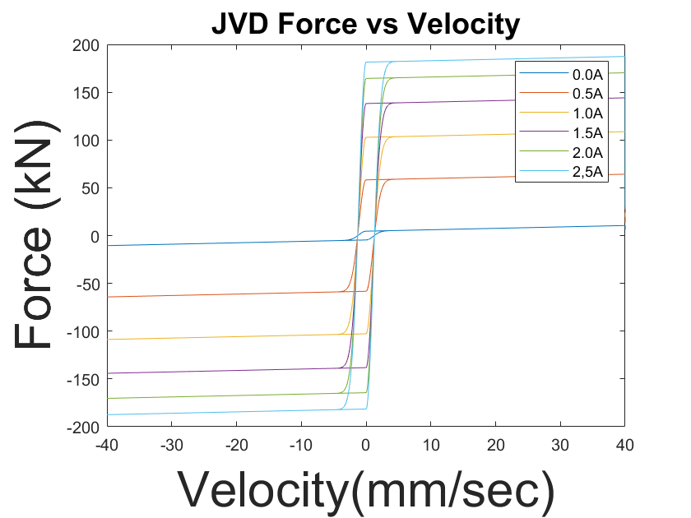
Figure 2: the two charts above show the data collected for a)“Force vs Displacement” and b)“Force vs Velocity” for the Viscous Plus Dahl Models using the Parameters identified by Professor Jiang.

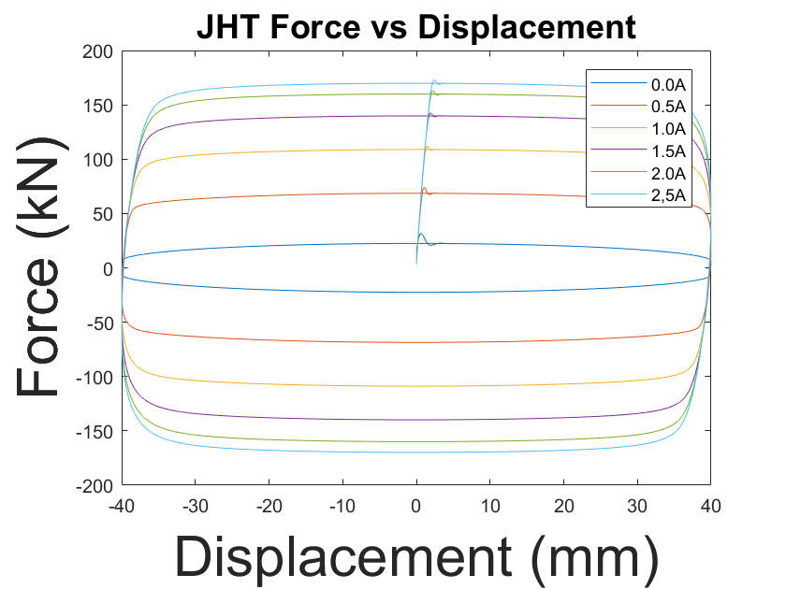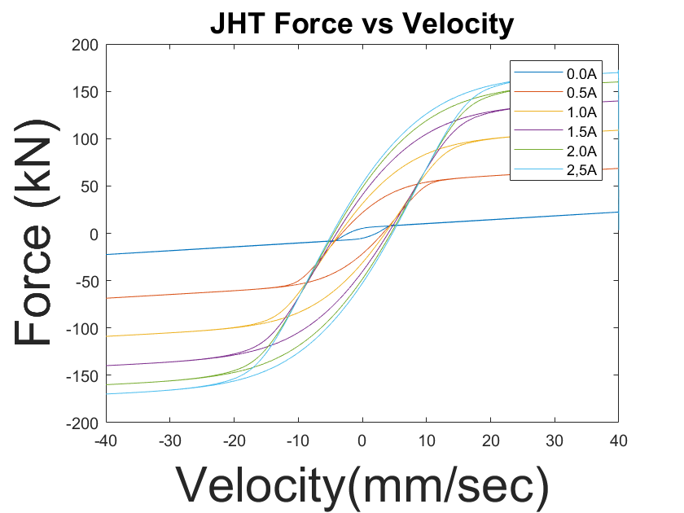
Figure 3: the two charts above show the data collected for a)“Force vs Displacement” and b)“Force vs Velocity” for the Hyperbolic Tangent Models using the Parameters identified by Professor Jiang.

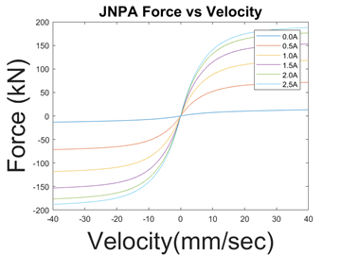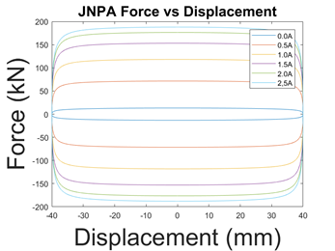
Figure 4: The two charts show the data collected for the a)“Force vs Displacement” and b)“Force vs Velocity” for the Non-Parametric Algebraic Model using the Parameters identified by Professor Jiang.

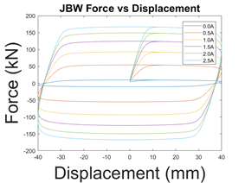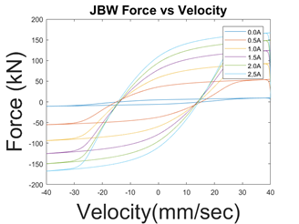
Figure 5: These two charts show the data collected for a)“Force vs Displacement” and b)“Force vs Velocity” for the Bouc-Wen model using parameters identified by professor Jiang.

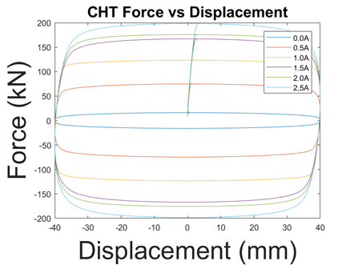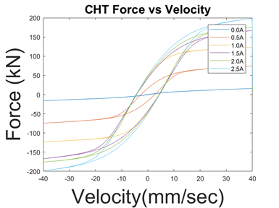
Figure 6: the two charts above show the data collected for a)“Force vs Displacement” and b)“Force vs Velocity” for the Hyperbolic Tangent Model using parameters identified by Professor Chae.

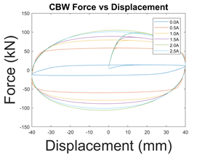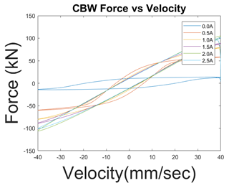
Figure 7: the two charts above show the data collected for a)“Force vs Displacement” and b)“Force vs Velocity” for the Bouc-Wen Model using parameters identified by Professor Chae.

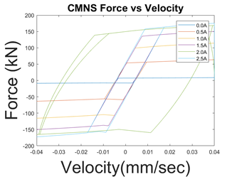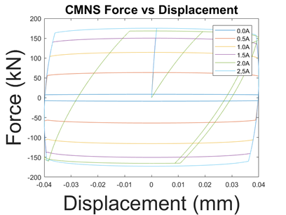
Figure 8: the two charts above show the data collected for a)“Force vs Displacement” and b)“Force vs Velocity” for the Maxwell Nonlinear Slider Model using parameters identified by Professor Chae.

3.2 UQ Lab

With UQLab we are able to produce sensitivity charts for the different models and parameters. We were able to determine the density and sensitivity of each parameter using the sensitivity charts. When observing the data the sensitivity of the different parameters is determined by its distance from zero. The farther a variables output was from zero the more sensitive the parameters is and vice versa. In other words, the variable with the highest value is the most sensitive while the value the closest to zero is the least sensitive. What “sensitivity” means is how much of an impact each parameter has on the different models. What this means is a sensitive variable will have a large impact on the output, while a variable that is not sensitive will have little to no impact on the output. Most of the models had one main parameters that had a high sensitivity, aside from the sensitive parameter some models also included 1-3 parameters that had about half the sensitivity of the main parameters. The remaining parameters had a low sensitively and had little to no impact on the output. We also noticed was there was no even distribution across all the parameters. The models did not have an ideal sensitivity distribution. The models focused on one main parameter and several secondary parameters as well as non-sensitive parameters that had no impact on the output.

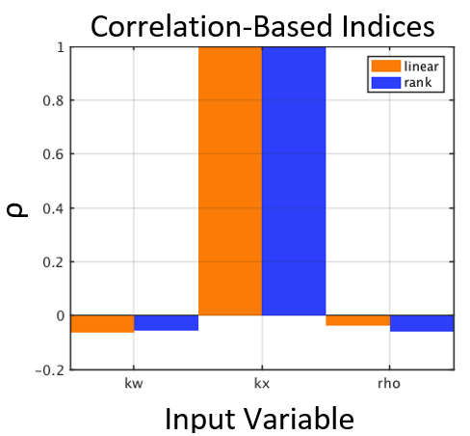
Figure 9: The table shows the data that we collected for our JVD model. For this figure, we have 3 variables and we can see that ‘k x’ is our most sensitive while ‘kw’ and ‘rho’ are the least sensitive.

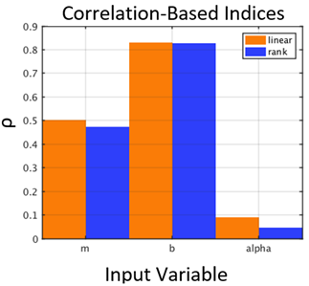
Figure 10: the chart table above shows the data collected for our JNPA model. For this one we have two variables with values that are close to one and only one variable close to zero.

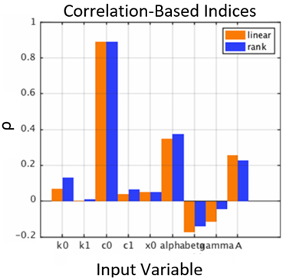
Figure 11: this chart shows the collected data for the JBW model. The most sensitive variable in this chart is the ‘c0’ variable while we have the ‘kl’ variable as the least sensitive.

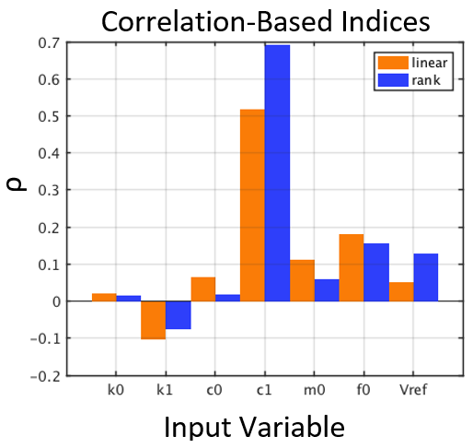
Figure 12: this chart shows the collected data for the JHT model. Here we have the variable ‘c1’ as the most sensitive while most of the other variables are closer to zero

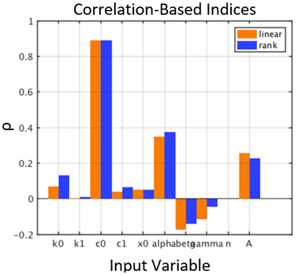
Figure 13: this table shows the data collected for the CBW model. For this model, our variable ‘c0’ is the most sensitive while variable ‘k1’ is the least sensitive.

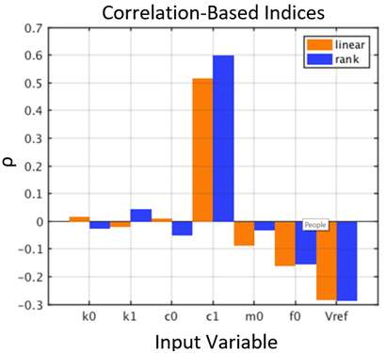
Figure 14: the table shows the data collected for the CHT model. Here our most sensitive variable is ‘c1’, we also have several variables who are bordering near the zero.

3.3 Metropolis Hasting Algorithm

During our research we did a comparison between the parameters using the MHA approach. In the Non-Parametric Algebraic and Viscous Dahl Model we compared the predicted force using deterministic parameters versus the predicted force using Liang probabilistic mean. The deterministic parameters were found by using optimization method, which were parameters found by Jiang and Christenson, and the Liang parameters were found by using the MHA approach. From the graphs (Figure 15 and 16) we analyzed that Liang's parameters were closer to the experimental data from MR Dampers, which means the probabilistic parameters are more precise.

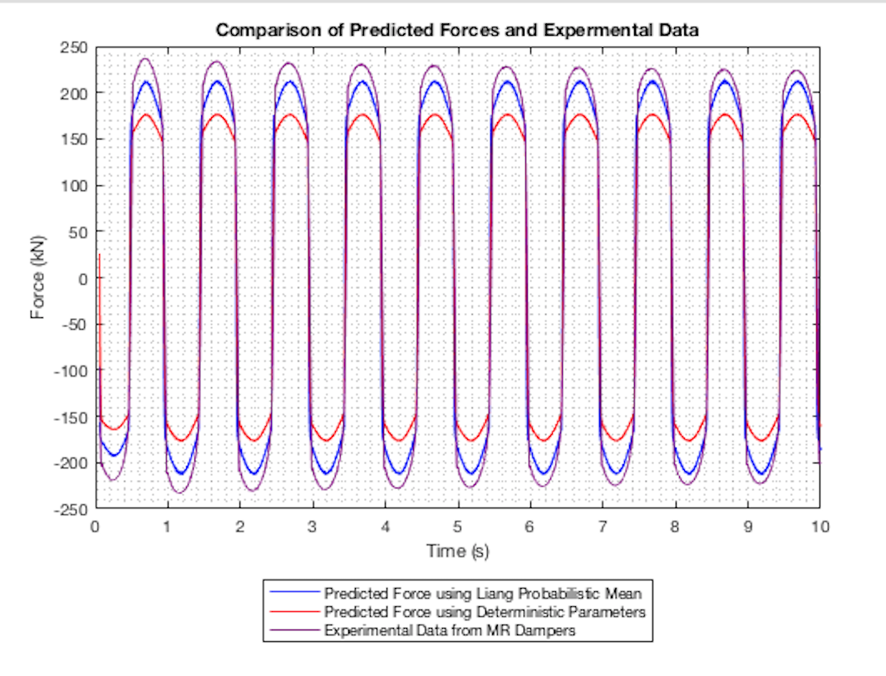
Figure 15: Viscous Dahl Model using Metropolis Hasting Algorithm

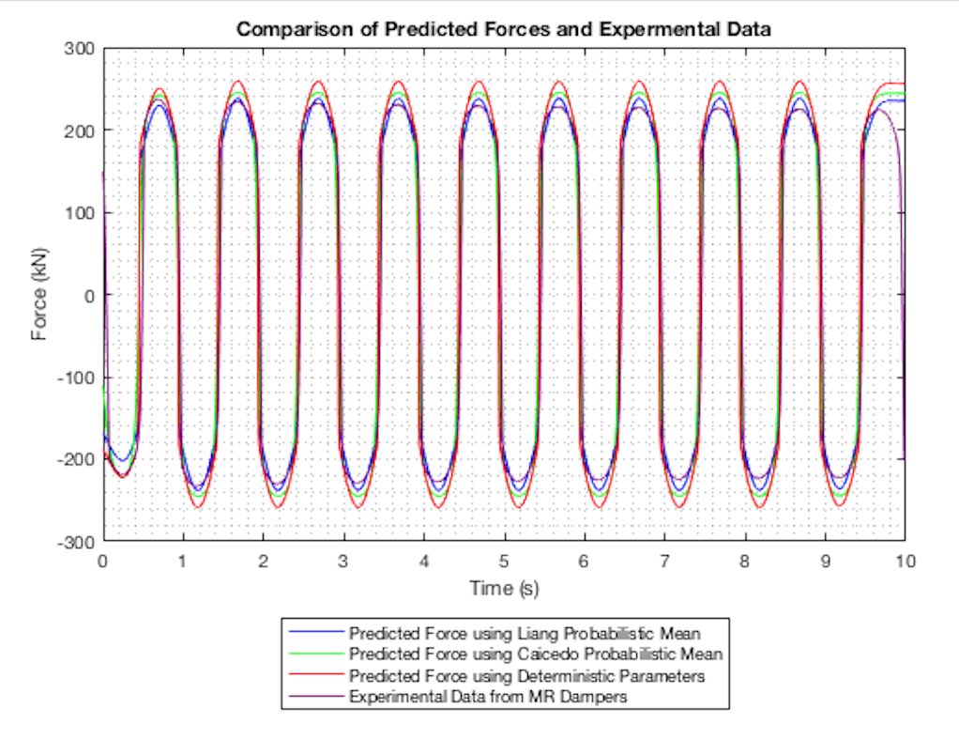Figure 16: Non-Parametric Algebraic Model using Metropolis Hasting Algorithm

4. Conclusion
The results that we received after generating the models in Simulink showed us how important the displacement and velocity affected the dampers. Like stated before the current manipulates how the damper reacts to the assumed ground motions, which will dictate what force value the damper will exert. From all of this data we were able to conclude how certain models can dissipate more energy than others at certain currents. Certain models can dissipate more energy at lower values of current while others had them at higher values as seen in the graphs previously. UQ lab gave us plenty of data when we ran the sensitivity analysis, and we were able to conclude one specific thing. Since each models have different parameters UQ lab showed us, which one’s were more sensitive in the model. Therefore we can conclude that there are models that are more sensitive than other making them more desirable for certain situations. Regarding Metropolis Hastings Algorithm we can conclude which results are more precise in this case Liang’s probabilistic parameters are more precise than the deterministic parameters set by previous research.
Some considerations for future work are analysis of single degree of freedom, and if successful the research will continue with multiple degrees of freedom analysis as well as non-linear analysis. This will allow for further research that will continue to improve how the Magneto-Rheological dampers behave.

Bibliography

1. Jiang, Z., and R. Christenson. "A Comparison of 200 KN Magneto-rheological Damper Models for Use in Real-time Hybrid Simulation Pretesting." Smart Materials and Structures 20.6 (2011): 065011. Web.

2. Chae, Yunbyeong, James M. Ricles, and Richard Sause. "Modeling of a Large-scale Magneto-rheological Damper for Seismic Hazard Mitigation. Part I: Passive Mode." Earthquake Engineering & Structural Dynamics 42.5 (2012): 669-85. Web.

3. Caicedo, Juan M., Zhaoshuo Jiang, and Sarah C. Baxter. "Including Uncertainty in Modeling the Dynamic Response of a Large-Scale 200 KN Magneto-Rheological Damper." ASCE-ASME Journal of Risk and Uncertainty in Engineering Systems, Part A: Civil Engineering 3.2 (2017): n. pag. Web.

4. D.Q. Troung and AhnK.K. “MR Fluid Damper and It’s Application to Force Sensorless Damping Control System.” Intech (2012): DOI: 10.5772/51391. Web

5. Liang, Jun Jian. "Comparison of Models for Large-Scale Magneto-Rheological Damper to Account for Uncertainty in Seismic Hazard Mitigation." Comparison of Models for Large-Scale Magneto-Rheological Damper to Account for Uncertainty in Seismic Hazard Mitigation (2018): 1-14. Web.

6. “USGS: California Has 99.7 Percent Chance of Big Earthquake in Next 30 Years.” Fox News, FOX News Network, 15 Apr. 2008, www.foxnews.com/story/2008/04/15/usgs-california-has-7-percent-chance-big-earthquake-in-next-30-years.html.

7. Truong, D. Q., and K. K. Ahn. “MR Fluid Damper and Its Application to Force Sensorless Damping Control System.” MR Fluid Damper and Its Application to Force Sensorless Damping Control System | InTechOpen, InTech, 17 Oct. 2012, www.intechopen.com/books/smart-actuation-and-sensing-systems-recent-advances-and-future-challenges/mr-fluid-damper-and-its-application-to-force-sensorless-damping-control-system.

8. Sidpara, Ajay. “Magnetorheological Finishing: a Perfect Solution to Nanofinishing Requirements.” Optical Engineering, International Society for Optics and Photonics, 1 Sept. 2014, opticalengineering.spiedigitallibrary.org/article.aspx?articleid=1857354.

9. Jiang, Zhaoshuo, et al. “Application of MR Damper in Real-Time Structural Damage Detection Using Extended Kalman Filter.” ResearchGate, 10 Aug. 2015,

10.www.researchgate.net/figure/281792403_fig2_Figure-31-Schematic-of-the-MR-damper-hyperbolic-tangent-model. “Uncertainty Quantification.” Uncertainty Quantification | SmartUQ, www.smartuq.com/resources/uncertainty-quantification/.

Appendix

I(A) | k0(kN/m) | k1(kN/m) | c0(kN*s/m) | c1(kN*s/m) | x0(m) | $α$(kN/m) | $β$(m^-2) | $γ$(m^-2) | n | A
0 | 56.09 | 2.940 | 105 | 32943 | 0.140 | 15.50 | 15.59 | 1.066 | 2.270 | 364.7
0.5 | 36.68 | 5.320 | 196.9 | 19541 | 0.160 | 55.60 | 49.64 | 1.657 | 5.270 | 1.923
1.0 | 9.710 | 1.880 | 179.6 | 13551 | 0.210 | 106 | 6.340 | 937.3 | 3.200 | 1013
1.5 | 30.12 | 3.480 | 208.2 | 12224 | 0.020 | 205.4 | 53.62 | 1.778 | 3.220 | 538.3
2.0 | 89.24 | 3.710 | 227.8 | 11445 | 0.170 | 164.3 | 9.100 | 775.1 | 8.070 | 628.1
2.5 | 10.36 | 1.210 | 209 | 11651 | 0.120 | 170.9 | 5.920 | 610.7 | 4.800 | 650.5

Table 1. Chae Identified Parameters for Bouc-Wen Model⁵

I(A) | k0(kN/m) | k1(kN/m) | c0(kN*s/m) | c1(kN*s/m) | x0(m) | $α$(kN/m) | $β$(m^-2) | $γ$(m^-2) | n | A
0 | 0.10 | 3.04 | 114.4 | 29223 | 0.17 | 7.60 | 10.04 | 1016.2 | 2.18 | 364.7
0.5 | 1.95 | 2.68 | 147.3 | 23653 | 0.16 | 61.1 | 12.26 | 983.9 | 3.45 | 1.923
1.0 | 3.30 | 2.34 | 173.0 | 19382 | 0.16 | 103.9 | 6.340 | 963.9 | 4.43 | 1013
1.5 | 4.22 | 2.03 | 192.5 | 16228 | 0.16 | 137.5 | 16.70 | 954.2 | 5.17 | 538.3
2.0 | 4.79 | 1.76 | 206.6 | 14018 | 0.16 | 163.1 | 18.84 | 952.7 | 5.69 | 628.1
2.5 | 5.07 | 1.51 | 216.3 | 12595 | 0.15 | 181.8 | 20.87 | 957.7 | 6.04 | 650.5

Table 2. Jiang Identified Parameters for Bouc-Wen Model⁵
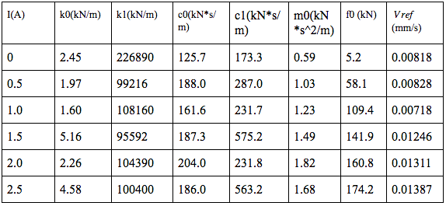
Table 3. Chae Identified Parameters for Hyperbolic Tangent Model⁵

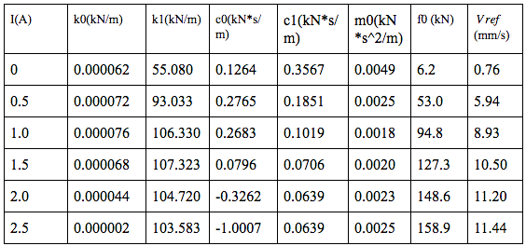
Table 4. Jiang Identified Parameters for Hyperbolic Tangent Model⁵

 | Positive Force Post-Yield Curve |  |  |  |  |  | Negative Force Post-Yield Curve
I (A) | c (kN*s/m) | $α$ (kN/m) | a (kN) | b (kN*s/m) | n (m) | x_dot⁺ | a (kN/m) | b (kN*s/m) | n | x_dot⁻ | m0 (kN*s^2/m)
0 | 10,000 | 100,000 | 7.5 | 243.5 | 1.62 | 0.010 | -7.3 | -235.6 | 1.60 | -0.010 | 0.50
0.5 | 11,000 | 100,000 | 53.1 | 162.5 | 0.85 | 0.010 | -53.1 | -162.5 | 0.85 | -0.010 | 0.50
1.0 | 12,000 | 118,000 | 91.5 | 122.5 | 0.52 | 0.010 | -96.0 | -134.9 | 0.60 | -0.010 | 1.60
1.5 | 12,000 | 118,000 | 126.7 | 152.1 | 0.58 | 0.010 | -126.7 | -152.1 | 0.58 | -0.010 | 1.50
2.0 | 11,491 | 110,030 | 148.5 | 166.3 | 0.66 | 0.003 | -146.8 | -182.1 | 0.71 | -0.003 | 1.05
2.5 | 12,278 | 112,890 | 138.5 | 161.8 | 0.46 | 0.017 | -133.5 | -171.8 | 0.46 | -0.012 | 1.04

Table 5. Chae Identified Parameters for Maxwell Nonlinear Slider Model⁵

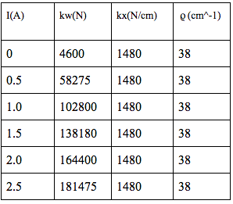
Table 6. Jiang Identified Parameters for Viscous Plus Dahl Model⁵

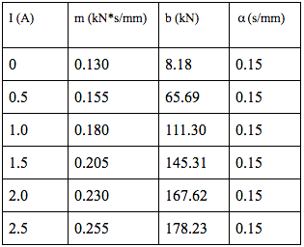
Table 7. Jiang Identified Parameters for Non-Parametric Algebraic Model⁵

