**Using Acoustic Sensors for Structural Health Monitoring**

**Ryan Yedinak1, Oskar Granados1, Vincent Tran1, Moises Vieyra1,**

**Alec Maxwell2, Zhaoshuo Jiang2, Amelito Enriquez1**

**1Cañada College/ 2San Francisco State University**

**Abstract**

The current technique used to monitor the structural health of buildings and bridges is to embed arrays of accelerometers or strain gages within the structure to get precise measurements and observe the overall health of the structure. However, installation and future maintenance costs of internal sensors are high, and the maintenance process is time consuming because the roads or buildings must be shut down to fix the sensors. In order to limit costs and improve the mobility of structural health monitoring devices, a non-contact, non-destructive method using microphone sensors is proposed. By implementing a series of microphone sensors directed at the structure, low-frequency (0-20 Hz) acoustic vibration signals can be captured from the structure and analyzed through spectral analysis using the Fast Fourier Transform. Experiments were run in which a single-degree-of-freedom (SDOF) structure was excited on a shake table with a microphone placed strategically at the direction of motion of the structure to capture low-frequency acoustic waves. After validation of the proposed technique, other microphones were placed opposite the SDOF structure to capture environmental noise signals that were also picked up by the first microphone. Several post processing techniques were developed in MATLAB to find the best method for eliminating these sources of noise. The results showed that although using microphone sensors is a valid technique for capturing the natural frequency of the structure, a more robust noise elimination technique needs to be developed to accurately characterize the health of a structure.

1. **Introduction**

Structural health monitoring is the process of monitoring a structure for damage to improve safety and reduce life-cycle costs. Methods currently being applied to detect the structural health of buildings, roads, and bridges range from using a series of accelerometers or strain gages placed on the structure to closing roadways and using visual inspection. The maintenance of accelerometers/strain gages can be costly since constant maintenance ranging from the cables connecting accelerometers/strain gages to the replacement of the monitoring devices. The drawback of visual inspection is that it is a subjective process that depends on the observer. The proposed technique of using microphones to monitor structures will reduce maintenance cost and create a more mobile platform for structural health monitoring. Preliminary test done with microphones has shown that the natural frequency of a SDOF structure is able to be detected. The challenge with using microphones is the excessive noise captured by the microphone and finding ways to cancel out other noises being captured by the microphone sensors. The goal of this experiment is to prove that non-contact microphones are capable to detect structural health, hence lowing cost and increasing efficiency.

1. **Structural Dynamics**

In order to understand the properties of structures, the principles of structural dynamics must be understood. The natural frequency is an inherent property of a structure, and is an important concept to explore in structural dynamics.

When analyzing the properties of a structure, the most destruction happens at the natural frequency, and it is important to prevent the structure from vibrating at its natural frequency. The power at which the structure is oscillating at the natural frequency can be determined in order to determine its overall structural health. This experiment focuses on the natural frequency of a SDOF structure, which can be observed in Figure 1.

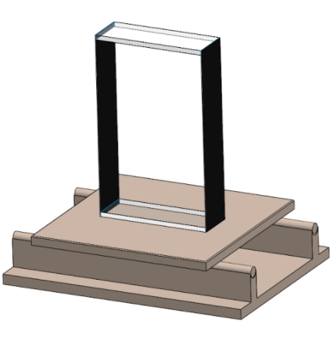

***Figure 1:*** *Diagram of SDOF structure on top of a shake table stand.*

One way in which the SDOF structure can be modeled is using a cart with mass *m* on a frictionless surface with a spring of linear elastic stiffness coefficient *k*, a damper of viscous damping coefficient *c*, and an external force $m{\ddot{x}}_{g}$ applied to the cart (Figure 2).

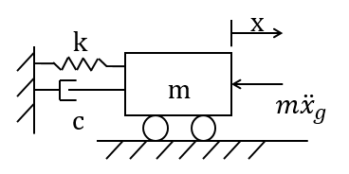

***Figure 2:*** *Model representation of SDOF structure with forces and coordinate system.*

From the representation of a SDOF structure an equation of motion (Eqn 1) was developed by considering all the forces acting on the structure using Newton’s Second Law where *x* represents the coordinate system and *t* represents time.

$m\ddot{x}+c\dot{x}+kx=-m{\ddot{x}}_{g}$ (Eqn 1)

After finding the equation of motion to describe the system, the natural frequency $f_{n}$ can be calculated numerically using Eqn. 2 by finding the stiffness *k* and mass *m*. The stiffness of the beams of the SDOF structure is assumed to be infinite, while the stiffness of the columns is calculated using the Young’s Modulus, moment of inertia, and height of the columns, as described in Eqn 3. The mass of the SDOF structure can be calculated using the density and volume of the beams and columns. Additional mass accounted for in this experiment included the accelerometer placed on top of the SDOF structure. The theoretical natural frequency was calculated using the parameters in Table 1.

$f_{n}= \frac{1}{2π}\sqrt{\frac{k}{m}}$ (Eqn 2)

$k= \sum{\frac{12E_{c}I_{c}}{h^{3}}}$ (Eqn 3)

$m_{SDOF}= ρ_{beam}V_{beam}+ ρ_{column}V_{column}+ m_{accelerometer}$ (Eqn 4)

|  |  |
| --- | --- |
| $$ρ_{beam}$$ | 1560 $\frac{kg}{m^{3}}$ |
| $$V_{beam}$$ | 0.003 $m^{3}$ |
| $$ρ_{column}$$ | 2400 $\frac{kg}{m^{3}}$ |
| $$V_{column}$$ | 0.001 $m^{3}$ |
| $$m_{accelerometer}$$ | 0.19 kg |
| $$E_{c}$$ | 42 GPa |
| $$I_{c}$$ | 6.67e-11 $m^{4}$ |
| $$h^{3}$$ | 0.125 $m^{3}$ |

***Table 1:*** *Values of parameters used to solve Eqn 2, 3, and 4.*

Using Eqn 2, the theoretical natural frequency of the SDOF structure was calculated to be 3.89 Hz. The main purpose for calculating the natural frequency of the SDOF structure numerically is to have a baseline to compare to when analyzing the SDOF structures properties through experimentation.

1. **System Identification using Traditional Accelerometers**

After calculating the natural frequency of the SDOF structure numerically, the natural frequency of the SDOF structure was found experimentally using traditional accelerometers. Experiments were conducted using a mobile app which allowed us to control the shake table and send in specific excitation signals. The mobile app allowed us to send in three different excitation signals which included sine wave excitation, sine sweep excitation, and earthquake signals using historical data records. The app also allowed us to change parameters such as frequency, amplitude, and duration of the signal. Figure 3 shows the setup of the shake table, data acquisition system, and accelerometers, as well as a diagram of how data and commands are transferred through devices. In order to find the natural frequency of the structure experimentally using traditional accelerometers, the SDOF structure was subjected to a sine sweep excitation in which the frequency of the ground movements increased from 0-10 Hz incrementally over a period of 60 seconds while having fixed amplitude. After observing the excitation of the structure, the acceleration and time data can be viewed on the mobile device and then transferred through the mobile device to MATLAB for post processing.

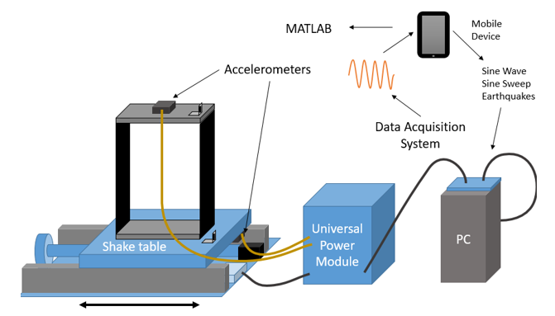

***Figure 3:*** *Setup for experimentation with traditional accelerometers.*

In order to capture acceleration data during the excitation of the SDOF structure, one accelerometer is attached to the shake table to monitor the acceleration of the ground (input signal), and one accelerometer on the top of the SDOF structure to monitor the response of the SDOF structure (output signal). Time data and acceleration data from the top and bottom of the structure are transferred from the shake table to the mobile app and can be viewed in real time in the time domain on the mobile device. Once the duration of the excitation of the structure has ended, the time and acceleration data can be exported to MATLAB for analysis. Figure 4 shows acceleration data from the top and bottom accelerometers plotted in the time domain.

Observing acceleration data in the time domain does not provide information on the frequency content of the signal. In order to better understand the content of a signal, the Fast Fourier Transform (FFT) can be used to deconstruct that signal into multiple sine waves. This transformation allows for observation of the power associated with each frequency within the captured signal. This can be accomplished in MATLAB using the FFT function to view the frequencies that make up the output acceleration signal from the accelerometer on the top of the SDOF structure. Figure 5 displays the transformed acceleration data in the frequency domain, where a large peak can be observed near the natural frequency of the structure.

The transfer function that describes the SDOF structure can then be found by performing FFT on a sine sweep trial and plotting the output acceleration data over the input acceleration data in the frequency domain and curve fitting the displayed peak. This can be done using the FIT function in MATLAB and adjusting the mass, stiffness, and damping coefficient values to get a curve that best fits the data. The experimental and numerical transfer functions can then be compared to determine the differences between results.



***Figure 4:*** *Plot of acceleration of the top and bottom of the SDOF structure during excitation.*

After performing FFT analysis on the acceleratometer data, the experimental natural frequency of the SDOF structure was found to be 3.87 Hz. When comparing this to the theoretical natural frequency of 3.89 Hz, there is only a 0.51 % difference between the two results.



***Figure 5:*** *Plot of the FFT of the acceleration data from the top and bottom of SDOF structure.*

1. **Acoustic Theory**

To understand how we will use microphone sensors to detect structural health, properties of acoustics must be examined. Sound is measured as the difference in pressure from atmospheric pressure, shown in Figure 6. A common way to model and better understand acoustics is to use the source-path-receiver concept. When an object is vibrating in the presence of air, the air molecules will start to vibrate at the surface of the object, sending the other air molecules nearby into motion. As the vibration propagates through air, pressure will oscillate at frequencies and amplitudes depending on the source. In our case the source is our SDOF structure, the medium is space between the structure and the microphone, and our receiver is a microphone.

Microphones are designed to transform pressure oscillations into electrical signals. We will be using pre-polarized condenser microphones, which have a pre-polarized material that is located between the diaphragm and backplate (Figure 7). Voltage is applied to the backplate, which creates the transducer that converts variants in acoustic pressure into an electrical signal. Changes in acoustic pressure due to a sound deflect the diaphragm, causing the gap between the diaphragm and backplate to change. The voltage generated by the gap change produces a voltage that corresponds to the microphone’s sensitivity in controlled atmospheric conditions.

Increase Pressure

Decrease Pressure

Atmospheric Pressure

Peak-to-Peak Pressure

***Figure 6:*** *The change in pressure can be described by a sinusoidal wave, where the equilibrium point is the atmospheric pressure.*

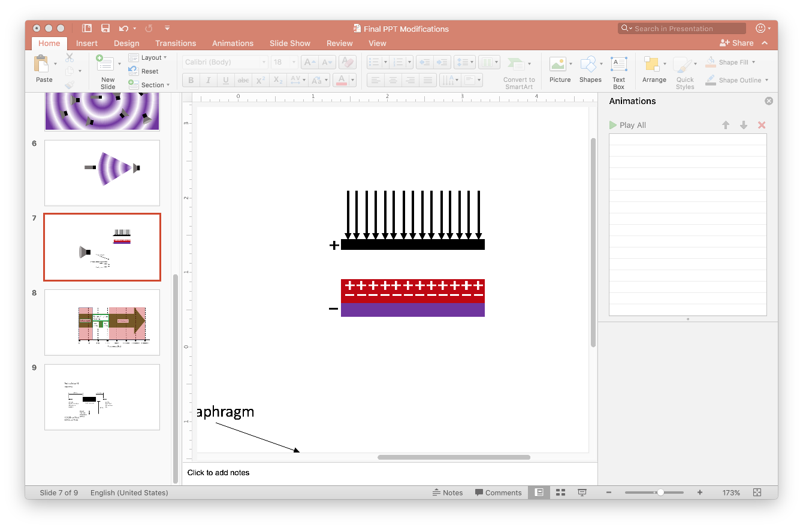

Diaphragm

Pre-polarized Material (Electret)

Backplate

***Figure 7:*** *Pre-polarized condenser microphone showing the polarization before any pressure is applied.*

The microphone will interpret soundwaves that are in-phase or off-phase of each other, depending on the degree of offset. In constructive interference, the amplitudes of the in-phase soundwaves are summed. Destructive interference occurs when two soundwaves are out of phase, which results in a reduction of amplitude. Frequency is measured by number of pressure variations per second. The frequency range we are interested in observing is inaudible noise, which is between 0-20 Hz since the natural frequency of many structures fall within that range. Microphones used in our experiments are passive, which means they do not omit anything to interpret sound. In our experiment, four arrangements of two free field microphones and one random incident microphone will be used. Free field microphones (Figure 8) capture the noise of the hemisphere which the microphone is pointed at, whereas the random incident microphone (Figure 9) captures the all noise in the room (spherical).

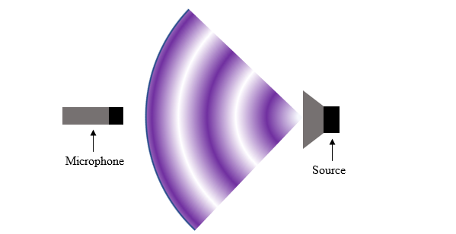

***Figure 8:*** *Free Field Microphone*

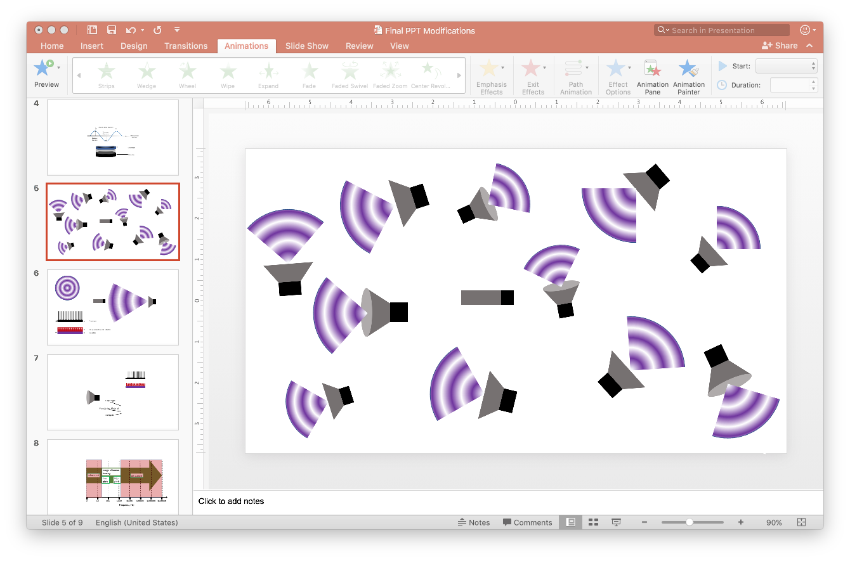

Microphone

***Figure 9:*** *Random Incidence Microphone*

1. **System Identification using Microphone Sensors**

After experimentally determining the natural frequency of the SDOF structure using traditional accelerometers, experiments were done in which microphone sensors were used to capture the motion of the SDOF structure and eliminate noise from the environment. Two different types of microphones were used in the experimentation when capturing acoustic waves from the SDOF structure and from the environment, the PCB 378A07 free-field microphone and the PCB 377C20 random incidence microphone. Two different microphone types were used in these experiments because these were the current resources supplied by the lab and in order to determine which type of microphone would be more practical for this application.

1. **Validation of Microphone Sensor Technique**

After determining the natural frequency of the SDOF structure using traditional accelerometers, experimentation was done to validate that microphone sensors could be used to determine the natural frequency as well. In order to accomplish this, one random incidence microphone was directed at and parallel to the SDOF, while a high-fidelity accelerometer was attached to the top of the structure. Figure 10 shows the spectral data from the high-fidelity accelerometer, while Figure 11 shows the spectral data from the microphone sensor.



***Figure 10:*** *High-fidelity accelerometer spectral data*



***Figure 11:*** *Random incidence microphone sensor spectral data after 21 trials*

When observing the high-fidelity accelerometer data in Figure 10, there were two observable peaks in the frequency domain, one at 3.78 Hz, and another at 36.41 Hz. The peak at 3.78 Hz is the natural frequency of the SDOF structure, while the peak at 36.41 Hz is the natural frequency of the stand to which the accelerometer was mounted. When observing the microphone sensor data in Figure 11, the same two peaks at 3.78 Hz and 36.41 Hz are observed, but there are many other peaks in the low frequency range. These peaks come from low frequency environmental noise signals. To show that the microphone sensor can be used equally well as an alternative to traditional accelerometers, these environmental noise signals must be eliminated.

1. **Techniques for Elimination of Environmental Noise**

To eliminate sources of noise from the environment picked up by the microphone capturing the structure’s movements, two more microphones (reference microphones) were incorporated into the experimental setup. Four different testing setups were developed to determine which would be the best method for cancelling noise. In addition to the four different microphone setups, there were also several different post processing scripts that were written in MATLAB to determine which combinations of microphones work best in cancelling noise. In these scripts, the signals from the microphone picking up the structure’s movement were combined with the two reference microphones picking up environmental noise to eliminate unwanted signals. The four post processing methods are as follows:

1. Subtract individual trials in time domain
2. Subtract individual trials in frequency domain
3. Subtract summation of trials in the time domain
4. Subtract summation of trials in the frequency domain

In Method 1, pressure data from all mics are captured and then subtracted from each other trial by trial. The theory is that the signal from reference microphones will act as destructive signal to the microphone capturing the motion of structure. After subtracting data of reference mics from data from mic capturing the structure, the only signal that will be left is the signal of the structure. The combined result is then passed through a 50 Hz low-pass filter and then taken to the frequency domain by Fast Fourier Transformation (FFT). The magnitudes of FFT results are saved and added on to the previous trial’s outcome. In Method 2, spectral data acquired and calculated by the data acquisition system is used, where spectral data from the reference microphones is subtracted from the microphone capturing the movement of the structure. Methods 3 and 4 are very similar to Methods 1 and 2 respectively; the only difference is that instead of subtracting data trial by trial, the summation of data from all trials is subtracted. Within these 4 methods there are different combinations of microphones being used for post processing. One situation is where we use data from all microphones; other situations include variations where only one reference microphone is used. Our learning objective is twofold; first, to find the most effective post processing method that eliminates unwanted noise signals, and second, to understand the most effective microphone placement and position in relation to the structure of interest. For each testing setup, environmental trials were run in which the microphone sensors picked up noise from around the lab for 32 seconds without any movement from the structure. Then 40 sine sweep trials with amplitude of 0.05 cm and 20 sine sweep trials with amplitude of 0.05 cm were run on the shake table.

1. **Results**

When analyzing the results for all four experimental setups, Method 1 showed promising results in terms of being able to capture the natural frequency of the structure and being able to eliminate some sources of environmental noise. Methods 3 and 4 displayed nearly identical results because only the spectral data was used in each algorithm. These two methods were most effective when only spectral data from one of the reference microphones was subtracted from the spectral data of the microphone capturing the structure’s movement. Method 2 showed inconsistent results when adding additional trials, meaning that collecting more data did not result in any clear patterns of noise signals present in the data. Therefore, the results for Methods 1 and 4 will be focused on when reporting the results for each experimental setup. Another note from analysis of the results is that the natural frequency of the structure changed slightly from the initial testing that was done with the accelerometers. Above the natural frequency was found to be 3.89 Hz theoretically and 3.89 Hz experimentally using traditional accelerometers. However, during the testing with microphone sensors, the natural frequency was slightly lower, at about 3.84 Hz. This is because the stiffness of the structure had been reduced due to screws connecting the beams to the columns or the bottom beam of the structure to the shake table coming loose over time and not being tightened between experiments.

1. **Testing Setup #1**

For Setup #1, shown in Figure 12, the two free-field microphones were placed parallel to the structure, one pointed towards the direction of motion of the structure (Mic) and one pointed away from the direction of motion (RefMic1). The third microphone, a random incidence microphone was placed perpendicular to the direction of motion of the structure, and pointed away from it (RefMic2).

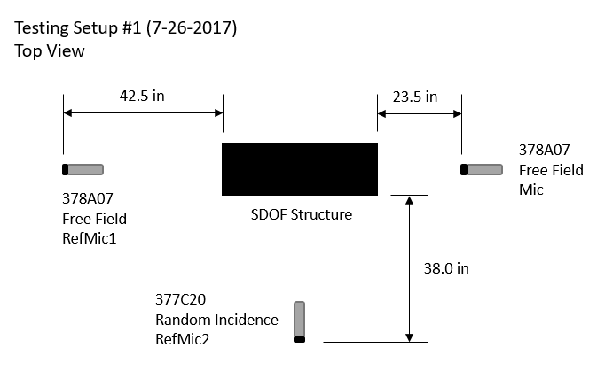

***Figure 12:*** *Diagram of Experimental Setup #1*

**1.1 Environmental Trials**

In order to understand the noise signals that exist in the lab before testing, environmental trials were run in which the microphone sensors captured signals from around the lab without any movement from the structure. Figure 13 shows the summation of frequency content and amplitude from 10 environmental trials for all three mics. Results indicate that there is noise in the 0 Hz – 2Hz range, 13 Hz – 14 Hz range, 19.22 Hz, 23.84 Hz, and 41.44 Hz. While all mics picked up these signals the power of these signals was different. Signals captured by RefMic1 were the highest when comparing to the other two mics. Mic captured the least amount of power for these signals. This is important because we can conclude that sources of the noise are coming from the side of the room closest to the door. Understanding the difference in power is also important because it will play a role in effectiveness of post processing methods. The large amount of power picked up by Mic and RefMic1 in the 0 Hz – 2 Hz range is caused by specification limitations of that specific sensor model.

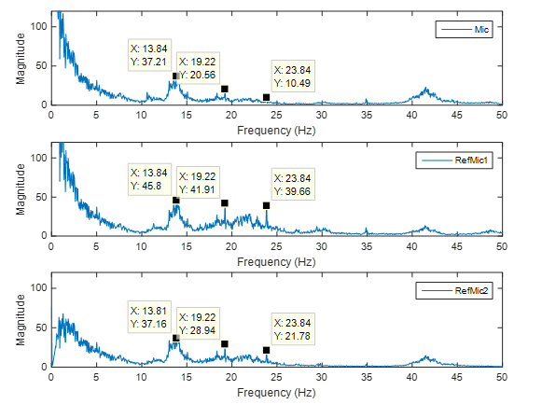

***Figure 13:*** *Environmental Noise – All Mics (Setup #1)*

**1.2 Method 1: Sine Sweep Trials (0.1 cm)**

When analyzing the data for all post processing methods, the processed data will be compared to a summation of spectral content picked up by Mic for all trials that are being investigated in order to determine the effectiveness of each method. Results shown in the top plot Figure 14 are from the 20 sine sweep trials where the amplitude of the shake table was 0.1 cm and they show that Mic was able to pick up the natural frequency of the structure, evident by the peak at 3.81 Hz, however noise sources at 10.63 Hz, 13.5 Hz, 13.97 Hz, and 19.25 Hz are prevalent. Effectiveness of microphone combinations will be judged in how effective they are at getting rid these signals. The bottom plot in Figure 14 displays results when pressure data from RefMic1 and RefMic2 was subtracted from Mic trial by trial. The signal of the structure was captured as evident by the peak at 3.84 Hz. However this method did not effectively cancel out any of the noise sources, as evident by the high power in the 0 Hz – 2 Hz range, 13 Hz – 14 Hz range, peak at 19.25 Hz, and peak at 23.81 Hz. Subtracting all the mics lead to ineffective results because the destructive signal doubles when the signals from both reference mics are subtracted from Mic at the same time. By doubling this destructive signal, the noise signals are not cancelled, but are essentially inverted in the time domain, so power and frequency content is maintained.

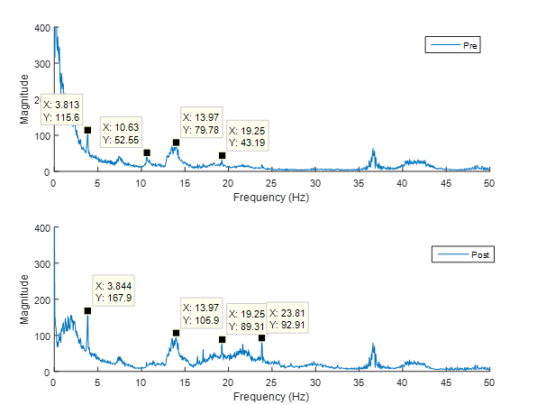

***Figure 14:*** *Individual Time – 3 Mic Combination (Setup #1)*

To avoid double subtraction of the data, an alternative post processing method using three microphones was developed. In this alternative method data from RefMic1 and RefMic2 are subtracted individually from Mic. These two results are then filtered, taken to the frequency domain, added together, and finally the calculated combined result is added to any previous trials (Figure 15). Method 1 was more effective in eliminating noise in the 0 Hz – 2 Hz range and 13 Hz – 14 Hz range because the power of the signals for the two frequency ranges mentioned are similar for all mics. This alternative method was not as effective at eliminating the noise at 10.59 Hz, 19.22 Hz and 23.81 Hz. These first two methods have shown that using all three mics may not be productive since it seems to amplify the noise sources due to the power of the noise sources not being the same for all mics. Furthermore the peak at 10.59 Hz is most likely not an environmental noise since it did not show up in the environmental trials and may in fact be a component of the shake table stand.

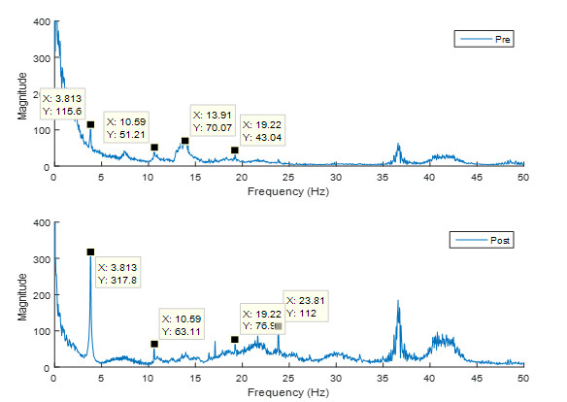

***Figure 15:*** *Individual Time – Alternate 3 Mic Combination (Setup #1)*

After looking at the data where all three microphones are used in the post processing, data was analyzed in which only two microphones were used. When the signal of RefMic1 is subtracted from the Mic signal, the natural frequency of structure was captured and noise sources at 0 Hz – 2 Hz, 13 Hz – 14Hz, 10.59 Hz and 19.22 Hz were lower than when compared to data from Mic with no post processing methods applied (Figure 16, bottom). However, the noise source at 23.81 Hz was actually amplified, but not as much when comparing to using the combination of all 3 mics. This microphone combination shows more promise compared to all three mics since many of the noise sources are reduced and not amplified. Reduction of noise source at 23.81 Hz can only be achieved if reference mic is close to mic capturing the movement of the structure, or if a filter of that frequency is directly applied to data.

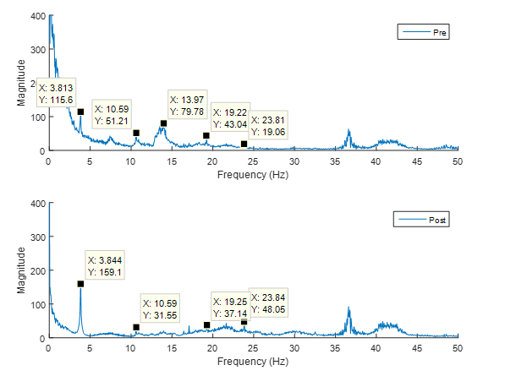

***Figure 16:*** *Individual Time – RefMic1 Combination (Setup #1)*

Summation of results when only looking at combining data from Mic and RefMic2 is shown in Figure 17. The signal of the structure was maintained however power of this signal was reduced when compared to the pre-processed results. The reason as to why this is occurring is that RefMic2 may have some noise in that frequency range. However power reduction is not significant enough to completely disregard this mic combination. Noise sources in the 0 – 2 Hz range were not eliminated, most likely due to the two microphones being of different types and having different limits on the low frequencies that they can capture. Noise sources in the 13 Hz – 14 Hz, and 19.22 Hz were eliminated, while noise sources at 10.59 Hz was reduced and the noise source at 23.81 Hz was kept the same when comparing to Mic data before post processing. Compared to the other mic combinations that have been detailed this combination does not amplify the noise at 23.81 Hz, which has been the primary noise source that has not been able to be eliminated. One theory as to why this is the case is that RefMic2 is closer to Mic than RefMic1. Therefore the power of the noise sources picked up by RefMic2 would be similar to the power of the noise sources picked up by Mic.

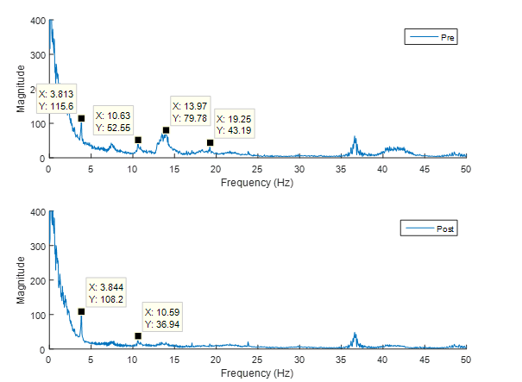

***Figure 17:*** *Individual Time – RefMic2 Combination (Setup #1)*

**1.3 Method 4: Sine Sweep Trials (0.1 cm)**

For Method 4, data was analyzed in which the summation of the spectral data from the reference microphones was subtracted from the summation of the spectral data from Mic in order to determine if subtraction in the frequency domain was able to eliminate sources of environmental noise. When analyzing data where all three mics are used, shown in Figure 18, the results are not promising. Although this combination effectively gets rid of all noise sources, it does not allow us to capture the natural frequency of the structure and shows that using three microphones with these post processing methods will not prove to yield promising results.

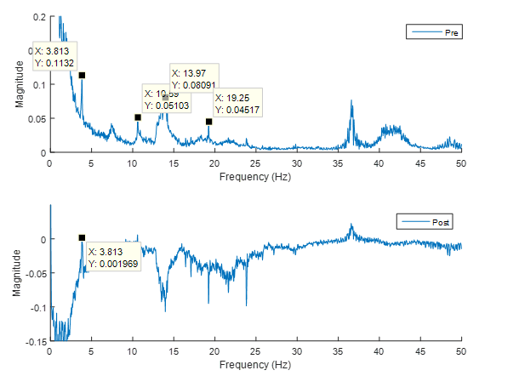

***Figure 18:*** *Total Frequency – 3 Mic Combination (Setup #1)*

When looking at the results when the spectral data from only RefMic1 is subtracted from the spectral data from Mic in Figure 20, there is a clear peak at the natural frequency, but the noise source at 10.59 Hz was not eliminated. Also, there is a reduction of power in the signal after post processing most likely due to RefMic1 being parallel to the motion of the structure and picking up the natural frequency at a low magnitude. The peak at 23.81 Hz, which was not eliminated using Method 1 was eliminated using Method 4 because that frequency was not picked up by Mic and thus became negative after post processing. Another note for this method of post processing is that there seems to be a correlation with the number of trials analyzed and the ability to capture the frequency of interest. As more trials are analyzed, the peak at the natural frequency increases relative to the sources of environmental noise.

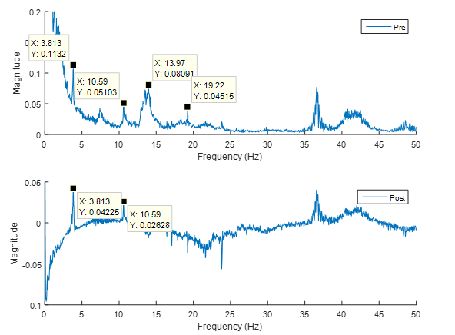

***Figure 19:*** *Total Frequency – RefMic1 Combination (Setup #1)*

When the spectral data for only RefMic2 was subtracted from the spectral data from Mic in Figure 20, there was less of a reduction in power of the signals than when RefMic1 was subtracted, and the natural frequency of the structure was captured at the highest magnitude. The noise sources between 13 – 14 Hz, at 19.22 Hz, and at 23.8 Hz were eliminated, but the noise source at 10.59 Hz was not.

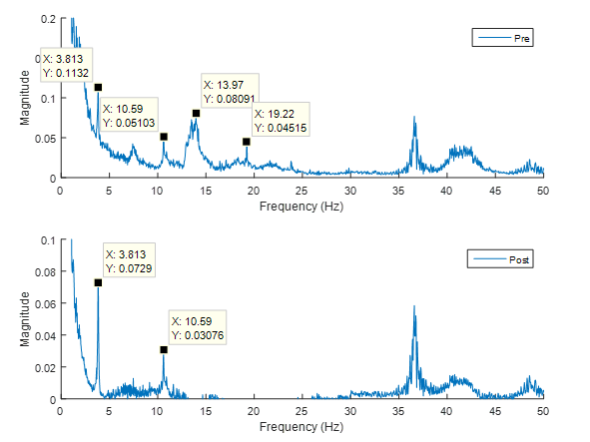

***Figure 20:*** *Total Frequency – RefMic2 Combination (Setup #1)*

In addition to running tests in which the SDOF structure was excited with a 0 – 10 Hz sine sweep with an amplitude of 0.1 cm, trials were also run in which the SDOF structure was excited with an amplitude of 0.05 cm. For Methods 1 and 4, the results were very similar to the 0.1 cm trials in terms of which frequencies were captured and eliminated, but the peak at the natural frequency was smaller in magnitude relative to the noise sources because the structure is not oscillating as much.

1. **Testing Setup #2**

For Setup #2 (Figure 21), the two free-field microphones were placed in the same locations and had the same orientations as Setup #1. The only change from the first setup was the orientation of the random incidence microphone. Rather than the orientation being horizontal, the microphone was turned vertically to test whether it could capture more of the environmental noise signals from around the lab.

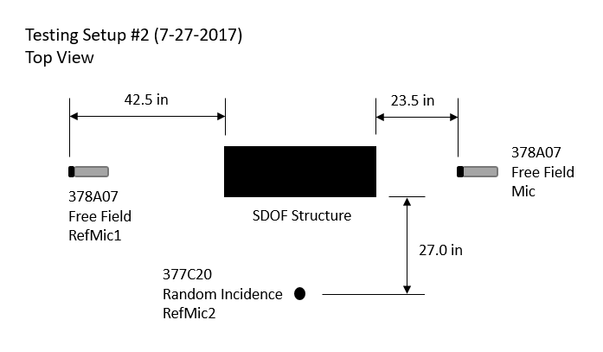

***Figure 21:*** *Diagram of Experimental Setup #2*

Since the only change made between Setup #1 and Setup #2 was the orientation of RefMic2, only the results in which data from RefMic2 is subtracted from Mic will be shown.

**2.1 Method 1: Sine Sweep Trials (0.1 cm)**

When subtracting the pressure data from RefMic2 individually from the pressure data of Mic (Figure 22, bottom), the peak at the natural frequency has the highest magnitude of the known peaks seen in the original Mic data (Figure 22, top), but there is a slight reduction in power when comparing the pre-processed data and the post-processed data. The peaks in the 13 – 14 Hz range, at 19.22 Hz, and at 23.84 Hz are all reduced from the original Mic data; however, the peak at 10.59 Hz was only slightly reduced. When comparing these results to the data from Setup #1, the peak at the natural frequency is greater for Setup #2, but the noise sources were not reduced as much as in Setup #1 with the same post processing method.



***Figure 22:*** *Individual Time – RefMic2 Combination (Setup #2)*

**2.2 Method 4: Sine Sweep Trials (0.1 cm)**

When subtracting the spectral data from RefMic2 from the spectral data of Mic after summing all 21 trials with 0.1 cm amplitude, the peaks at noise signals at 13.53 Hz, 19.5 Hz, and 23.88 Hz were all eliminated, while the peak at 10.59 Hz was only reduced in magnitude by half from the original Mic signal (Figure 23). Although the peak at the natural frequency was the highest of any identified peak, the power of the signal was reduced by almost half of the power from the original Mic signal. This is most likely due to the same issue discussed for Setup #1 in which RefMic1 was picking up the natural frequency of the SDOF structure. In this case, when the random incidence microphone is directed vertically, it may also be picking up the natural frequency of the structure, but at a smaller magnitude than Mic.



***Figure 23:*** *Total Frequency – RefMic2 Combination (Setup #2)*

1. **Testing Setup #3**

For Setup #3 (Figure 24), the microphone types for Ref Mic 1 and Ref Mic 2 were switched so that the random incidence microphone was now parallel to the structure, while one of the free field microphones was now perpendicular to the motion of the structure. These changes were made in order to determine which microphone type would be best at capturing environmental noise from around the lab in each location.

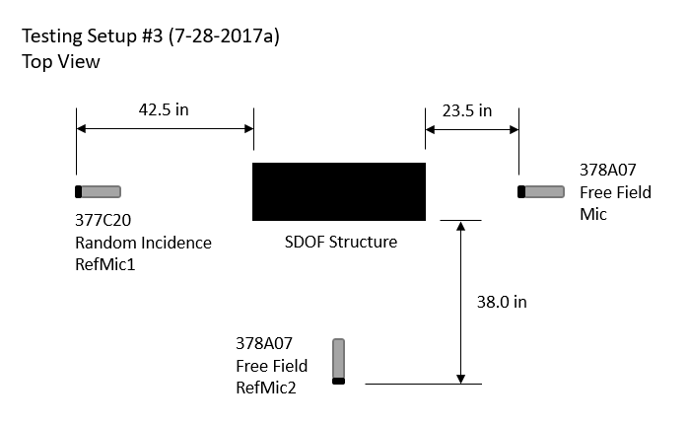

***Figure 24:*** *Diagram of Experimental Setup #3*

**3.1 Environmental Trials**

When looking at the environmental trials for Setup #3 (Figure 25), the identified sources of noise occur at 13.72 Hz, 19.22 Hz, and 23.88 Hz, similar to the previous two setups. RefMic1 picked up the signals at 19.22 Hz and 23.88 Hz at the highest magnitude of the three microphones, while RefMic2 picked up the signal at 13.72 Hz at the highest magnitude of the three microphones.



***Figure 25:*** *Environmental Noise – All Mics (Setup #3)*

**3.2 Method 1: Sine Sweep Trials (0.1 cm)**

When the pressure data from RefMic1 is subtracted from the pressure data of Mic trial by trial, shown in Figure 26, the magnitude of the peak at the natural frequency is the largest, but the peaks at 19.5 Hz and 23.88 Hz were increased. Also, the peak at 10.59 Hz was only decreased slightly when applying this post processing method. When comparing this setup to Setup #1 when the same post processing method is applied, the peaks at the signals 10.59 Hz, 19.22 Hz, and 23.88 Hz are larger for Setup #3. This indicates that the free field microphone did a better job of reducing the noise signals than the random incidence microphone.



***Figure 26:*** *Individual Time – RefMic1 Combination (Setup #3)*

When the pressure data of both microphones are subtracted individually from the pressure data of Mic, shown in Figure 27, the magnitude of the peak at the natural frequency is the largest, but the peaks at 19.5 Hz and 23.88 Hz were amplified. Also, the peak at 10.59 Hz was only decreased slightly when applying this post processing method. When comparing Setup #3 to Setup #1 when the same post processing method is applied, the peaks at the signals 10.59 Hz, 19.22 Hz, and 23.88 Hz are larger for Setup #3. This indicates that the random incidence microphone did a better job of reducing the noise signals than the free field microphone when placed in the RefMic2 location.



***Figure 27:*** *Individual Time – RefMic2 Combination (Setup #3)*

**3.3 Method 4: Sine Sweep Trials (0.1 cm)**

When the spectral data from RefMic1 was subtracted from the spectral data from Mic, shown in Figure 28, the natural frequency is still the most prominent peak, but there is a reduction in power when comparing the magnitudes of the pre-processed signal and post-processed signal. Similar to the Total Frequency results when only the spectral data from RefMic2 was subtracted from the spectral data from Mic for Setup #2, the noise sources at 13.5 Hz, 19.5 Hz, and 23.88 Hz were all eliminated. Also, the peak at 10.59 Hz is only reduced by about half when this post processing method is applied.



***Figure 28:*** *Total Frequency – RefMic1 Combination (Setup #3)*

When the spectral data from RefMic2 was subtracted from the spectral data from Mic, shown in Figure 29, results were similar to when only RefMic1 data was subtracted. Again, the peaks at 13.5 Hz, 19.5 Hz, and 23.88 Hz were all eliminated. Also, the low frequency noise from 0 – 2 Hz was also eliminated, which is most likely due to the same type of microphone being subtracted from each other because they displayed the same behavior in this low frequency range. Similar to the previous results, the peak at 10.59 Hz was not completely eliminated and there was a reduction of power in the peak at the natural frequency.



***Figure 29:*** *Total Frequency – RefMic2 Combination (Setup #3)*

1. **Testing Setup #4**

For Setup #4, shown in Figure 30, the microphone directed at the structure to capture its vibrations was moved closer, to half the distance of the previous trials, in order to investigate the effects that the distance from the source to the sensor has on capturing the natural frequency of the structure and noise signals from around the lab.

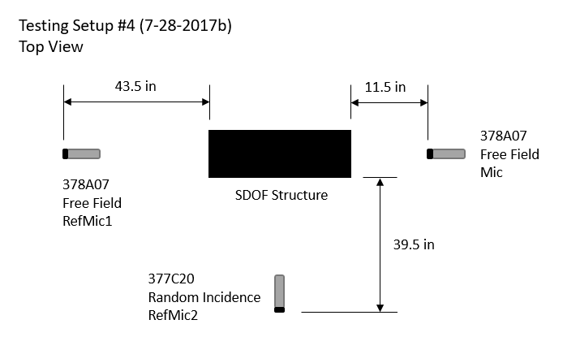

***Figure 30:*** *Diagram of Experimental Setup #4*

**4.1 Environmental Trials**

When observing the environmnetal trials for Setup #4, RefMic1 picked up the noise signals at 13.56 Hz, 19.5 Hz, and 23.88 Hz at the highest magnitude of the three microphones. RefMic2 picked up these frequecnies at the second highest magnitude, and Mic picked these up the least.



***Figure 31:*** *Environmental Noise – All Mics (Setup #4)*

**4.2 Method 1: Sine Sweep Trials (0.05 cm)**

For this test setup, the 0.05 cm amplitude sine sweep trials will be analyzed to see if placing the microphone closer to the structure will improve the results when smaller ground movements are applied to the structure.

When the pressure from both RefMic1 and RefMic2 are subtracted from the pressure data of Mic individually trial by trial as shown in Figure 32, the peak at the natural frequency is the greatest, but the other sources of noise are amplified. The signals at 19.5 Hz and 23.88 Hz are more than doubled, while the signal at 10.59 Hz is amplified by about half. Similar to when this post processing method was used for other setups, it does not do the job of eliminating noise sources, but rather amplifies them. Similar results are shown when only the pressure data from RefMic1 is subtracted from the pressure data of Mic as shown in Figure 33.



***Figure 32:*** *Individual Time – Alternate 3 Mic Combination (Setup #4)*



***Figure 33:*** *Individual Time – RefMic1 Combination (Setup #4)*

When only the pressure data from RefMic2 is subtracted from the pressure data of Mic as shown in Figure 34, the natural frequency of the structure is more prominent then when using other post processing methods. Although the noise signals at 10.59 Hz, 19.5 Hz, and 23.88 Hz are not completely eliminated, they are reduced significantly when compared to the other post processing methods.



***Figure 34:*** *Individual Time – RefMic2 Combination (Setup #4)*

1. **Conclusions**

After performing experiments using traditional accelerometers and using microphone sensors, it was determined that the microphone sensor can accurately capture the natural frequency of the structure similar to the accelerometer. However, when looking at the microphone sensor data in the frequency domain, there are many sources of noise present in the signal. In order to eliminate these noise signals, more microphone sensors were introduced and post processing was done in MATLAB to try to eliminate these signals while maintaining the peak at the natural frequency. The post processing method that was most effective in completing this task and were the Individual Time method (Method 1). Methods 3 and 4 provided similar results and were both able to reduce peaks from most of the environmental noise signals, but also reduced the peak at the natural frequency. Method 2 provided inconsistent results in terms of the changes as more trials were added together and provided results that interfered with the signal even more. Within Methods 1, 3, and 4, subtracting only one reference microphone from the microphone capturing the structure’s movement provided more promising results than subtracting both reference microphones. In the cases where data from only one reference microphone was subtracted, not all of the identified noise signals were eliminated, but were reduced in some cases. In order to completely eliminate all sources of noise from the environment through these types of post processing methods, a more robust method must be developed. One way to accomplish this would be to combine Methods 1 and 4. One Method would be used to eliminate some noise signals and identify other sources, and the other would be used to filter out the remaining noise signals identified by the first Method. In addition to a more robust post processing algorithm, experimentation must be done on more complex structures such as a double-degree-of-freedom structure.

**Acknowledgments**

This project is supported by the US Department of Education through the Minority Science and Engineering Improvement Program (MSEIP, Award No. P120A150014); and through the Hispanic-Serving Institution Science, Technology, Engineering, and Mathematics (HSI STEM) Program, Award No. P031C110159.

**References**

[1] MATLAB & Simulink, Natick, MA: MathWorks, 2017. Computer software.

[2] Rao, Singiresu S. Mechanical Vibrations. 4th ed. Hoboken(N.J): Pearson education, Inc., 2017. Print.

[3] Barnard, Andrew. Fundamentals of Acoustic and Microphone Measurement. PCB Piezotronics, Inc. 2017. Print.