STEM Opportunities
_______________________________________________________________________________________________________________________________________
Volunteering
- Freely giving time and energy to service the community
Research Experience for Undergraduates (REUs) Internships
- Work on research programs at hosted four-year institutions
- Students work closely with faculty and present their research findings
- Typically granted stipends, and in many cases, assistance with housing and travel
Industry Internship
- Typically PT during Spring/ Fall Semester & FT in the Summer
- Opportunity offered to students to work at a firm for a fixed period of time
- Gain practical skills, training, workplace experience and greater knowledge of that industry
Why do an internship?
- Apply classroom knowledge to the real world, you can potentially receive college credits
- Explore different career paths with minimal commitment
- Potentially get paid (although there are unpaid internships)

When should you do an internship?
It is never too early to get an internship, engage in a research opportunity, or work a part-time job. It is important to have a strategy when searching for internships. This will help you to search in advance. Many employers expect students to have 2-3 internships upon graduation from their undergraduate career.
Second Year — This is a great time in college to begin trying out internships. This will help you become more qualified for competitive internships.
Third Year/Fourth Year — This is when you can begin focusing on competitive internships. Your prior part-time jobs, on-campus involvement, and projects should have prepared you to be a competitive candidate.

Search & Hiring Timelines
Large companies begin recruiting for their Summer internship programs early in the fall. For example, if you want to apply for a Research Experience for Undergraduate (REU) for Summer 201 you would begin the application process in Fall 2020 (around November and December). Many companies will have several rounds of interviews (video, phone, in-person) before they make their final offers. Small companies offer less formal internship programs. They may be seeking summer interns in the beginning of Spring or later.
Search more efficiently
Setting up saved searches on employment platforms can be a huge help with finding opportunities. For example, many company employment pages and LinkedIn offer similar search capabilities.
Identify Your Goals _____________________________________________________________________________________________________________________________________
- First year student: Career exploration, job shadowing, build technical skills via free courses online, develop projects, engage in tutoring, and volunteering opportunities
Goal 1: (i.e. take a course via Coursera on Machine Learning to learn more about data analytics)
Goal 2:
Goal 3:
- Second year student: On-campus jobs, gain industry knowledge, attend STEM conferences, build your LinkedIn & Resume
Goal 1: (i.e. Connect with three employers on LinkedIn and conduct informational interviews)
Goal 2:
Goal 3:
- Transfer and Beyond: Find mentors, attend job fairs, network, keep building skills and experiences
Goal 1: (i.e. attend job fair and connect with at least three employers)
Goal 2:
Goal 3:
Internship Planning Timeline _______________________________________________________________________________________________________________________________________ 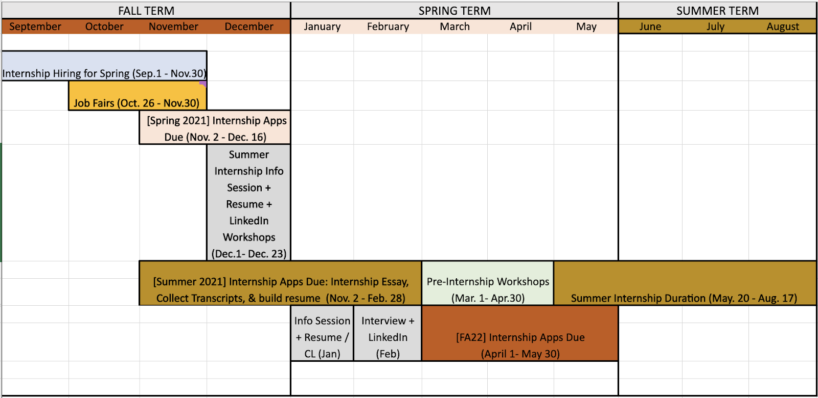

Internship Opportunities Master list
_______________________________________________________________________________________________________________________________________
Step 1: Go to https://canadacollege.edu/stemcenter
Step 2: On the far left panel click Internship/jobs
Step 3: Select the button “ Stem Internship Master List”

- Direct Link: Internship Master List Link
REU Common Application Materials
_______________________________________________________________________________________________________________________________________
Resume Tips
o Resume Template on next Page (review tips on format and structure in comments section)
o Utilize strong action verbs to start each of your bullet point statements
o Tips on generating sample bullet points for resume: ResumeCompanion Builder (NOTE: Finished resume created through the website can only be downloaded if you pay for the subscription. Should you want to use the site to get support and copy and paste onto your resume you may do this, we will also have a downloadable sample template for you to use down below)

REU Interest Essay Guiding Questions
o Please describe your personal background and what experience(s) led you to where you are today in your education?
o What relevant extracurricular activities, any interesting or unusual circumstances or obstacles in your personal or academic background
o Please describe any relevant experience with data analysis and coding. Also, what have you learned from these experiences and how do these experiences make you a good candidate for the program?
o After you obtain your bachelor's degree, what are your long-term academic/career aspirations?
o If you are unclear about a specific career/academic path, please share a number of possibilities you foresee in your future. How do you plan to reach these goals?
o How will this research program support your academic/career goals? What do you hope to gain from this experience?

Cover Letter
o Cover Letter Format Tips
o Indeed Cover Letter Sample
o Cover Letter Samples by Professions

Retrieve Transcripts
o Step 1: Log into WebSMART. Select “Student Records” under the Student Services tab.
o Step 2: Request Unofficial (can be sent directly to you email and you will receive right away)/ Official Transcripts (will usually take a few weeks) – Double check if you need one or the other

Requesting Letters of Recommendation
o Send a well-written email to your professor letting them know your interest in applying for an internship. Kindly as if they would be willing to serve as your reference and attach your resume to the email so they have background information to speak to in your recommendation. (NOTE: Inform your references at least 2 months in advance to serve as a internship reference)

E-mail Subject Line: Letter of Recommendation Request - Your Name

Dear Professor _____________,

I hope you are having a great week so far. I am reaching out to you to kindly request if you would be willing to serve as my reference for potential internship opportunities I may be applying for this upcoming Summer 2021. I took your Biology 230 course this past class Fall 2020 and would appreciate the opportunity to put you down as a reference to speak to my work ethic within the course, active participation, and any other positive characteristics you deem important.

Attached, you’ll find a copy of my resume for your reference in the event you’d like to incorporate any information to the letter of recommendation. If you are willing and able to serve as my reference that would be greatly appreciated. Additionally, if you could kindly confirm the best email and phone number to reach you at that would be greatly appreciated.

Best,
First Name Last Name

Industry Research Tips
_______________________________________________________________________________________________________________________________________

- Top Tech Companies in San Mateo
- Network with industry leaders on LinkedIn and at job fairs
- Intern-worthy Skills: 8 Must-Have Skills For Your Intern Resume
- Five Skills You Need to Become a Researcher

Up Skill & Expand Your Knowledge
_______________________________________________________________________________________________________________________________________
- InsideSherpa
- Harvard online learning
- MIT open learning
- Independent learner course
- Coursera
Connect on LinkedIn
_______________________________________________________________________________________________________________________________________

Utilize LinkedIn.com as an online networking tool. Connect with industry leaders, employers, and company employees, while showcasing your array of experience and skills sets.
· 95% of recruiters utilize LinkedIn as a major sourcing tool to find candidates that possess top-tier talent. Over 75% of people who recently changed jobs used LinkedIn to inform their career decision (LinkedIn Business Insider).

Expand Your Connections
You know more people than you think! Start by adding your friends and family. Then, add your peers, colleagues, and professors. To find alumni, search Canada College and select ”See Alumni”. From there, you can filter alumni by where they work, what they do, and what they studied. Expand your network by joining professional organizations and groups. There might be a LinkedIn group for your major! Follow any targeted employers to stay updated on opportunities and latest relevant news.

Note: If you want to connect with an alum you do not know, request to add a personalized message. Introduce yourself and mention what year you are in your studies along with your major. You want to note that you noticed they were a recent alum of the program and would like to connect as a fellow Canadian.

Building Your Profile
Think of your LinkedIn profile as an extension of your resume, but instead of it being tailored for a specific opportunity it is a curated portfolio of your skills, work, and experiences. Here are some tips and tricks to build creating a great LinkedIn profile to capture job seekers:

TIP #1- Claim your LinkedIn URL at linkedin.com/in/ yourname
Click on the me Icon at the top of your LinkedIn homepage. Click View profile. On the right hand side of the page click Edit public profile & URL. Include this URL on your resume so employers can find you easily.
TIP #2- Include a Professional Headshot.
Make sure you take a clear headshot of yourself. Wear appropriate attire, smile, and utilize images with less background distractions.
Tip #3- Create a catchy brand utilizing a captivating headline and summary section.
Highlight your key skills and what type of opportunities you are looking for (i.e. Recent engineering graduate looking for innovative ways to solve data-driven solutions for complex operational problems or Computer Science student currently seeking internship opportunities)
TIP #4 Make your profile dynamic!
Add work samples, interesting articles, photos, personal websites, blog feeds, and or relevant social media
TIP #5 Use industry keywords, list transferable, & technical skills
If you aren’t sure what they are, look at other professionals’ profiles, especially at companies you want to work (i.e. Content Database, Technical Support, Machine Learning, C++, Python, JAVA, SQL, and JavaScript).
TIp#6 Utilize the social aspects
Ask for recommendations and endorsements from past colleagues, supervisors, project team members, and company collaborators.
Tip #7 On the Career interest box, turn the option on to let recruiters know you are open to opportunities
Tip #8 Fill our 100% of your profile
For more help on optimizing your LinkedIn profile, check out the Purdue Global Tips.
Skills Assessment Plan
_______________________________________________________________________________________________________________________________________
Once you find a job or internship opportunity that interests you use the handout below to analyze the requirements, identify the skills and experiences needed to perform the duties, as well as any potential gaps. The goal of this activity is to help you assess what you need to develop in order to be a strong candidate.

Job/ Internship of Interest:___________________________________________________________________

Below list the skills, knowledge, qualification, and characteristics required for your position of interest. Check off the ones you already have and identify any gaps that could strengthen your profile.

Skills: technical, creative, transferable skills, etc.
· i.e. Excel graphing
·
·
·
·

Knowledge: subjects, topics, theories, etc.
· i.e. planetary science
·
·
·

Characteristics: quality, feature, trait, etc.
· i.e. growth mindset oriented
·
·
·

Skill Gap:
· i.e. presenting research
· I.e. C++
·
·
·
·

How to Develop
· i.e. obtain REU internship
· i.e. enroll in CIS 250 + CIS 252
·
·
·

