Division Meeting February 5, 2021

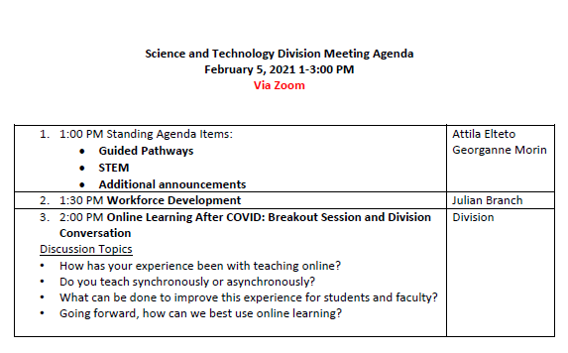
- Attila Elteto: Guided Pathways Update
  - Schedule next Success Team Meeting
  - Meeting in about 2wks for Interest Area staff – be on lookout
    - Faculty: review Program Mapper
    - Colts-CON: streamline and make mandatory for students, 3 day long program, need faculty/staff input – review workshops, what is missing
  - CRM update from Sandra Rodrigues: new management system for A&R, counseling, PROMISE - see infor about student, who student has seen, what services student may need and notes can be added by those who have contact with student.
    - Student Success Link: all faculty/staff who are involved with student, student can access appointments and schedule with any success team members.
    - Rollout: April 5
- Georganne Morin: STEM Update
  - Rance Bobo: STEM Speaker Series started 2/3/21, all will be Cañada alum
    - Classroom visits start in 2 weeks
    - Looking for class of 2022 to start STEM 3
  - Gonzalo Arrizon: Retention Splst
    - Reminder: instructors can submit Early Alert (link to instructions) https://canadacollege.edu/stemcenter/Early%20alert%20steps%20provided%20by%20the%20Admissions%20and%20Records%20office.pdf
      - Submit report based on academic progress, attendance, and academic quality,
      - Working with Naidya Sigona, lead for Early Alert, working hard to connect with students
  - Josue: STEM tutor coordinator
    - Working with Learning Center to connect students with SSO to connect students with tutors
    - STEM Center tutor, sign in using SSO
    - In Canvas: new tab “Cañada Tutors” made live this week (link to college website for tutoring) https://www.canadacollege.edu/stemcenter/tutoring.php
    - Working with LC Tutoring for marketing so students are informed
    - Working on creating classroom visits, Krystal will send out info once completed
    - Is there a link to where faculty can see if there course has a tutor? Scroll to bottom of STEM Center Tutoring website to see list of all courses with tutors available. Email recommendations to Josue Alcaraz alcarazj@smccd.edu
    - Net Tutoring contracted with district, no control over who the tutors are
      - More like a tutoring hotline
  - Starting planning for Pi Day, getting ideas from faculty, please email ideas to Georganne moring@smccd.edu
- Additional Announcements:
  - Students can turn non-honors courses into honors courses with Honors Contract: please contact Susan Mahoney for additional info mahoneys@smccd.edu
    - Have contract turned return in the next week or 2
    - Link to honors program contract: https://canadacollege.edu/honorsprogram/contract.php
    - Benefit: honors denotation on transcript, has priority admissions and transfer opportunities if complete honors program, must complete 15 units of Honors work, students have chance to work more closely with professors,
  - Question: Program review: how will that work for next review cycle
    - No official discussions for details, good practice to do review even if no funds available, best to have record
      - Didn’t have to submit form this past year, submit request, but no formal review required:
        - Ameer will get further information
  - Review announcements in meeting request for division meeting: COVID training mandatory for all district employees
- Julian Branch: Workforce Development Update
  - Link to presentation PowerPoint
  - Finding the synergy between Student, Institution and Industry needs
    - New Program Development Elements:

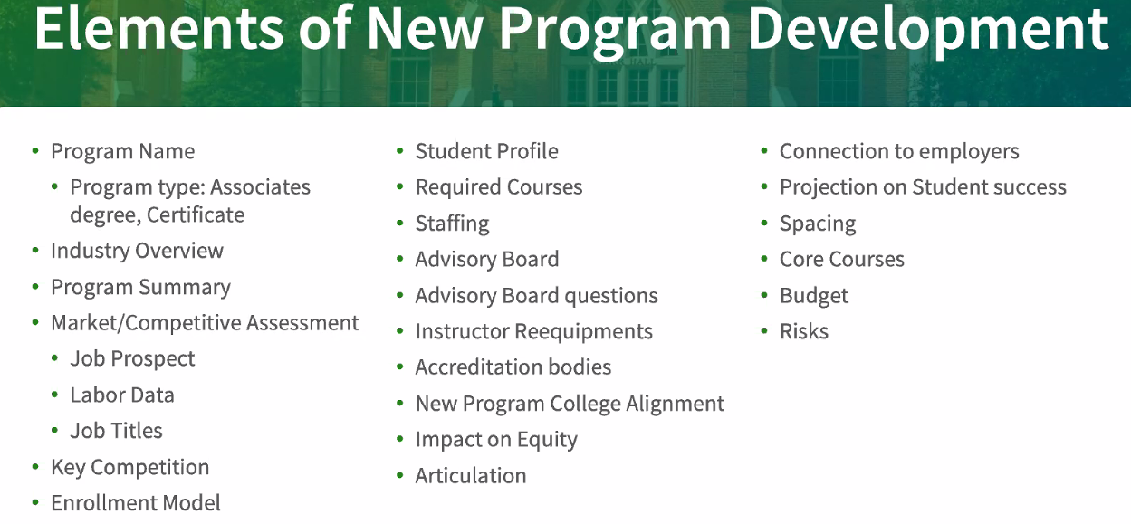

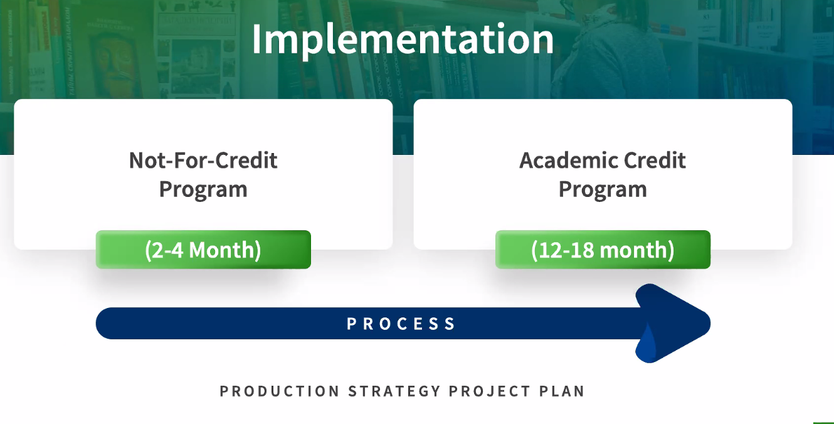
- Menlo Park: houses all Not-for-credit programs
- Looking for additional grant opportunies - contact Julian to review process
- Cloud Computing: students learn expertise to work with companies like Zoom, and other companies
  - Looking to change name to Amazon Web Services
    - Use Google Trends to view most sereached terms to help advertise program
- Ramki: Photonics Program
  - Shortage of photonics and laser technitions
  - Background in photonics and lasers, come up with new certification
    - Any technology that involves light
      - Any sector from manufacturing, etc.
    - Allows HS students to enter program and learn to be technicition and can upskill along the way to gain access to higher paying positions
    - SJ State retrains currently industry employees
    - Our program will be broader
      - First certificate: entry level jobs
      - Advanced certificate
    - Need faculty who teach physics (Attila and Martin)
- Funeral Education: Mortuary Science
  - Doug Hirzel instrumental
  - Career paths: mortician, crematorium tech, funeral services
    - Program includes classes that support GE science classes
  - Only 2 colleges offer this type of program: LA and Fresno
  - In Chaptering process, last leg of process to approval
- Cyber Security: not-for-credit route currently
  - Running at Menlo Park site
    - First iteration not as strong as would like: 18 students
    - Would like 30 students with waitlist
      - Adding on Cisco and Comptia
        - Cisco Certification
- Water Treatment: looking into NFC (Not For Credit) and ACP (Academic Credit Program)
  - Looking into programs that recessions and pandemic proof,
    - No matter what happens, everyone needs water
    - Waste water has lot of certifications, inhibits students from access, long process
    - Students can access industry via 2 industry certifications: D1,D2,T1, T5
      - CalWater is sponsoring students to go through program
        - Looking to diversify workforce
        - Give internships
        - Entry level jobs available
    - Propose bring program to S&T and want to bring it to Curriculum Committee to house it in S&T
      - Susan Mahoney interested in working with program – worked at Santa Rosa Junior College, has great water treatment program
- Questions: ITS program – Job outlook for 20-30yrs out? Student interest
  - Yes – advisory boards and research into what jobs available and ensure industry support
  - Working with HS to survey students’ interest, try things out before moving into larger investment of time/money
  - What is industry looking for from gradtuates: is that reviewed as programs move through process?
    - Yes: extensive research of industry to ensure graduates have skills needed, that drives what route NFC or ACP, a certificate/degree will go through
      - Try programs in NFC to see how things go in some cases, make sure students time valued and used wisely
  - Optician Program:
    - one cohort - 30
    - closed down on campus
    - employers weren’t paying that much
    - toured several programs in the state
    - review license process
    - looking to bring faculty into conversation
    - working with Lens Crafters
    - looking to see if we can bring program back to campus
    - most likely a semester long program
    - looking to get students in making a livable wage in shorter certificate course, that way they can plan for longer programs while being sustained
- Feedback from breakout rooms:
  - Survey of nursing programs – not taking students if science programs online, do you know of any programs
    - Pre-covid, that was the case; post-covid most likely accepted, but will look into, programs are more understanding
  - From Attila Elteto to Everyone: 02:36 PM
    - Group problem solving and lab group work has definitely has taken a major hit. My students themselves have also complained about this.
  - Online Testing: cheating, wiki answers, long questions/answers issues
    - Looking into more hybrid course solutions
  - Ramki: “Due to the diversity in the type of classes in engineering: lecture only, lecture + some lab, lecture + lot of lab, and lab only - I have encountered different successes and challenges but some common themes are emerging:
1. challenges:
1. achieving the type of student-student and faculty-student interactions that come in a classroom has been very difficult
2. Planning of about info content delivered varied widely with number oil students and class type, so more flexibility is required in content planning.
2. Successes
1. Student access flexible content offering in various formats
2. Office hours can be offered in different ways”
  - Bob Tricca: labs: wet labs
    - Walk through kit and document to lab and group creates time to do it and it’s working out pretty well for some of the students
      - Learning curve for all
      - Right for certain students
      - Lectures all recorded, optional synchronous viewing
      - Labs recorded
      - Students reported asynch working well for CHEM
      - Expansion in CHEM dept
      - Concern with Kits: down the road will Grad students balk at at-home labs? In short term, no, long term, maybe
  - Ramki: range of classes for ENGR, many lab and lecture based
    - Some classes are really small and really large
    - Many ENGR offered online/hybrid
    - Students benefit from accessing content when convenient
    - Issue: interaction process not the same from instructor and student POV
    - Overall: takeaway, offer as many classes as possible in hybrid format
      - Kits evolving with tech
  - Jeanette Medina: CHEM lower division/majors course taught
    - 2 groups: committed students, totally prepared and works well for them
      - Less committed students
    - Research into what works best for students and offer course accordingly
      - Students have a lot of misconceptions of what online classes are, make more informed decisions
  - Roz: Lab Coordinator
    - Making presentation on what goes into preparing kits so faculty can see how labor intensive it is
    - Likes hybridization, reopen
      - 2.9mil fed $$$ to help students, spend some in PHYS and ENGR to update kits, get wishlist together for all departments who have kits for courses.
  - Lezlee: survey asking about returning to “normal” campus life
    - Not good definition of “normal”
    - Pre-covid in person classes not safe
  - Doug Hirzel: in the past, Physiology labs half in person, half online
    - We can be creative about how we return to campus
    - We can have best of both worlds
  - Juleh: CHEM 192 online working great
    - Retention going up dramatically
    - Labs are going very well, students engaged
    - Having issues with exams, but looking into solutions for academic honesty
  - Susan: Fall schedule development – where are we in the process?
    - Not started yet, prepping for online, but don’t know yet
  - Jeanette G: need better descriptions of classes so students have better understanding of what each course entails.

