Division Meeting November 13, 2020

- Breakout rooms: Conversation starters
  - How are you doing?
  - How do you plan to spend your winter break?
  - What can I (Ameer) do to help?
- Mental Health awareness: Claremont Employee Assistance Program

- Guided Pathways – Attila Elteto
  - GP: policy for all community colleges currently being implemented, year 4 of 5yr implementation plan.
  - Get involved early to have a say in how the plan will go
  - Program Mapper – accessible to students and faculty alike at https://canadacollege.edu/academics/interest-areas/
    - Review your program map for consistency and curricular changes (must have Curriculum Committee approval prior)
    - Lots of information for students to plan
  - FYE: First Year Program (FYE) elements
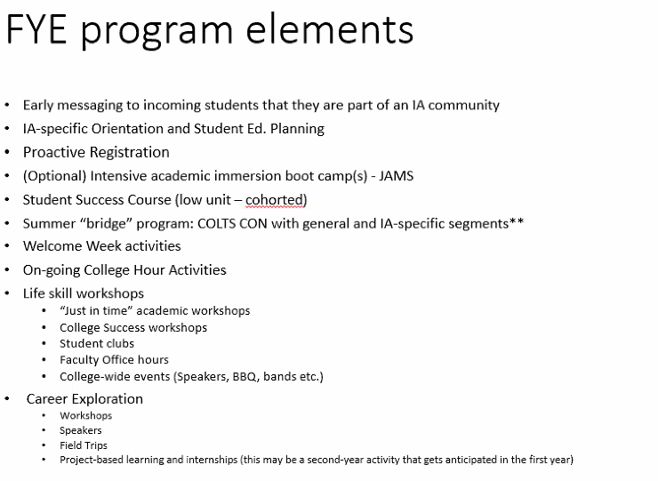
  - Attila’s availability to discuss GP or Program Mapper issues
    - Door card info https://doorcard.smccd.edu/preview_doorcard.asp?varname=eltetoa&term=202008&college=canada
- Sharon Quach: Program Service Coordinator for TRABAJO Grant
  - Help students with career exploration options
  - Formerly with PSC at Skyline – worked with foster care and student parent population
  - TRABAJO: TRAINING Research Activities Bettering Access to Job Opportunities
    - How to get faculty involved to help bridge gab to opportunities for job shadowing and internships
    - Project Leads: Marcella Assistant Project Director
    - Prof. Ramki Kalyanaraman (PI)
    - Sharon
  - National Science Foundation grant
  - Vision: strengthen student career knowledge through experiential learning opportunities through
    - Classroom visits
    - Job shadowing
    - Internships
  - Main roll to help students feel encouraged to apply for internships and shadowing by help with:
    - applications
    - Resumes
    - Housing logistics
    - Transportation logistics
  - Kolb’s Experiential Learning Cycle
    - 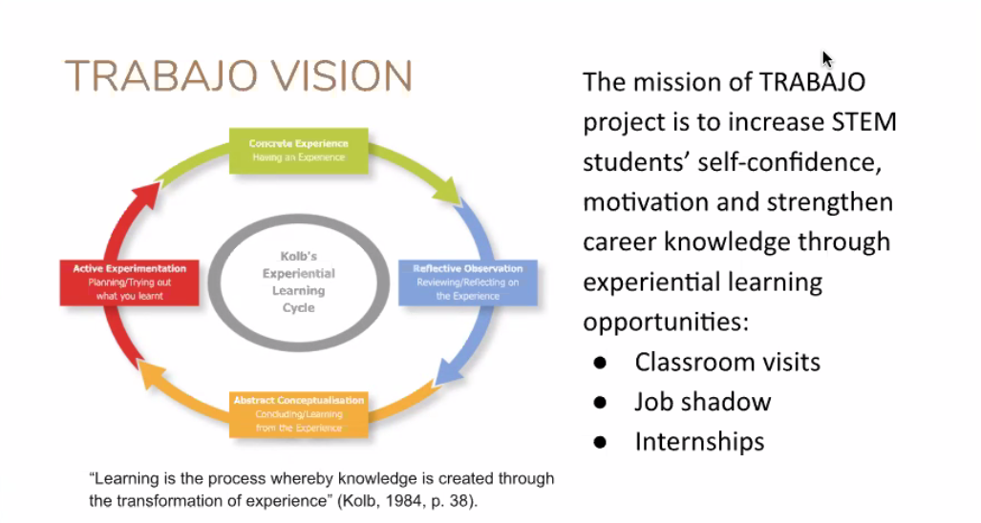
    - Build self-efficacy to pursue jobs opportunities by exposure to exploration
    - Help students in under represented communities enhance their skills to select majors that lead to careers via
      - Researching majors
      - Job shadowing options
      - Connecting classroom learning to jobs in the field
    - Helps employers see that community college students can compete at same level as 4yr college interns
    - Connect with employers and previous alum to develop connections to employers in the field to job shadow and internship opportunities
    - Impact of Career Exploration actives:
      - Looking to capture metrics of impact through design of job shadow and internships
      - Experience of employers hosting interns
    - Internship Opportunities
      - Goal: 10 sites in first year, add 5 every year after
      - Class visits to job sites: 5 annually
      - Job shadowing and industry observation
        - 10 sites in 1st yr
        - 5 every subsequent yr
        - 40+ students by year 5
    - Faculty Collaboration –
      - Internship Criteria
        - 2.5 min GPA
        - Grit and growth mindset
        - Personal statements
        - Interviews
        - Faculty recommendations
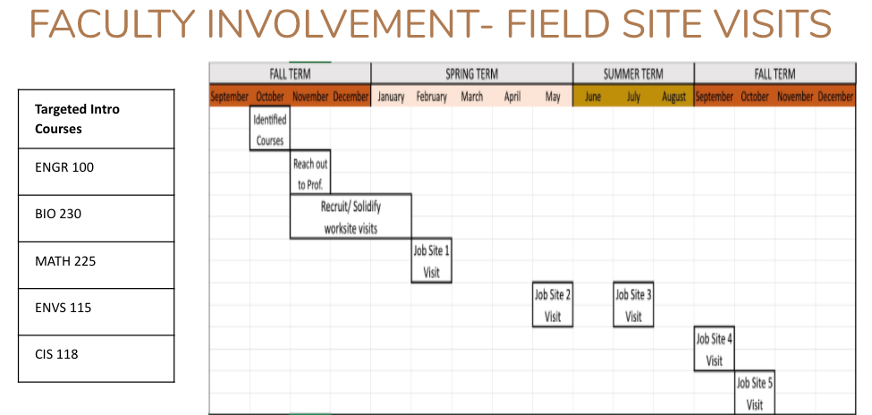
    - TRABAJO next steps
      - Maps out steps for students to research industries, campus resources for further exploration
      - Resume building
      - Career assessments guide
      - STEM majors guide worksheet
      - STEM Internships guide
    - Moving forward
      - Infor session for students
      - Looking for suggestions from faculty to internships, etc.
    - Questions from faculty:
      - Major challenge: finding students to receive the info, how to plan to find students for info?
        - Present to faculty classes, info sessions, and create cohort bases by interest area, canvas announcement blasts, office hours for Sharon to help students one-on-one, welcome to suggestions as well
      - Honors attempting something similar – creating course for career exploration and internships: possibility for collaboration? Connect with Susan Mahoney, honors coordinator
        - Yes!
        - 695 use as exploratory course? Possibility
      - GP would like to get involved as well
- Mayra Arellano – Early College Exposure: High School Transitions Program Updates
  - Dual Enrollment – welcome to connect with faculty for questions and collaboration
    - Commitments
      - K-12 & Adult School partnership: create K-14 pathway
      - Enhance marketing – create HS student website in Eng/Span
      - Create a culture of inclusivity
      - Institutionalize effective student support structures that close obligation gaps
    - Pyritizing Equity: Anti-Racist Framework
      - Access to Early College Access is NOT EQUITABLE
        - Disparities in student access - Black and Latinx students
        - Students coming from a home with college-educated parents
      - Shifting the Narrative
        - Increase ESL student participation
        - Expose students to career pathways
        - Information nights for parents (bilingual presentations)
        - Partnering with HS counselors to promote early college exposure
    - Prioritizing Equity in Early College programs
      - COVID-19 Pandemic - school districts and colleges report a surge in interest in concurrent enrollment
      - Provide low cost opportunities for students to advance postsecondary attainment and entry into workforce
    - HS Transition Options
      - 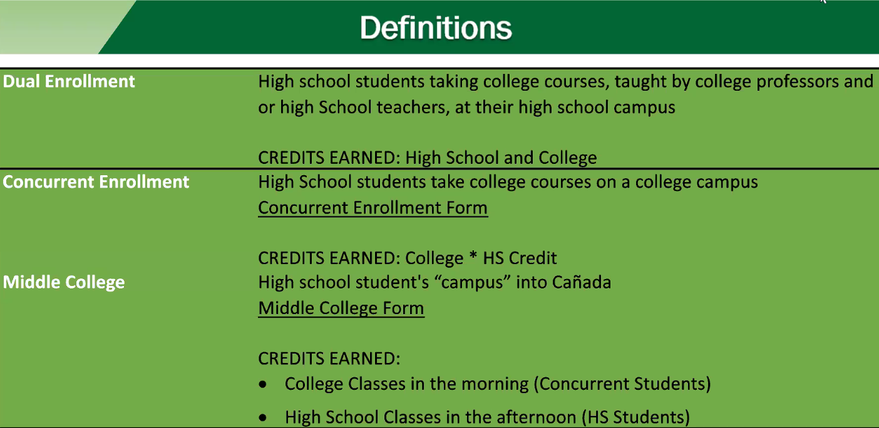
    - Goal – more college classes on HS campuses
      - Increase opportunity for students to get early college experience by
        - Equity recruitment: engage parents and community partners, change HS culture and counselor support
        - Onsite collaboration with HS partners: access career exploration, college and career day, counseling support and peer mentorship program
        - Dual enrollment program:
        - PROMISE Scholars Program
        - First Year Experience
      - Making sure students are accessing our programs and dismantling stigma of community college
      - Promise Scholars Program
        - Biggest admitted class in PSP – 144 students
        - Total enrolled: 464 *30 students taking CLOA
        - Orientations for 2020 cohort in August
      - High School and Community Partners Forum
        - Overview of certificates
        - Transfer programs
        - Financial aid and promise scholar program
        - Adulty Ed program ESL
        - Dual enrollment
        - Etc.
      - Faculty roles
        - Connect with Mayra or Ameer to see how we can help expand access for Black and Latinx students,
        - collaboration with K-12 partners
        - working on ENGR pathway
          - looking to share out at next division meeting
          - get more student involved and excited, specifically Black and Latinx students
      - questions:
        - how to ensure college courses are taught in line with college curriculum set – Susan M
          - ensure college faculty review and be involved as professors on HS campus
        - concerns: barriers - Jeanette
          - buy in from faculty and admin
          - accommodation difference in college/hs
          - lots to consider
          - transportation for concurrent enrollment
          - buy-in from parents
            - start working group for dual enrollment, connect with Mayra to join
        - Honors: dual enrollment component
          - Connect with Mayra
- VPA Graciano Mendoza: PBC Economic Outlook for FY 2021-22
  - Summary of funded items 2020-21
    - Total requested resources: $2.3M
      - Personnel $1.0M, Operations $1.3M
      - Funded Items: $2M
        - Net additional replacement cost for additional academic reassign time (2.6 FTE) $138,000
        - 3 additional FT Faculty (net of $70k received per position) $171,000
        - Summer Fall MOU $490k
        - Emergency Preparedness $125k
  - Economic Challenges:
    - COVID-19 Pandemic
    - Wild Fires
  - Milestones:
    - SP20 – multi year revenue projections (assess tax calculation
    - May revise – proposed reduction to categorial programs and additional reductions to basic aid districts - thankfully the level of cuts proposed weren’t implemented, but the long-term effects will be significant
  - During last recession 08
    - About 18mos before district felt the effect
    - Pandemic will be different as ongoing
  - Projected worse case, medium and best-case scenarios based on pre-COVID funding
  - May revise proposed reductions: worse-case scenario: about $2M+
    - Strong workforce
    - Student equity and achievement program
    - Lottery
    - Guided pathways
    - AB-19
    - EPA
    - Categorial funding
  - Recommend not get too stuck on numbers, but get sense of range of possibilities for long-term implications
  - Other financial implications: one-time items: little over $3.4M
    - Ending grants – personnel $1.6M to resolve
    - COVID-19 and Emergency Preparedness
    - Operational Items: No COLA for Categorical Funds, Deferred maintenance, PC Tech refresh, Lab Tech refresh, operational requested resources
    - Facilities and Construction – Bldg 1
  - Budget Development Milestones
    - Jan 2021 – Governor’s proposed budget to understand funding for comm college system
    - April-May – district multi-year revenue and site allocation projections
    - May 2021 – May revise
    - June 2021- approved state budget
  - PBC guidance for Program request for FY 2021-22
    - 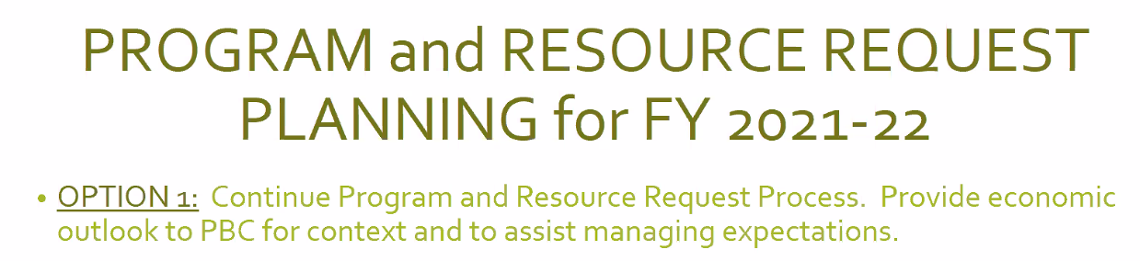
  - Questions: one-time funding for personnel get hired?
    - Office of instruction will lead (instructional designer) with HR and candidates will know before accepting position how long the assignment will be
    - No further details from VPA office – assumption is positions are one-time funding and will go away.

