Safety Committee
Agenda
Friday, May 21, 2021
2:30 pm – 3:30 pm
ZOOM Meeting

- Agenda/Minutes (5 minutes)

- Report/Updates
  - Public Safety (5 minutes)
    - Will be removing access points.
  - Facilities (5 minutes) (move to next meeting)
  - Emergency Preparedness Office (5 minutes)
    - Walk thru with red cross. Two separate MOU’s . Gym will be a shelter location. Facilities will be present at the walk thru. Flooring covering will be used.
    - Radio collection will continue. All radio’s will be updated for building captains. Radio cache will be created for each campus. Radios will be assigned to correct people. Training will be provided. Efforts to enhance communication.
    - New ADDs will be purchased and deployed on campuses. Also getting pediatric ADD’s. Updating district’s emergency plans. Intruder and evacuation annexs. Will be brought to each Safety Committee at each college. Will be completing the process by end of this year.

- Reporting On Safety Concerns (5 minutes)
OPEN DISCUSSION:
Effective immediately, campus open for recreational use. June 15th, all access points will be going away. Board requested all access to open sooner. Continuity plans currently being developed. Want to create an environment which is safe for all people. CAL OSHA will be updatind new guidelines in the next few days. We can now occupy same space without mask. Small groups, no larger than 5 people.

Student Services expanded group and town hall meeting were areas where discussions have recently taken regarding recovery. Goal is to return to campus up to 50%. Currently requesting feedback for policy group.

What will it look like when we return if vaccines are not mandated? Expect to see them remove requirement for masks and social distancing. This information is being provided for transparency.

If employees are not able or choose not to be vaccinated, they would require weekly testing. Communication plan will be implemented once board approved.

After June 15th, access points go away however the buildings will still be closed and access to buildings will still require current access protocol.

Looking for Board approval for granting campus access to vaccinated employees if they chose to return.

- Recovery Update (25 minutes)
BEN ZARA MINKIN /DISCUSSION:

- Committee Membership (5 minutes)
ACTION REQUIRED: Finalize Membership
FEEDBACK RECEIVED:
  - Representative from Health Center
  - Director of DRC and PCC
  - Student Life Representative
  - ITS member
  - Division Member and/or Faculty Representative
  - Public Safety Representative
  - Facilities Representative
  - PIO
  - Building Capt./ Building Manager
  - Title IX Coord.
  - Union Representation
  - All Vice Presidents
  - President

  - EOC Staffing Organization chart which will need to be covered by Safety Committee Members:
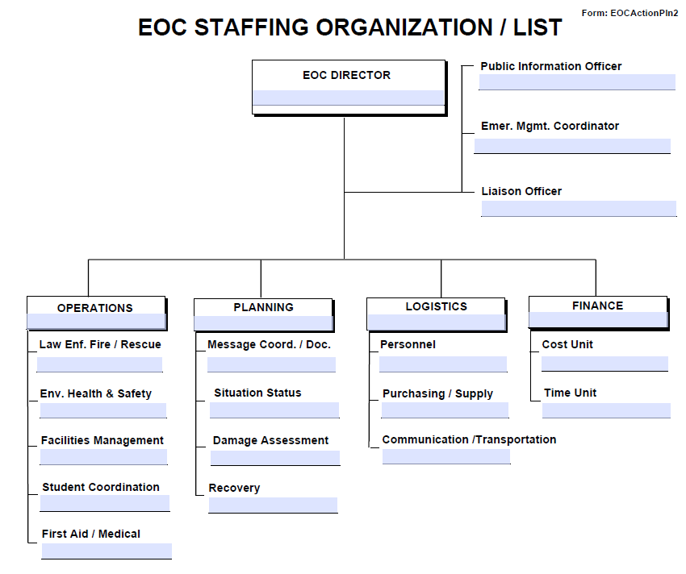

- Establishing Work Group/Teams (2 minutes)
ACTION REQUIRED: Need 2 to 3 volunteers for each work group.

    - Building Safety Infrastructure. [Building safety and training.] (Membership: Alex)
    - Chemical Safety and Hygiene. [Chemical safety on campus.] (Membership: Karen, Roz, Graciano)
    - Identifying and addressing safety concerns. (Membership: )
    - Injury/Illness Incidents. [HR/Student and Health Services/ Behavioral Intervention Team. Better understanding of health and safety regarding employee and student trends on campus.] (Membership: Max)
    - Title 9. (Membership: Michiko, Max, Adrian ) (VPSS Perez to review and make recommendations.)
    - EOC Implementation. (Membership: Mary Chries)

- Roundtable/Adjourn (3 minutes)

Future Topics:
- Finalize Committee Membership
- Establish Work Groups and Identify Volunteer Leads
    - Building Safety Infrastructure [Building safety and training.]
    - Chemical Safety and Hygiene [Chemical safety on campus.]
    - Injury/Illness Incidents: (HR/Student and Health Services/ Behavioral Intervention Team (Dean Hartman) [Better understand health and safe of employee and student trends on campus.

