Safety Committee
Draft Minutes
Thursday, January 28, 2021
11:00 am – 12:00 pm
ZOOM Meeting

- Agenda/Minutes (5 minutes)

- Report/Updates
  - Public Safety (5 minutes): Shared that the campus entrance check point has been moved to the campus entrance.
  - Facilities (5 minutes): The current storm has impacted our campus, however all items have been addressed. The Facilities team was recognized and thanked for all of their work on campus and resulting from COVID-19 pandemic.
  - Emergency Preparedness Office (5 minutes)
Ben Zara provided an overview of current plans related to testing sites and potential future vaccination sites. CSM has contracted with third party Company that provides no cost testing for our community. Block times were reserved for our faculty, staff and students and their respective families. Appointments can be made at the following website:

https://lhi.care/covidtesting

- Reporting On Safety Concerns (15 minutes)
OPEN DISCUSSION:

-Committee should assist with the identification of safety concerns. Is there a gap to voice a safety concern? If so, how should we address the gap?
-Committee should facilitate resolution of identified concerns.

No items were identified at this time, since faculty and staff are currently working remotely. It was suggested that we include this item as a standing item on our agenda, once we return to campus.

- Committee Membership (15 minutes)
ACTION REQUIRED: Finalize Membership
FEEDBACK RECEIVED:
  - Representative from Health Center: Dr. Wong (Wissim will check in)
  - Director of DRC and PCC: Bettina Lee
  - Student Life Representative: Adian Afif (student), Michicko
  - ITS member: Need to ask ITS for representative.
  - Division Member and/or Faculty Representative: TBD
  - Public Safety Representative: Brian Tupper
  - Facilities Representative: Karen P.
  - PIO: Megan R.
  - Building Capt./ Building Manager: Alex Claxton
  - All Vice Presidents: Tammy, Manuel, Graciano
  - President: Dr. Moore
  - Union representation: It was recommended that we include in membership.

- EOC Staffing Organization chart which will need to be covered by Safety Committee Members:

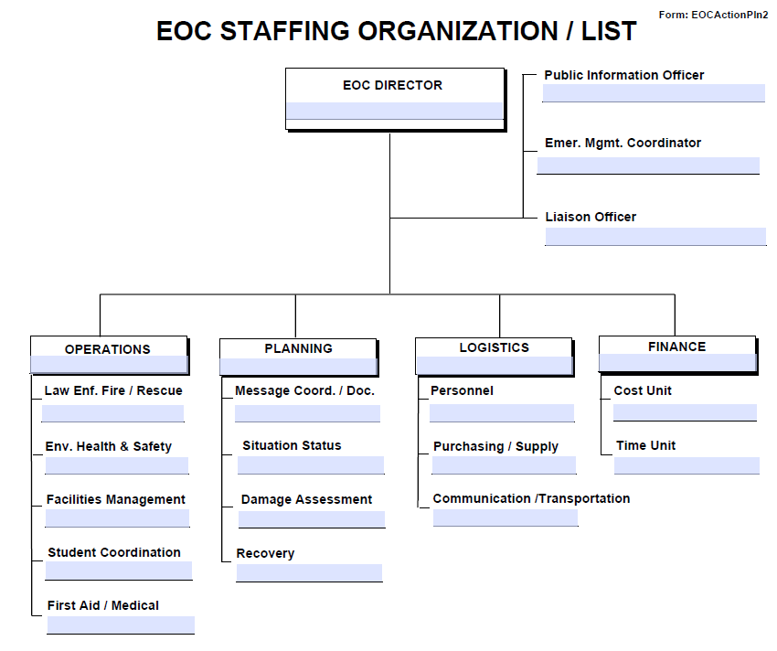

Informed the group that we will be working with Ben Zara and President, to begin identifying and assigning people to roles. Once we have a draft, it will be presented to committee for review, edits and ultimately finalization.

- Establishing Work Group/Teams (5 minutes)
ACTION REQUIRED: Need 2 to 3 volunteers for each work group.

    - Building Safety Infrastructure. [Building safety and training.] (Membership: Alex)
    - Chemical Safety and Hygiene. [Chemical safety on campus.] (Membership: Karen, Roz, Graciano)
    - Identifying and addressing safety concerns. (Membership:Bettina Lee )
    - Injury/Illness Incidents. [HR/Student and Health Services/ Behavioral Intervention Team. Better understanding of health and safety regarding employee and student trends on campus.] (Membership: Max)
    - Title 9. (Membership: Michiko, Max, Adrian ) (VPSS Perez to review and make recommendations.)
    - EOC Implementation. (Membership: Mary Chries)

- Roundtable/Adjourn (5 minutes)

Future Topics:
- Finalize Committee Membership
- Establish Work Groups and Identify Volunteer Leads
    - Building Safety Infrastructure [Building safety and training.]
    - Chemical Safety and Hygiene [Chemical safety on campus.]
    - Injury/Illness Incidents: (HR/Student and Health Services/ Behavioral Intervention Team (Dean Hartman) [Better understand health and safe of employee and student trends on campus.

Members Present for Today’s meeting:

Roz
Bettina
Mary Chries
Alex
Megan
Debbie
Jose Garcia
Ben Zara
Adrian Afif
Xittalic
Manuel
Max
Vince Garcia
Karen P
Moore
Brian T.

