English & Literature
Comprehensive Program Review Data Packet
7A. Enrollment Trends
Use the data provided by PRIE to examine your enrollments by department or courses. Describe trends in headcount, FTES, and load. If applicable, describe any other enrollment data that is relevant to your program

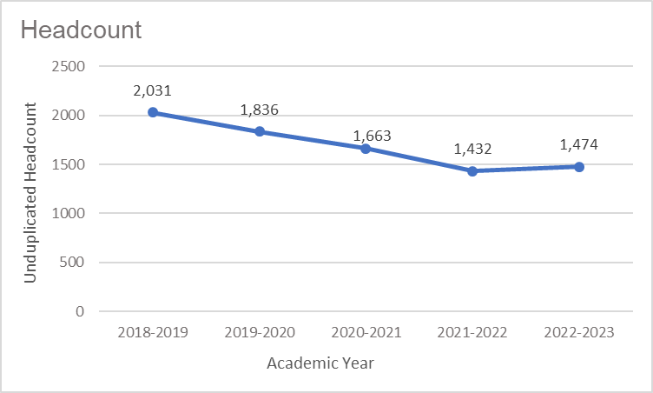
Headcount in English and Literature was down 27.4% in 2022-2023 (1,474 students) compared to 2018-2019 (2,031 students). Headcount declined steadily for four academic years then increased slightly in the most recent academic year.

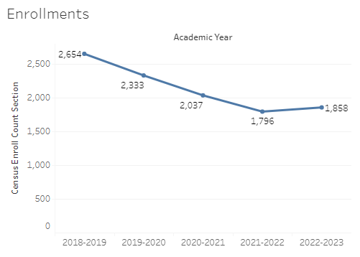
Enrollment in English and Literature was down 30% in 2022-2023 compared to five years ago in 2018-2019. English enrollment reached a five-year high in 2018-2019 with 2,654 enrollments and a five-year low of 1,796 enrollments in 2021-2022.

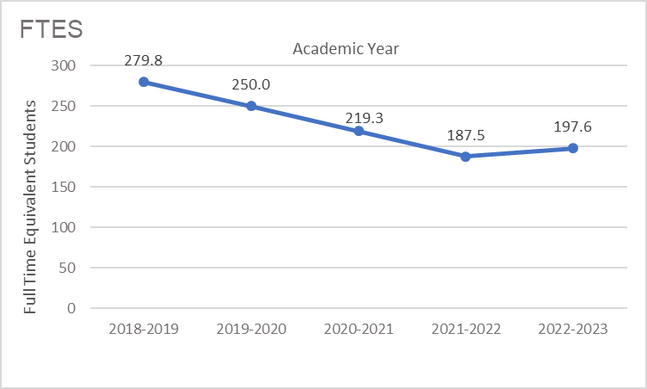
The count of full-time equivalent students (FTES) in English and Literature was down 29.4% in the most recent academic year (2022-2023) compared to five years ago (2018-2019), a decrease of 82.2 FTES.

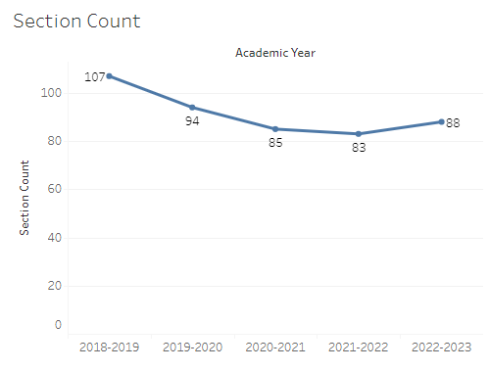
The number of sections offered in English and Literature decreased steadily for four academic years, followed by a slight increase in the most recent academic year. The section count for English and Literature went from a high of 107 sections in 2018-2019 to a low of 83 sections in 2021-2022. In 2022-2023 the number of sections increased to 88.

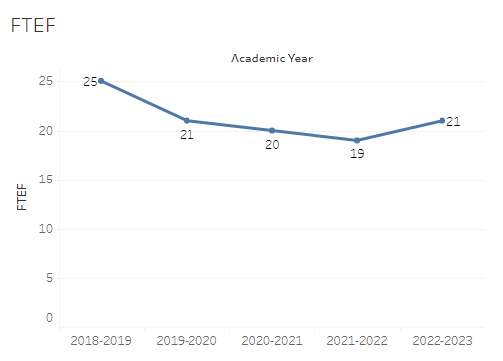
The number of full-time equivalent faculty (FTEF) in English and Literature went from a five-year high of 25 in 2018-2019 to a low of 19 in 2021-2022. The count of FTEF in 2022-2023, the most recent academic year, was 21.

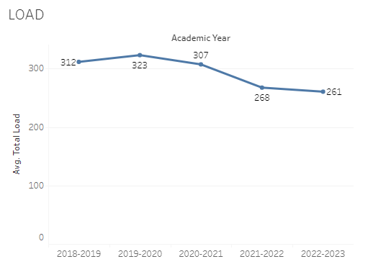
Load in English and Literature fluctuated over the last five academic years with a high of 323 in 2019-2020 and a low of 261 in 2022-2023.

8A. Access & Completion
Describe the student completion and success rate in your courses and/or program using the data provided by PRIE. Look at your course offerings, in the last program review cycle was it possible for a student to complete your certificates or degrees while only completing courses at Cañada College? How can the college help you improve student completion and success? What changes could be made?

Note: See the Course Enrollment & Success Detail Report for additional course-level data. This report can be found on PRIE’s Data Dashboards & Packets page under the program name.

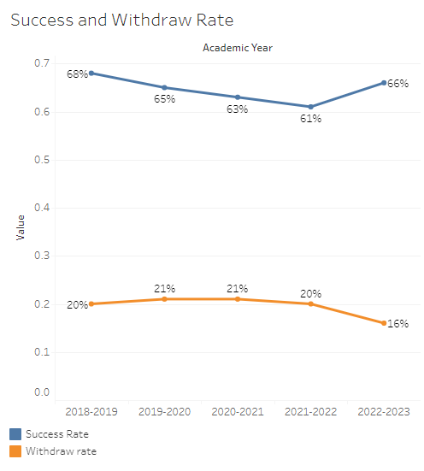
The overall success rate in English and Literature decreased from 68% in 2018-2019 to 61% in 2021-2022, followed by an increase of five percentage points in 2022-2023. Withdraw rates held steady for four academic years at 20-21% then decreased to 16% in the most recent academic year.
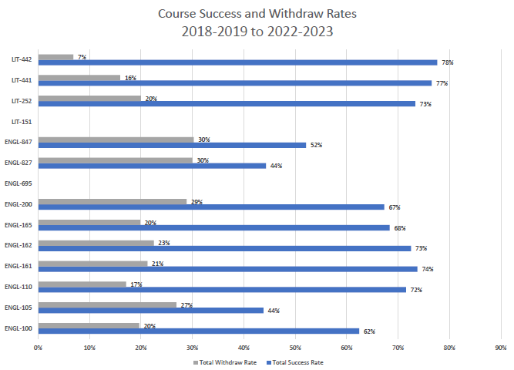
Course success rates in English ranged from a minimum of 44% in ENGL 105 and ENGL 827 to a maximum of 74% in ENGL 161. Withdraw rates in English ranged from a max of 30% in ENGL 827 and ENGL 847 to a minimum of 17% in ENGL 110. Success rates in Literature were between 73% and 78%, while withdraw rates in Literature ranged from a high of 20% to a low of 7%.

8B. Student Equity
One of the goals of the College’s Student Equity plan is to close the performance gaps for disproportionately impacted students. Use the data provided by PRIE that indicates which groups are experiencing a disproportionate impact in your program. Which gaps are most important for improving outcomes in your program? How can the college help you address these gaps? What changes could be made?

The Equity and Disproportionate Impact (DI) dashboard was used to identify subgroups that may have been disproportionately impacted in English and Literature classes in the most recent academic year (2022-2023). The three metrics used to examine potential disproportionate impact were enrollment rates (referred as access), success rates, and withdraw rates. The rate for each subgroup was compared to either the college-wide rate (access) or the overall program-level rate (success and withdraws). The difference between the two rates is known as the ‘gap’ and may be referred to as a performance gap or equity gap. Student subgroups that may have been disproportionately impacted in English appear below (see Table 1-3). There was no evidence of DI in Literature classes in 2022-2023.
Access
Access is an indicator of what student subgroups are enrolling in courses, based on unique student counts. Enrollment data revealed six student subgroups were underrepresented in English and Literature classes compared to the college-wide population (see Table 1). For instance, the proportion of students in English with a unit load considered ‘less than part-time’ (fewer than 6 units) was 39.3 percentage points lower than the proportion of ‘less than part-time’ students enrolled college-wide.
Table 1.
Student Subgroup | Gap
Unit load - Less than part-time (less than 6 units) | -39.3
Course modality Face-to-face: Females | -15.9
Females | -9.3
Not low income | -8.3
Not first generation | -6.0
Not disabled | -3.5

Success
Success is the rate at which different student subgroups pass courses and is based on enrollments. The success rate for different subgroups in English was compared to the overall success rate in English. The difference between the two rates (the gap) revealed ten subgroups may have been disproportionately impacted (see Table 2). For example, the success rate for Black non-Hispanic male students enrolled in online sections was 33.9 percentage points lower than the overall success rate in online English sections during the 2022-2023 academic year.

Table 2.
Student Subgroup | Gap
Course modality Online: Black Non-Hispanic Males | -33.9
Course modality Online: Black Non-Hispanic | -32.8
Black – Non-Hispanic Females | -21.7
Black – Non-Hispanic | -18.2
Course modality Face-to-face: Hispanic Males | -11.7
Hispanic Males | -9.8
Course modality Face-to-face: Hispanic | -8.5
Unit load – Part-time (6 - 11.9 units) | -5.6
Hispanic | -5.4
First Generation | -4.5

Withdraws
Withdraws is the rate at which a student withdraws from a course, with higher numbers being worse, as they indicate greater withdraw rates. The withdraw rates for subgroups in English was compared to the overall withdraw rate for the program. Four subpopulations had withdraw rates that were significantly higher than the overall rate, suggesting these groups experienced disproportionate impact in English. One subgroup, Filipino students enrolled in online English sections had withdraw rates 21.8 percentage points higher than the overall withdraw rate for English sections offered online.
Table 3.
Student Subgroup | Gap
Course modality Online: Filipino | +21.8
Filipino | +15.2
Age 23-28 | +8.3
Unit load - Less than part-time (less than 6 units) | +5.5

8C. Completion – Success Online
The college has a goal of improving success in online courses. Using the data provided by PRIE, what significant gaps do you see in success between online/hybrid and non-online courses? What changes could be made to reduce these gaps? If your program does not offer online/hybrid courses, please write “not applicable”.
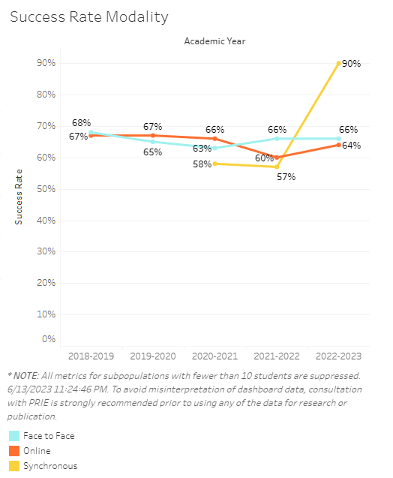
There was little to no difference in online and face-to-face success rates for four out of five academic years. The only exception was in 2021-2022 when the success rate in online sections dropped 6 percentage points below face-to-face sections. The success rate in synchronous sections was lower than online and face-to-face sections for two academic years, then success in synchronous sections increased dramatically in the most recent academic year, surpassing the other modalities.
The equity and disproportionate impact data presented in the previous section (see 8B. Student Equity) revealed Black non-Hispanic students and particularly Black non-Hispanic males enrolled in online English sections had success rates 33-34 percentage points lower than the overall success in online English sections.

Source: https://canadacollege.edu/prie/dashboards/disproportionate-impact.php

