**Final Application to SEM for 2019-20 submitted February 22, 2019**

The 10 individuals I’ve listed as participants are:

Jamillah Moore, College President

Hyla Lacefield, Academic Senate President

Jeanne Stalker, Classified Senate President

Karen Engel, Dean of PRIE

Lezlee Ware, Distance Education Coordinator

Max Hartman, Dean of Counseling

Myra Arellano, College Recruiter

Leonor Cabrera, Dean of BDW

Adam Windham, Dean of STEM

James Carranza, Dean of SSH

(of course, I didn’t use acronyms in the proposal).

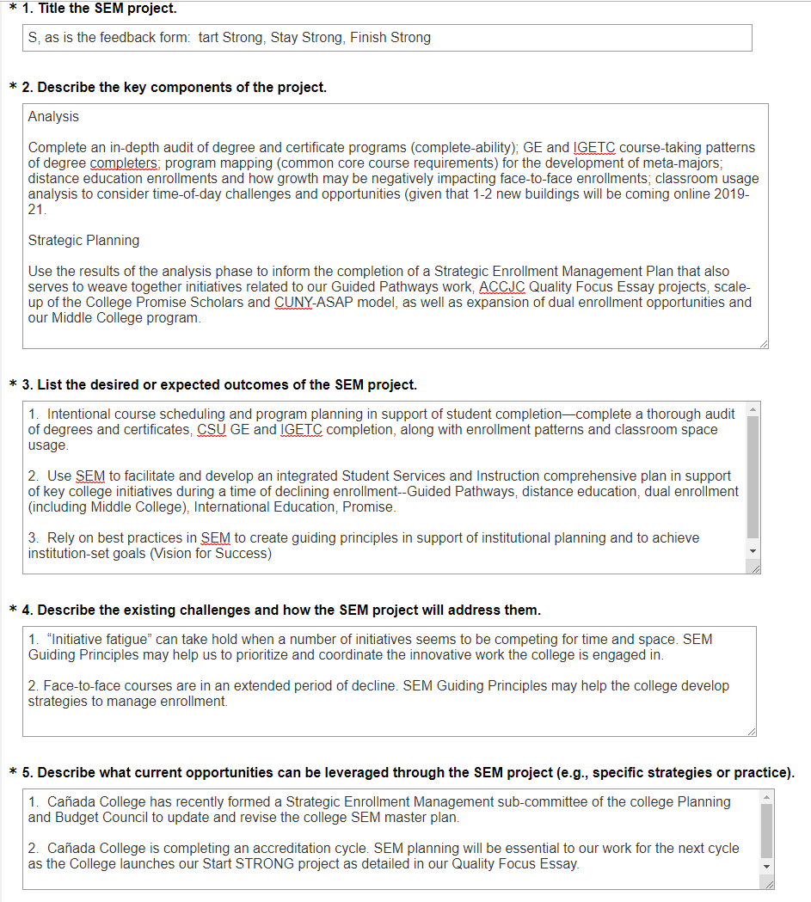

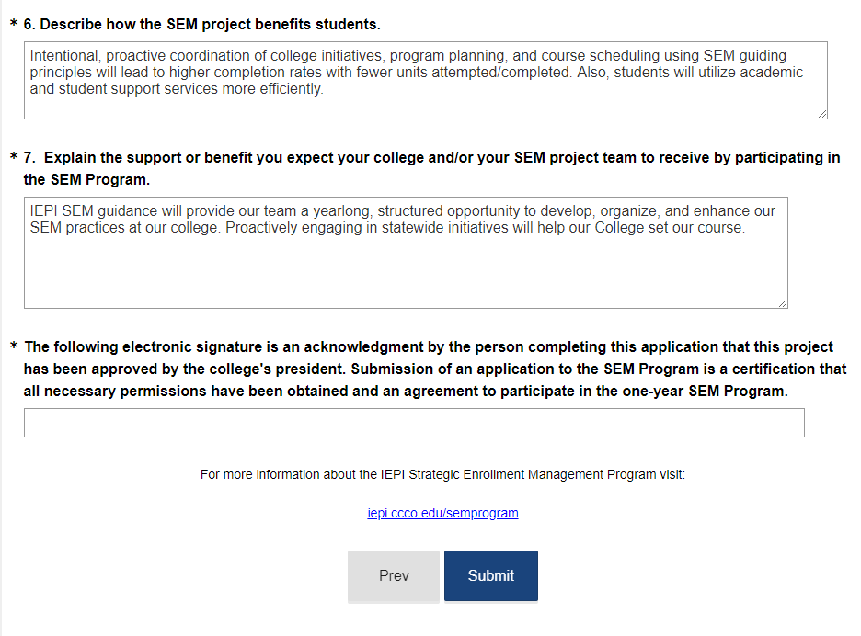

Karen Engel, Ph.D.

Dean of Planning, Research, Innovation and Effectiveness (PRIE)

Accreditation Liaison Officer

Cañada College

(650) 306-3145