DATA PACKET: 2026-27
for Instructional Comprehensive Program Review

Spanish

Current State of the Program

As stated in the 2022-2027 EMP: “Cañada College continuously assesses processes and removes barriers to student access, success, and completion.” The program review is an essential part of that process.
- For the following questions, please use the data provided by PRIE that indicates which groups are experiencing a disproportionate impact in your program.
- Please note: “program of study” refers to any specific degree or certificate that a student can complete. A “program” as a discipline may contain multiple programs of study.

5A. Program Changes
List any significant changes that have occurred over the prior years in your program's curricular offerings, scheduling, or mode of delivery. Please describe if any changes impacted specific programs of study within your discipline. For decisions made by your department, explain the rationale for these changes. If applicable, how have state policy changes affected your program offerings?

To help answer these questions, consider the following data reports from PRIE found on PRIE’s Data Dashboard & Packets website under your program name:
- Course Enrollment Report
- Data for Comprehensive PR Questionnaire
- Program of Study Report
- Degrees & Certificates Awarded Report

5B. Program of Study Completability
Look at your course offerings, in the last program review cycle: was it possible for a student to complete your certificate(s) or degree(s) while only completing courses at Cañada College? If not, was your certificate(s) or degree(s) completable within the District?

To help answer these questions, consider the Program Complete-ability Dashboard on PRIE’s Data Dashboard & Packets website. Use the Program Requirements Summary tab to determine if your programs were complete-able at Cañada College during the last two years.

5C. Program of Study Maps
Review your discipline’s currently listed program(s) of study maps. Are any updates needed? If so, please list the needed changes. (These changes will be forwarded to the PRIE office after the Program Review process is completed, or you may submit changes using the PRIE Data request form.)

Program Maps are available on the Cañada College website here.

6: Enrollment Trends and Changes

Use the data provided by PRIE to examine your enrollments by discipline and courses. Analyze each of the following:
- trends, significant changes, and any disproportionate enrollment impacts in course offerings,
- any disproportionate enrollments of student subpopulations indicated in PRIE data,
- trends in headcount, FTES, and load.

Based on your analysis of the data, discuss what you believe is noteworthy. For example, has there been a significant increase or drop in FTES or Load? If applicable, consider trends in class cancellation rates and how it might have affected your course offerings. If needed, consider how the pattern of course offerings (times/days/duration/delivery mode/number of sections) affected your enrollment.

To help answer these questions, consider the Course Enrollment Report provided for your program on PRIE’s Data Dashboard & Packets website under your program name.

Trends in headcount, FTES, and load

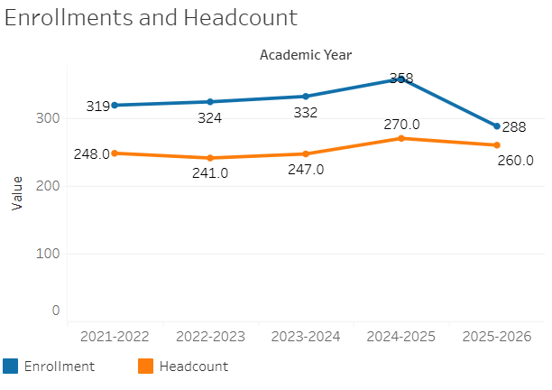
The trend in enrollment shows steady growth that peaked in 2024–2025, followed by a decline in both enrollment and headcount in 2025-26.
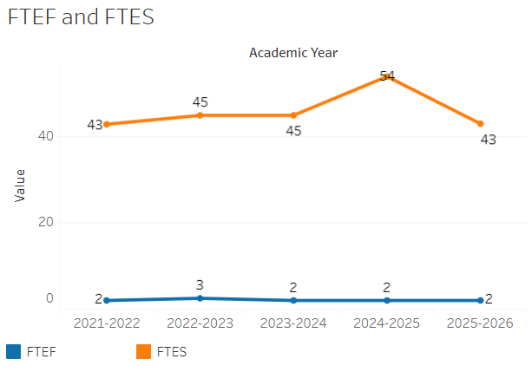
The trend shows FTES steadily growing to a peak in 2024–2025 before declining back to its starting level, while FTEF remained almost entirely flat throughout the entire period.

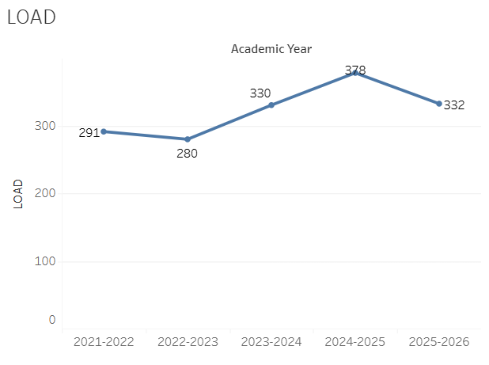
The trend shows load values rising steadily after a small initial dip, peaking in 2024–2025 before declining in the final academic year. Load remains below the college target of 525.

The following table provides information about any student sub-populations experiencing disproportionately negative access to your program’s courses between 2021-2026:

Student Sub-Population | Overall Course Enrollment Equity Gaps | Year of Gap
Age group 18-22 | -11.9% | 2024-25
Age group 18-22 | -12.3% | 2025-26
Age group 23-28 | -11.6% | 2021-22
First Generation | -10.4% | 2023-24
Less than Part-time | -8.1% | 2024-25
 | -13.0% | 2025-26

Overall, equity gaps in access to Spanish are fairly isolated and sporadic, although students ages 18-24 appear to be disproportionately not enrolling in Spanish classes in recent years.
The number of sections offered in Spanish across courses declined slightly over the 5-year period:

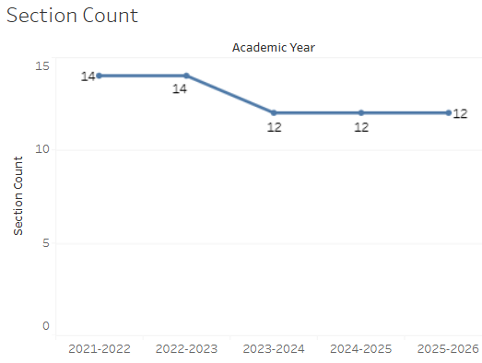

7: Retention and Success

7A. Current Retention and Success Data
Describe the retention and student success rates in your courses and any disproportionate enrollment impacts using the data provided by PRIE.

To help answer these questions, consider the Course Enrollment Report provided for your program on PRIE’s Data Dashboard & Packets website under your program name.

The Overall Success and Withdraw Rates for your Department (retention rates are the inverse of withdraw rates) are:
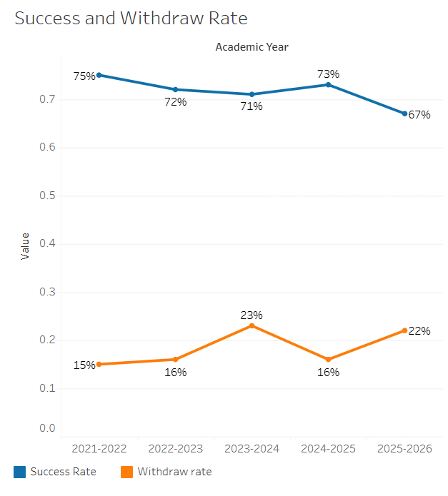
Overall course success rates declined over the 5-year period, and withdraw rates increased.

Equity gaps in course success and retention are also available in PRIE’s Equity & Disproportionate Impact Dashboard. The following data is highlighted in red for your program on that dashboard.

Course Success Rates: Equity Gaps

Student Sub-Population | Overall Course Success Rates Equity Gaps | Year of Gap
Asian-Male | -29.5% | 2022-23
Hispanic-Male | -16.6% | 2021-22
Age Group 29-39 | -13.1% | 2022-23
Disability | -23.1% | 2024-25

The trend here is highly positive. While there were scattered equity gaps in earlier years, every single one of these demographic gaps was completely eliminated by the 2025–2026 academic year.

Course Withdraw Rates: Equity Gaps

Student Sub-Population | Overall Course Withdraw Rate Equity Gaps | Year of Gap
Age Group 29-39 | -13.1% | 2022-23
Note: Withdraw rates are the inverse of retention rates.

There are no equity gaps in withdraw and retention rates of concern.

7B. Online Success
The college has a goal of improving success in online courses. Using the data provided by PRIE, what significant gaps do you see in success between different course modalities: asynchronous, synchronous, hybrid, and face-to-face courses? Analyze any disproportionate online course retention and success rates by modality. If your program does not offer online courses, please write “not applicable.”
Please consult the Course Enrollment Report posted for your discipline on the PRIE website to review student success at the course level. For the discipline as a whole, the course success rates by modality are:

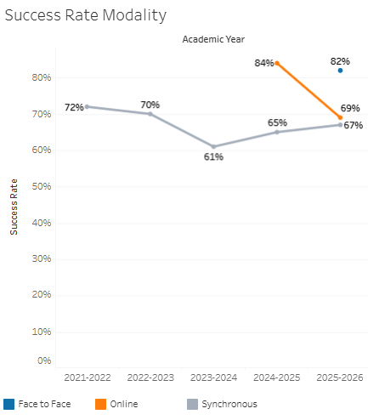
Course success rates by modality indicate that the synchronous modality success rates declined over the 5-year period. Other modalities do not show sufficient data to indicate a trend.

Equity gaps in course success and retention by modality are also available in PRIE’s Equity & Disproportionate Impact Dashboard using the Modality filter. The following data is highlighted in red for your program on that dashboard.

Course Success Rates: Equity Gaps by modality

Student Sub-Population | Overall | Online Courses (ASYNC) | Face-to-Face Courses | Hybrid Courses | Synchronous Courses (SYNC) | Year of Equity Gap
Asian-Male | -29.5% |  |  |  |  | 2022-23
Hispanic-Male | -16.6% |  |  |  | -18.2% | 2021-22
Hispanic-Male |  |  |  | -29.5% |  | 2024-25
Age Group 29-39 | -13.1% |  |  | -18.2% |  | 2022-23
Disability | -23.1% |  |  |  |  | 2024-25
Male |  |  |  |  | -11.6% | 2021-22
Male |  |  |  |  | -18.9% | 2022-23
Hispanic |  |  |  |  | -13.6% | 2025-26
Low Income |  |  |  |  | -20.0% | 2025-26

The program may want to consider the impact of synchronous course methodologies on various student populations, include Male, Hispanic, and Low Income students groups.

10B. Improving Retention and Success Rates
What changes does your program propose to make to improve student course retention and success, particularly for disproportionately impacted students identified in Question 7? How can the college help you improve student retention and success?
Consider course offerings, curricular and/or pedagogical changes. You are encouraged to collaborate with the Director of Equity and/or Faculty Equity Coordinator to develop strategies for addressing equity gaps and to include those here. Examples of possible strategies include trials of new equitable grading strategies, use of OER/ZTC textbooks, surveys to capture student voices and needs in the classroom, new or improved partnerships with student services, and/or plans for faculty recruitment and faculty training.

Please note: PRIE’s ZTC/OER Dashboard might be a good resource for answering these questions.

