**Sociology**

**Comprehensive Program Review Questionnaire Data & Sources 2025-26**

**6: Enrollment Trends and Changes**

**Trends, significant changes, and any disproportionate enrollment impacts in course offerings**

Please consult the *Course Enrollment Report* posted for your discipline on the [PRIE website](https://canadacollege.edu/prie/data-dashboards.php).

**Any disproportionate enrollments of student subpopulations indicated in PRIE data**

|  |  |  |
| --- | --- | --- |
| **Student Sub-Population** | **Overall Course Enrollment Equity Gaps** | **Year of Gap** |
| Male | -9.8% | 2024-25 |
| -10.7% | 2023-24 |
| -10.8% | 2022-23 |
| -9.7% | 2021-22 |
| -13.8% | 2020-21 |

Sociology has seen disproportionately fewer enrollments from Male students across the past five years.

**Trends in headcount, FTES, and load**

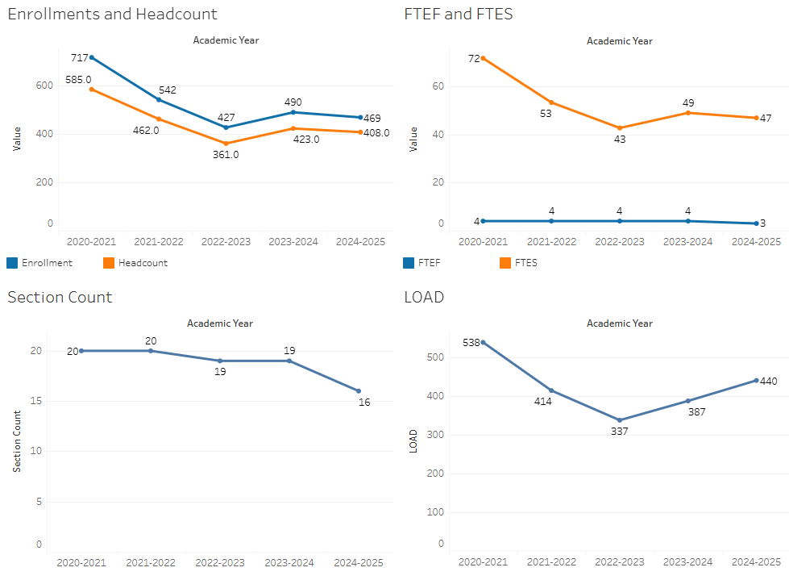

After declining enrollment, enrollments have stabilized over the past few years. The total number of sections offered has not fully adjusted to the new enrollment numbers.

### 7A. Current Retention and Success Data

Describe the retention and student success rates in your courses and any disproportionate enrollment impacts using the data provided by PRIE.

**Overall Success and Withdraw Rates (retention rates are the inverse of withdraw rates):**

Success rates have shown increases over the past few years, and remain high. Withdraw rates have declined and remain below the college average.

**Course Success Rates: Equity Gaps**

|  |  |  |
| --- | --- | --- |
| **Student Sub-Population** | **Overall Course Success Rates Equity Gaps** | **Year of Gap** |
| Hispanic | -8.1% | 2021-22 |
| Hispanic Female | -10.5% | 2022-23 |
| -8.6% | 2021-22 |
| 23-28 (Age Group) | -14.1% | 2024-25 |
| First Generation | -9.4% | 2021-22 |
| Synchronous | -9.6% | 2021-22 |

**Course Retention Rates: Equity Gaps**

There are no equity gaps in retentions rates in Sociology.

Please check the [Equity & Disproportionate Impact Dashboard](https://canadacollege.edu/prie/dashboards/disproportionate-impact.php) on the PRIE website to look for equity gaps by specific course.

### 7B. Online Success

The college has a goal of improving success in online courses. Using the data provided by PRIE, what significant gaps do you see in success between different course modalities: asynchronous, synchronous, hybrid, and face-to-face courses? Analyze any disproportionate online course retention and success rates by modality.

Please consult the *Course Enrollment Report* posted for your discipline on the [PRIE website](https://canadacollege.edu/prie/data-dashboards.php) to review student success at the course level. For the discipline as a whole, the course success rates by modality are:

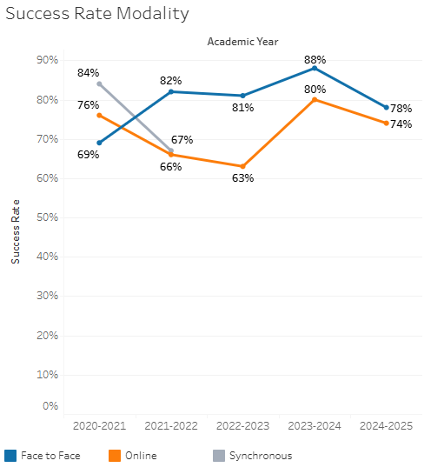

Online success rates generally have fallen below face to face rates, however in recent years the gap has been substantially reduced.

**Course Success Rates: Equity Gaps by modality**

|  |  |  |  |  |  |  |
| --- | --- | --- | --- | --- | --- | --- |
| **Student Sub-Population** | **Overall** | **Online Courses (ASYNC)** | **Face-to-Face Courses** | **Hybrid Courses** | **Synchronous Courses (SYNC)** | **Year of Equity Gap** |
| 23-28 (Age Group) |  |  | -14.1% |  |  | 2024-25 |
| 23-28 (Age Group) |  | -10.0% |  |  |  | 2020-21 |
| First Generation |  | -7.6% |  |  |  | 2021-22 |
| First-Generation |  |  |  |  | -13.9% | 2021-22 |