**Philosophy**

**Comprehensive Program Review Questionnaire Data & Sources 2025-26**

**6: Enrollment Trends and Changes**

**Trends, significant changes, and any disproportionate enrollment impacts in course offerings**

Please consult the *Course Enrollment Report* posted for your discipline on the [PRIE website](https://canadacollege.edu/prie/data-dashboards.php).

**Any disproportionate enrollments of student subpopulations indicated in PRIE data**

|  |  |  |
| --- | --- | --- |
| **Student Sub-Population** | **Overall Course Enrollment Equity Gaps** | **Year of Gap** |
| Female | -9.0% | 2023-24 |
| -7.3% | 2021-22 |

Philosophy has seen an occasional disproportionate impact for Female students, but it is not consistent.

**Trends in headcount, FTES, and load**

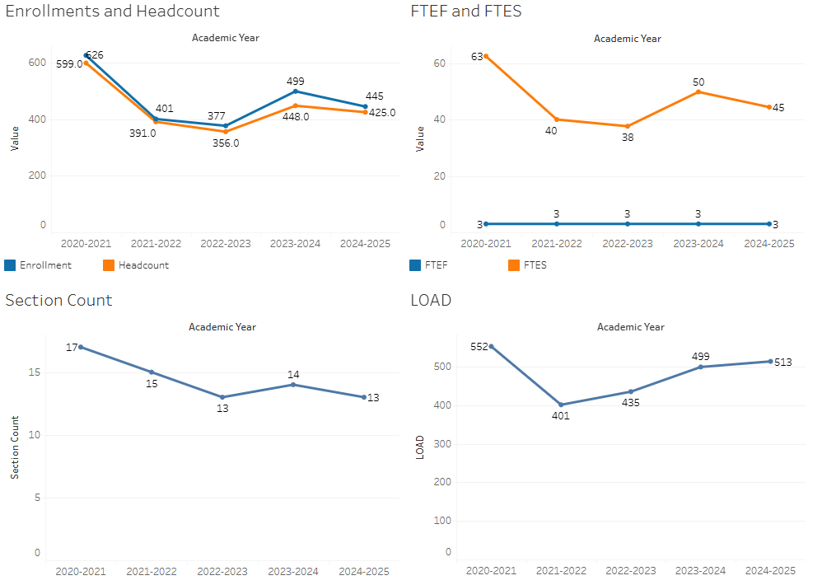

Philosophy enrollment has rebounded in recent years after a large drop off in 2021-2022. The sections offered seem properly scaled to current demand for courses.

### 7A. Current Retention and Success Data

Describe the retention and student success rates in your courses and any disproportionate enrollment impacts using the data provided by PRIE.

**Overall Success and Withdraw Rates (retention rates are the inverse of withdraw rates):**

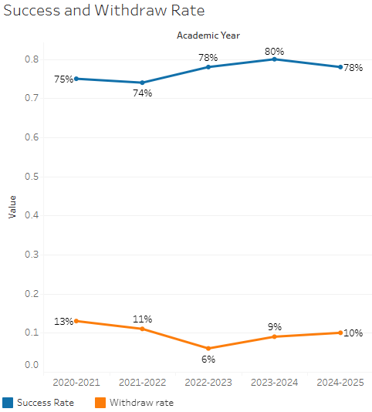

Overall success rates are high and had a slight increasing trend over the past few years. Withdraw rates remain stable and low.

**Course Success Rates: Equity Gaps**

|  |  |  |
| --- | --- | --- |
| **Student Sub-Population** | **Overall Course Success Rates Equity Gaps** | **Year of Gap** |
| Black-Non-Hispanic | -44.4% | 2020-21 |
| Hispanic | -9.2% | 2024-25 |
| -11.6% | 2023-24 |
| -10.5% | 2022-23 |
| Black Non-Hispanic Female | -43.0% | 2020-21 |
| Hispanic Female | -13.5% | 2023-24 |
| -18.2% | 2022-23 |
| 23-28 Age Group | -13.2% | 2024-25 |
| 29-39 Age Group | -29.3% | 2022-23 |
| First Generation | -9.0% | 2023-24 |
| Low Income | -11.1% | 2023-24 |

**Course Retention Rates: Equity Gaps**

|  |  |  |
| --- | --- | --- |
| **Student Sub-Population** | **Overall Course Withdraw Rates Equity Gaps** | **Year of Gap** |
| 29-39 (Age Group) | 17.1% | 2022-23 |

Please check the [Equity & Disproportionate Impact Dashboard](https://canadacollege.edu/prie/dashboards/disproportionate-impact.php) on the PRIE website to look for equity gaps by specific course.

### 7B. Online Success

The college has a goal of improving success in online courses. Using the data provided by PRIE, what significant gaps do you see in success between different course modalities: asynchronous, synchronous, hybrid, and face-to-face courses? Analyze any disproportionate online course retention and success rates by modality.

Please consult the *Course Enrollment Report* posted for your discipline on the [PRIE website](https://canadacollege.edu/prie/data-dashboards.php) to review student success at the course level. For the discipline as a whole, the course success rates by modality are:

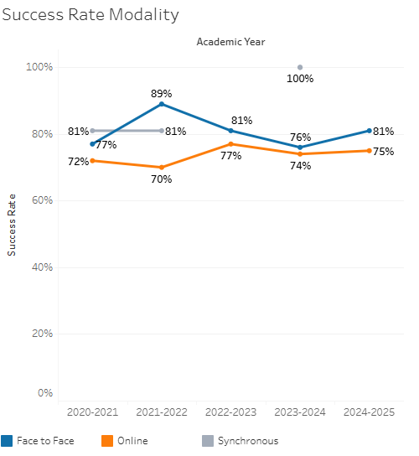

Online success rates have improved in recent years but remain slightly below face to face success rates.

**Course Success Rates: Equity Gaps by modality**

|  |  |  |  |  |  |  |
| --- | --- | --- | --- | --- | --- | --- |
| **Student Sub-Population** | **Overall** | **Online Courses (ASYNC)** | **Face-to-Face Courses** | **Hybrid Courses** | **Synchronous Courses (SYNC)** | **Year of Equity Gap** |
| Hispanic |  |  | -9.2% |  |  | 2024-25 |
|  |  | -14.2% |  |  | 2023-24 |
| 23-28 (Age Group) |  |  | -13.2% |  |  | 2024-25 |
| Black Non-Hispanic |  | -46.2% |  |  |  | 2020-21 |
| Black Non-Hispanic Female |  | -42.2% |  |  |  | 2020-21 |
| Hispanic-Female |  | -17.9% |  |  |  | 2023-24 |
|  | -16.0% |  |  |  | 2022-23 |
| 29-39 (Age Group) |  | -26.8% |  |  |  | 2022-23 |
| Hispanic Male |  |  |  |  | -31.5% | 2020-21 |