Photonics and Laser Technology
Comprehensive Program Review Questionnaire Data & Sources 2025-26

6: Enrollment Trends and Changes
Trends, significant changes, and any disproportionate enrollment impacts in course offerings

Please consult the Course Enrollment Report posted for your discipline on the PRIE website.

Any disproportionate enrollments of student subpopulations indicated in PRIE data

There are no course enrollment equity gaps for Photonics and Laser Technology due to the low number of enrollments.

Trends in headcount, FTES, and load
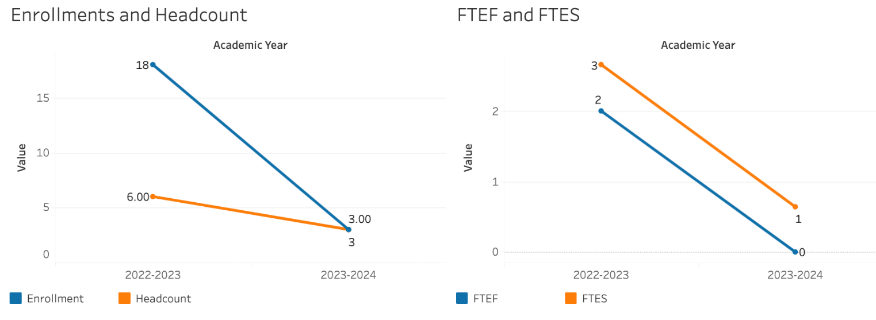
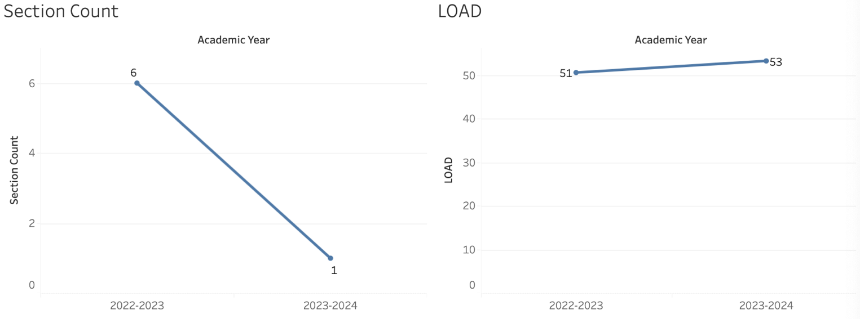
There are no reliable trends based on the limited data.

7A. Current Retention and Success Data
Describe the retention and student success rates in your courses and any disproportionate enrollment impacts using the data provided by PRIE.
Overall Success and Withdraw Rates (retention rates are the inverse of withdraw rates):
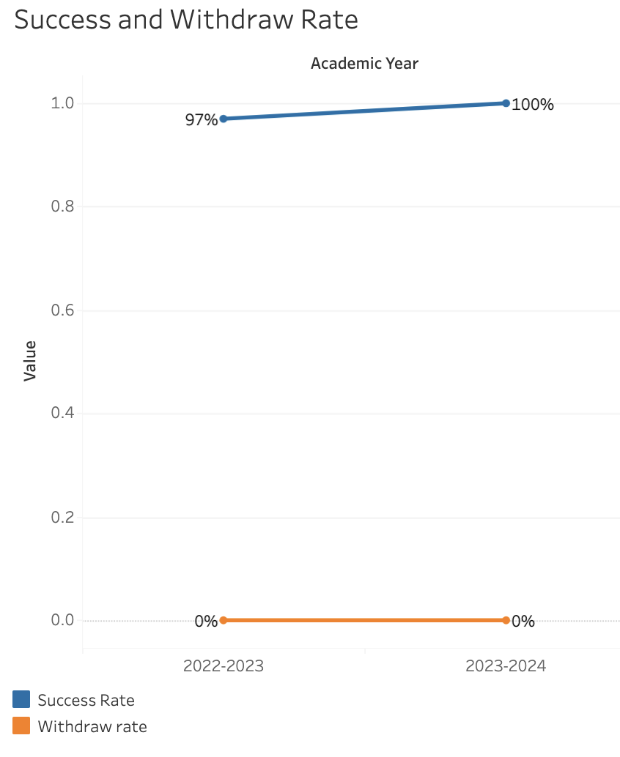
Course Success Rates: Equity Gaps
There are no success rate equity gaps in Photonics and Laser Technology due to the low number of enrollments.
Course Retention Rates: Equity Gaps
There are no equity gaps in retentions rates in Photonics and Laser Technology due to the low number of enrollments.
Please check the Equity & Disproportionate Impact Dashboard on the PRIE website to look for equity gaps by specific course.

7B. Online Success
The college has a goal of improving success in online courses. Using the data provided by PRIE, what significant gaps do you see in success between different course modalities: asynchronous, synchronous, hybrid, and face-to-face courses? Analyze any disproportionate online course retention and success rates by modality.
Please consult the Course Enrollment Report posted for your discipline on the PRIE website to review student success at the course level. For the discipline as a whole, the course success rates by modality are:

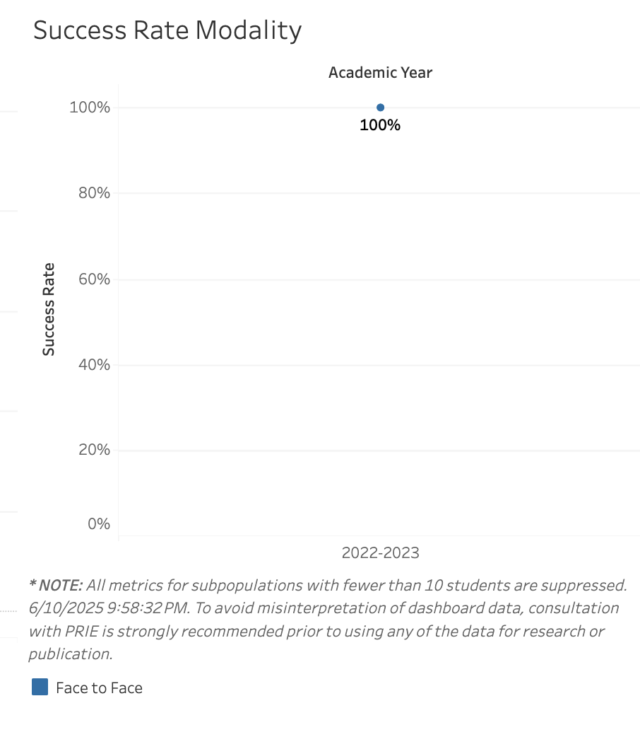
Course Success Rates: Equity Gaps by modality
There are no success equity gaps by modality in Photonics and Laser Technology due to the low number of enrollments.

