**History**

**Comprehensive Program Review Questionnaire Data & Sources 2025-26**

**6: Enrollment Trends and Changes**

**Trends, significant changes, and any disproportionate enrollment impacts in course offerings**

Please consult the *Course Enrollment Report* posted for your discipline on the [PRIE website](https://canadacollege.edu/prie/data-dashboards.php).

**Any disproportionate enrollments of student subpopulations indicated in PRIE data**

|  |  |  |
| --- | --- | --- |
| **Student Sub-Population** | **Overall Course Enrollment Equity Gaps** | **Year of Gap** |
| Female | -5.4% | 2024-25 |
| -10.0% | 2023-24 |
| -10.0% | 2022-23 |
| -8.1% | 2021-22 |
| -6.8% | 2020-21 |

Fewer Female students enrolled in the program consistently over the past five years.

**Trends in headcount, FTES, and load**

Enrollments decreased until 2022-2023 but rebounded and stabilized in 2023-2024 and 2024-2025. The number of sections offered appears to be in line with demand in the past two years, after the rebound in enrollments.

### 7A. Current Retention and Success Data

Describe the retention and student success rates in your courses and any disproportionate enrollment impacts using the data provided by PRIE.

**Overall Success and Withdraw Rates (retention rates are the inverse of withdraw rates):**

Success rates have ticked up recently and withdraws have slightly decreased in this time window.

**Course Success Rates: Equity Gaps**

|  |  |  |
| --- | --- | --- |
| **Student Sub-Population** | **Overall Course Success Rates Equity Gaps** | **Year of Gap** |
| Hispanic | -6.7% | 2023-24 |
| -5.5% | 2022-23 |
| -5.9% | 2021-22 |
| -5.4% | 2020-21 |
| Pacific Islander | -44.7% | 2024-25 |
| Hispanic Female | -8.0% | 2021-22 |
| Hispanic Male | -8.7% | 2023-24 |
| -9.6% | 2022-23 |
| Pacific Islander-Female | -45.1% | 2024-25 |
| 23-28 (Age Group) | -12.9% | 2024-25 |
| First Generation | -5.9% | 2024-25 |
| -5.6% | 2023-24 |
| -7.2% | 2021-22 |
| Veteran | -20.3% | 2023-24 |
| -23.7% | 2022-23 |
| Low Income | -7.5% | 2024-25 |
| Hybrid | -9.0% | 2023-24 |
| Synchronous | -10.0% | 2021-22 |

**Course Retention Rates: Equity Gaps**

|  |  |  |
| --- | --- | --- |
| **Student Sub-Population** | **Overall Course Withdraw Rates Equity Gaps** | **Year of Gap** |
| Synchronous | 12.5% | 2021-22 |

Please check the [Equity & Disproportionate Impact Dashboard](https://canadacollege.edu/prie/dashboards/disproportionate-impact.php) on the PRIE website to look for equity gaps by specific course.

### 7B. Online Success

The college has a goal of improving success in online courses. Using the data provided by PRIE, what significant gaps do you see in success between different course modalities: asynchronous, synchronous, hybrid, and face-to-face courses? Analyze any disproportionate online course retention and success rates by modality.

Please consult the *Course Enrollment Report* posted for your discipline on the [PRIE website](https://canadacollege.edu/prie/data-dashboards.php) to review student success at the course level. For the discipline as a whole, the course success rates by modality are:

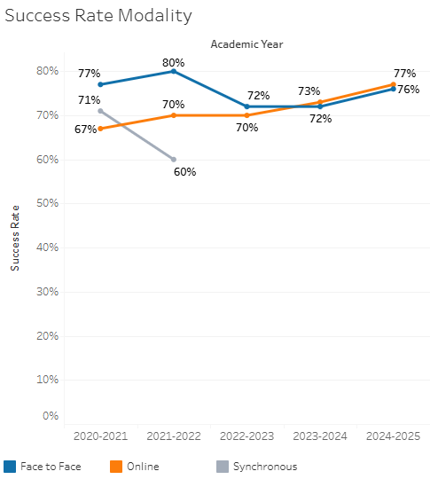

Both Online and Face to Face success rates have increased over the past few years and remain very similar.

**Course Success Rates: Equity Gaps by modality**

|  |  |  |  |  |  |  |
| --- | --- | --- | --- | --- | --- | --- |
| **Student Sub-Population** | **Overall** | **Online Courses (ASYNC)** | **Face-to-Face Courses** | **Hybrid Courses** | **Synchronous Courses (SYNC)** | **Year of Equity Gap** |
| Pacific Islander |  |  | 33.2% |  |  | 2024-25 |
| Pacific Islander- Female |  |  | -35.6% |  |  | 2024-25 |
| 40-49 (Age Group) |  |  | 24.7% |  |  | 2024-25 |
| 40-49 (Ege Group) |  |  |  |  | 26.9% | 2021-22 |
| Hispanic |  | -9.5% |  |  |  | 2023-24 |
|  | -7.5% |  |  |  | 2021-22 |
| Hispanic-Female |  | -11.8% |  |  |  | 2021-22 |
| Hispanic-Male |  | -10.4% |  |  |  | 2020-21 |
| First Generation |  | -7.2% |  |  |  | 2021-22 |
| Veteran |  | -29.4% |  |  |  | 2022-23 |