**Education and Human Development**

**Comprehensive Program Review Questionnaire Data & Sources 2025-26**

**6: Enrollment Trends and Changes**

**Trends, significant changes, and any disproportionate enrollment impacts in course offerings**

Please consult the *Course Enrollment Report* posted for your discipline on the [PRIE website](https://canadacollege.edu/prie/data-dashboards.php).

**Any disproportionate enrollments of student subpopulations indicated in PRIE data**

|  |  |  |
| --- | --- | --- |
| **Student Sub-Population** | **Overall Course Enrollment Equity Gaps** | **Year of Gap** |
| Male | -30.8% | 2024-25 |
| -30.9% | 2023-24 |
| -28.5% | 2022-23 |
| -28.9% | 2021-22 |
| -30.0% | 2020-21 |
| 18-22 (Age Group) | -15.9% | 2024-25 |
| -15.4% | 2023-24 |
| -13.0% | 2022-23 |
| 23-28 (Age Group) | -15.5% | 2020-21 |

Education and Human Development has seen disproportionately fewer enrollments from Male students ever year and younger students across many years

**Trends in headcount, FTES, and load**

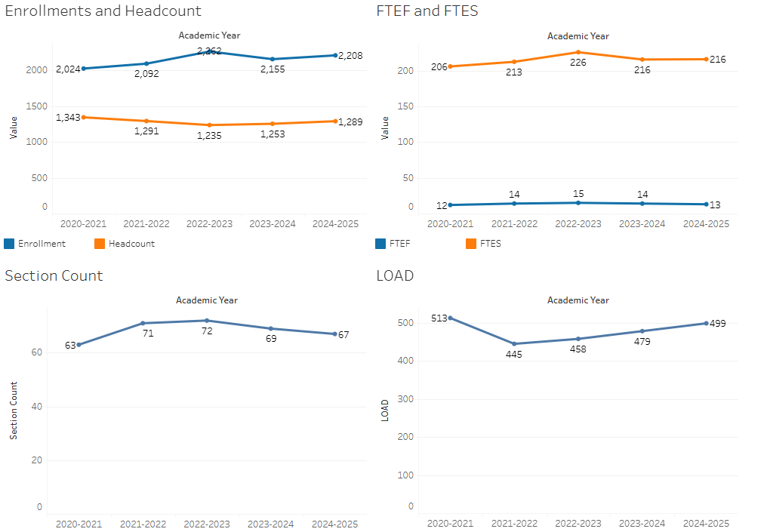

Enrollment has slowly been increasing year over year, while the number of sections has remained very stable. This appears to be meeting student demand overall.

### 7A. Current Retention and Success Data

Describe the retention and student success rates in your courses and any disproportionate enrollment impacts using the data provided by PRIE.

**Overall Success and Withdraw Rates (retention rates are the inverse of withdraw rates):**

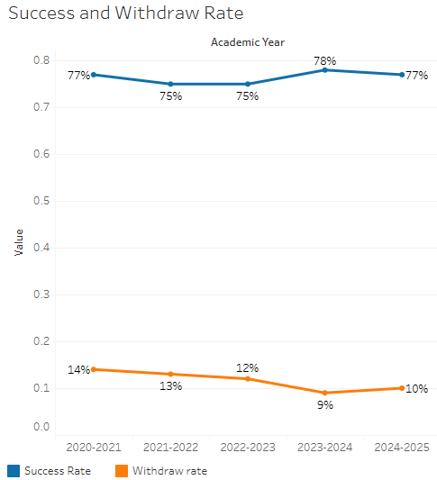

Success rates have remained very stable over time, while withdraw rates have generally declined .

**Course Success Rates: Equity Gaps**

|  |  |  |
| --- | --- | --- |
| **Student Sub-Population** | **Overall Course Success Rates Equity Gaps** | **Year of Gap** |
| Filipino | -16.3% | 2022-23 |
| Hispanic | -3.7% | 2024-25 |
| -5.5% | 2023-24 |
| -5.0% | 2022-23 |
| -4.1% | 2021-22 |
| -5.0% | 2020-21 |
| Pacific Islander | -53.0% | 2023-24 |
| -38.6% | 2022-23 |
| Pacific Islander-Female | -51.5% | 2023-24 |
| -36.8% | 2022-23 |
| 18-22 (Age Group) | -10.1% | 2024-25 |
| 23-28 (Age Group) | -8.9% | 2022-23 |
| -7.8% | 2021-22 |
| -10.5% | 2020-21 |
| Disability | -20.6% | 2024-25 |
| First Generation | -5.0% | 2024-25 |
| -4.9% | 2023-24 |
| -3.5% | 2022-23 |
| Low Income | -8.7% | 2024-25 |
| -6.4% | 2023-24 |
| -7.2% | 2022-23 |
| Synchronous | -16.7% | 2023-24 |

**Course Retention Rates: Equity Gaps**

|  |  |  |
| --- | --- | --- |
| **Student Sub-Population** | **Overall Course Withdraw Rates Equity Gaps** | **Year of Gap** |
| Filipino | 14.5% | 2022-23 |
| Filipino-Female | 13.9% | 2022-23 |
| Pacific Islander Female | 23.4% | 2022-23 |
| 23-28 (Age Group) | 6.0% | 2021-22 |
| 6.3% | 2020-21 |
| Synchronous | 13.3% | 2023-24 |

Please check the [Equity & Disproportionate Impact Dashboard](https://canadacollege.edu/prie/dashboards/disproportionate-impact.php) on the PRIE website to look for equity gaps by specific course.

### 7B. Online Success

The college has a goal of improving success in online courses. Using the data provided by PRIE, what significant gaps do you see in success between different course modalities: asynchronous, synchronous, hybrid, and face-to-face courses? Analyze any disproportionate online course retention and success rates by modality.

Please consult the *Course Enrollment Report* posted for your discipline on the [PRIE website](https://canadacollege.edu/prie/data-dashboards.php) to review student success at the course level. For the discipline as a whole, the course success rates by modality are:

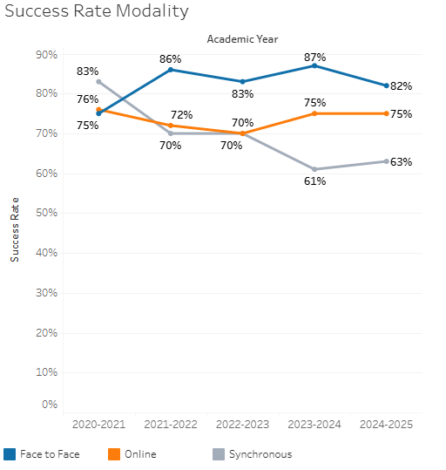

Online course success is consistently lower than face to face, but the gap has shrunk in recent years.

**Course Success Rates: Equity Gaps by modality**

|  |  |  |  |  |  |  |
| --- | --- | --- | --- | --- | --- | --- |
| **Student Sub-Population** | **Overall** | **Online Courses (ASYNC)** | **Face-to-Face Courses** | **Hybrid Courses** | **Synchronous Courses (SYNC)** | **Year of Equity Gap** |
| Hispanic |  |  | -3.7% |  |  | 2024-25 |
|  |  | -9.1% |  |  | 2022-23 |
| LGBTQ+ |  |  | -25.1% |  |  | 2023-24 |
| 18-22 (Age Group) |  |  | -10.1% |  |  | 2024-25 |
| Disability |  |  | -20.6% |  |  | 2024-25 |
| First Generation |  |  | -5.0% |  |  | 2024-25 |
|  |  | -5.6% |  |  | 2023-24 |
| Low Income |  |  | -8.7% |  |  | 2024-25 |
| Male |  | -12.5% |  |  |  | 2021-22 |
| Filipino |  | -17.2% |  |  |  | 2022-23 |
| Hispanic |  | -5.7% |  |  |  | 2023-24 |
|  | -4.9% |  |  |  | 2022-23 |
|  | -5.3% |  |  |  | 2020-21 |
| Pacific Islander |  | -50.3% |  |  |  | 2022-23 |
| Filipino-Female |  | -14.6% |  |  |  | 2022-23 |
| Hispanic-Female |  | -6.1% |  |  |  | 2023-24 |
|  | -5.5% |  |  |  | 2022-23 |
|  | -4.8% |  |  |  | 2020-21 |
| Pacific Islander-Female |  | -50.3% |  |  |  | 2022-23 |
| White-Non-Hispanic Male |  | -29.9% |  |  |  | 2021-22 |
| 18-22 (Age Group) |  | -10.9% |  |  |  | 2022-23 |
| 23-28 (Age Group) |  | -7.1% |  |  |  | 2023-22 |
|  | -6.3% |  |  |  | 2022-21 |
|  | -11.0% |  |  |  | 2020-21 |
| Low Income |  | -6.0% |  |  |  | 2022-23 |