**Economics**

**Comprehensive Program Review Questionnaire Data & Sources 2025-26**

**6: Enrollment Trends and Changes**

**Trends, significant changes, and any disproportionate enrollment impacts in course offerings**

Please consult the *Course Enrollment Report* posted for your discipline on the [PRIE website](https://canadacollege.edu/prie/data-dashboards.php).

**Any disproportionate enrollments of student subpopulations indicated in PRIE data**

|  |  |  |
| --- | --- | --- |
| **Student Sub-Population** | **Overall Course Enrollment Equity Gaps** | **Year of Gap** |
| Female | -19.4% | 2024-25 |
| -21.5% | 2023-24 |
| -20.5% | 2022-23 |
| -19.6% | 2021-22 |
| -18.7% | 2020-21 |
| Low Income | -5.7% | 2023-24 |

Cañada defines

**Trends in headcount, FTES, and load**

Enrollments have largely recovered after a severe drop in 2021-2022. As enrollments appear to be stabilizing, section counts can be fine-tuned.

### 7A. Current Retention and Success Data

Describe the retention and student success rates in your courses and any disproportionate enrollment impacts using the data provided by PRIE.

**Overall Success and Withdraw Rates (retention rates are the inverse of withdraw rates):**

Overall, success rates remain stable, though below the college wide average.

**Course Success Rates: Equity Gaps**

|  |  |  |
| --- | --- | --- |
| **Student Sub-Population** | **Overall Course Success Rates Equity Gaps** | **Year of Gap** |
| Filipino | -35.0% | 2021-22 |
| Hispanic | -13.1% | 2024-25 |
| -7.6% | 2023-24 |
| -8.4% | 2020-21 |
| Hispanic Female | -16.0% | 2022-23 |
| -16.7% | 2020-21 |
| Hispanic-Male | -16.4% | 2024-25 |
| First Generation | -12.9% | 2024-25 |
| -10.9% | 2023-24 |
| -13.2% | 2022-23 |
| -9.8% | 2020-21 |
| Low Income | -14.5% | 2024-25 |
| -16.6% | 2023-24 |
| Online | -10.5% | 2020-21 |

**Course Retention Rates: Equity Gaps**

|  |  |  |
| --- | --- | --- |
| **Student Sub-Population** | **Overall Course Withdraw Rates Equity Gaps** | **Year of Gap** |
| First Generation | 6.7% | 2020-21 |
| Online | 8.6% | 2020-21 |

Please check the [Equity & Disproportionate Impact Dashboard](https://canadacollege.edu/prie/dashboards/disproportionate-impact.php) on the PRIE website to look for equity gaps by specific course.

### 7B. Online Success

The college has a goal of improving success in online courses. Using the data provided by PRIE, what significant gaps do you see in success between different course modalities: asynchronous, synchronous, hybrid, and face-to-face courses? Analyze any disproportionate online course retention and success rates by modality.

Please consult the *Course Enrollment Report* posted for your discipline on the [PRIE website](https://canadacollege.edu/prie/data-dashboards.php) to review student success at the course level. For the discipline as a whole, the course success rates by modality are:

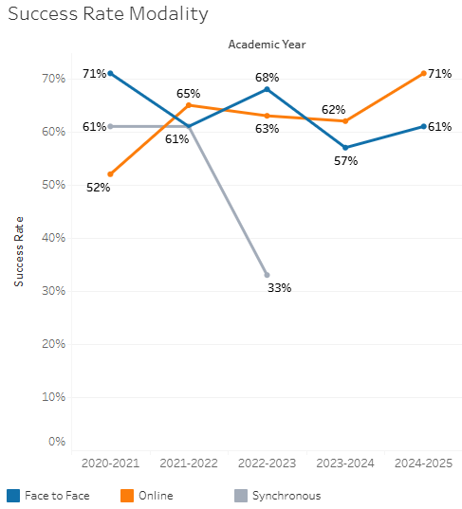

Online and face to face success rates are generally similar, though there was an uptick in online success in the 2024-2025 academic year.

**Course Success Rates: Equity Gaps by modality**

|  |  |  |  |  |  |  |
| --- | --- | --- | --- | --- | --- | --- |
| **Student Sub-Population** | **Overall** | **Online Courses (ASYNC)** | **Face-to-Face Courses** | **Hybrid Courses** | **Synchronous Courses (SYNC)** | **Year of Equity Gap** |
| Hispanic |  |  | -13.1% |  |  | 2024-25 |
| Hispanic-Female |  |  | -28.2% |  |  | 2022-23 |
| Hispanic-Male |  |  | -16.4% |  |  | 2024-25 |
| 23-28 (Age Group) |  |  | -16.2% |  |  | 2023-24 |
| First Generation |  |  | -16.2% |  |  | 2022-23 |
|  |  | -11.3% |  |  | 2023-24 |
|  |  | -12.6% |  |  | 2024-25 |
| Low Income |  |  | -12.5% |  |  | 2023-24 |
|  |  | -14.5% |  |  | 2024-25 |
| Female |  | -14.5% |  |  |  | 2022-23 |
| Hispanic |  | -14.2% |  |  |  | 2023-24 |
| 29-39 (Age Group) |  | -29.0% |  |  |  | 2021-22 |
| 40-49 (Age Group) |  | -29.5% |  |  |  | 2023-24 |
| First Generation |  | -10.9% |  |  |  | 2023-24 |
|  | -16.6% |  |  |  | 2020-21 |
| Low Income |  | -23.6% |  |  |  | 2023-24 |
| Hispanic |  |  |  |  | -12.1% | 2020-21 |
| Hispanic-Female |  |  |  |  | -28.1% | 2020-21 |