**Cooperative Education**

**Comprehensive Program Review Questionnaire Data & Sources 2025-26**

**6: Enrollment Trends and Changes**

**Trends, significant changes, and any disproportionate enrollment impacts in course offerings**

Please consult the *Course Enrollment Report* posted for your discipline on the [PRIE website](https://canadacollege.edu/prie/data-dashboards.php).

**Any disproportionate enrollments of student subpopulations indicated in PRIE data**

|  |  |  |
| --- | --- | --- |
| **Student Sub-Population** | **Overall Course Enrollment Equity Gaps** | **Year of Gap** |
| Low Income | -24.1% | 2022-23 |
| -15.6% | 2021-22 |
| -29.2% | 2020-21 |

Cooperative Education has seen disproportionately fewer enrollments from low income students between 2020 and 2023 school years.

**Trends in headcount, FTES, and load**

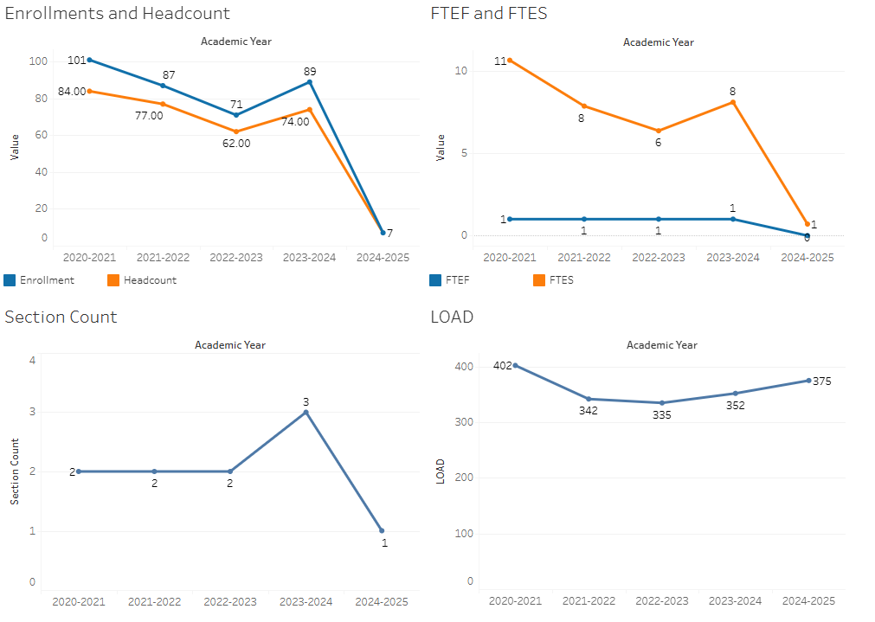

There was a precipitous drop in enrollments in 2024-2025, though prior to that most metrics were relatively stable.

### 7A. Current Retention and Success Data

Describe the retention and student success rates in your courses and any disproportionate enrollment impacts using the data provided by PRIE.

**Overall Success and Withdraw Rates (retention rates are the inverse of withdraw rates):**

In 2022-2023 and 2023-2024 success rates dropped dramatically, but recovered in 2024-2025. Withdraw rates have dropped dramatically over this time period.

**Course Success Rates: Equity Gaps**

|  |  |  |  |  |  |  |
| --- | --- | --- | --- | --- | --- | --- |
| **Student Sub-Population** | **Overall** | **Online Courses (ASYNC)** | **Face-to-Face Courses** | **Hybrid Courses** | **Synchronous Courses (SYNC)** | **Year of Equity Gap** |
| Male |  |  | -15.9% |  |  | 2023-24 |
|  |  | -24.1% |  |  | 2020-21 |
| Hispanic Male |  |  | -28.9% |  |  | 2023-24 |
|  |  | -32.7% |  |  | 2022-23 |

**Course Retention Rates: Equity Gaps**

There are no equity gaps in retentions rates in Cooperative Education.

Please check the [Equity & Disproportionate Impact Dashboard](https://canadacollege.edu/prie/dashboards/disproportionate-impact.php) on the PRIE website to look for equity gaps by specific course.

### 7B. Online Success

The college has a goal of improving success in online courses. Using the data provided by PRIE, what significant gaps do you see in success between different course modalities: asynchronous, synchronous, hybrid, and face-to-face courses? Analyze any disproportionate online course retention and success rates by modality.

Please consult the *Course Enrollment Report* posted for your discipline on the [PRIE website](https://canadacollege.edu/prie/data-dashboards.php) to review student success at the course level. For the discipline as a whole, the course success rates by modality are:

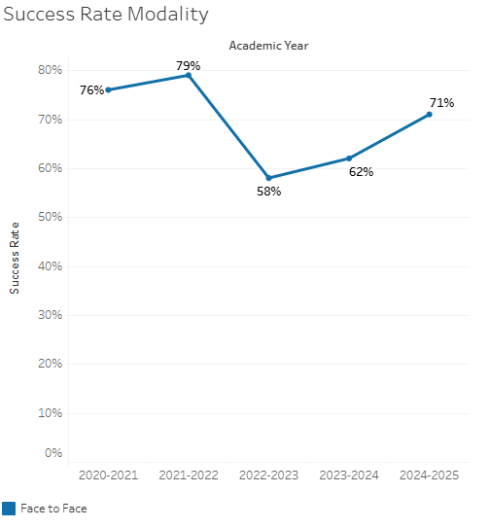

Only face to face sections have been offered.