**Computer Science**

**Comprehensive Program Review Questionnaire Data & Sources 2025-26**

**6: Enrollment Trends and Changes**

**Trends, significant changes, and any disproportionate enrollment impacts in course offerings**

Please consult the *Course Enrollment Report* posted for your discipline on the [PRIE website](https://canadacollege.edu/prie/data-dashboards.php).

**Any disproportionate enrollments of student subpopulations indicated in PRIE data**

|  |  |  |
| --- | --- | --- |
| **Student Sub-Population** | **Overall Course Enrollment Equity Gaps** | **Year of Gap** |
| Female | -29.9% | 2024-25 |
| -32.9% | 2023-24 |
| -32.8% | 2022-23 |
| -29.7% | 2021-22 |
| -33.2% | 2020-21 |
| Hispanic-Female | -16.9% | 2020-21 |
| First Generation | -9.7% | 2020-21 |

Computer Science has seen persistent gaps in Female student enrollment.

**Trends in headcount, FTES, and load**

After a decline in enrollments in 2021-2022 enrollment has slowly increased over the next three years.

### 7A. Current Retention and Success Data

Describe the retention and student success rates in your courses and any disproportionate enrollment impacts using the data provided by PRIE.

**Overall Success and Withdraw Rates (retention rates are the inverse of withdraw rates):**

Overall success rates have improved in recent years, though they remain below the college average. Withdraws are also on the rise and above the college average.

**Course Success Rates: Equity Gaps**

|  |  |  |
| --- | --- | --- |
| **Student Sub-Population** | **Overall Course Success Rates Equity Gaps** | **Year of Gap** |
| Black-Non-Hispanic | -23.7% | 2022-23 |
| Filipino | -20.9% | 2022-23 |
| Hispanic | -7.8% | 2024-25 |
| -12.4% | 2023-24 |
| -8.9% | 2022-23 |
| -9.3% | 2021-22 |
| -16.6% | 2020-21 |
| Filipino-Male | -33.0% | 2022-23 |
| Filipino-Female | -25.9% | 2022-23 |
| 19.6% | 2020-21 |
| Hispanic-Male | -10.7% | 2024-25 |
| -13.8% | 2023-24 |
| -14.2% | 2024-25 |
| 23-28 (Age Group) | -12.2% | 2023-24 |
| -14.2% | 2022-23 |
| -13.8% | 2021-22 |
| 29-39 (Age Group) | -12.7% | 2024-25 |
| -12.2% | 2023-24 |
| -11.6 | 2020-21 |
| First Generation | -8.6% | 2024-25 |
| -8.8% | 2022-23 |
| -9.5% | 2021-22 |
| -11.1% | 2020-21 |
| Veteran | -41.4% | 2024-25 |

**Course Retention Rates: Equity Gaps**

|  |  |  |
| --- | --- | --- |
| **Student Sub-Population** | **Overall Course Withdraw Rates Equity Gaps** | **Year of Gap** |
| Hispanic | 12.1% | 2020-21 |
| Hispanic-Female | 20.1% | 2020-21 |
| Hispanic-Male | 8.6% | 2024-25 |
| 9.6% | 2020-21 |
| 23-26 (Age Group) | 11.8% | 2022-23 |
| 50-59 (Age Group) | 29.7% | 2023-24 |
| First Generation | 7.9% | 2024-25 |
| Veteran | 38.4% | 2024-25 |

Please check the [Equity & Disproportionate Impact Dashboard](https://canadacollege.edu/prie/dashboards/disproportionate-impact.php) on the PRIE website to look for equity gaps by specific course.

### 7B. Online Success

The college has a goal of improving success in online courses. Using the data provided by PRIE, what significant gaps do you see in success between different course modalities: asynchronous, synchronous, hybrid, and face-to-face courses? Analyze any disproportionate online course retention and success rates by modality.

Please consult the *Course Enrollment Report* posted for your discipline on the [PRIE website](https://canadacollege.edu/prie/data-dashboards.php) to review student success at the course level. For the discipline as a whole, the course success rates by modality are:

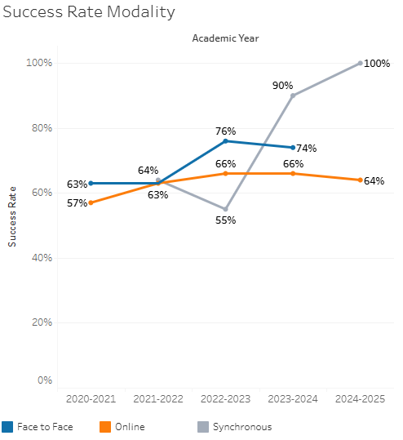

Online success rates are not quite reaching the level of the face to face courses, when face to face is offered.

**Course Success Rates: Equity Gaps by modality**

|  |  |  |  |  |  |  |
| --- | --- | --- | --- | --- | --- | --- |
| **Student Sub-Population** | **Overall** | **Online Courses (ASYNC)** | **Face-to-Face Courses** | **Hybrid Courses** | **Synchronous Courses (SYNC)** | **Year of Equity Gap** |
| Female |  |  | 22.2% |  |  | 2020-21 |
| Hispanic -Male |  |  | -10.7% |  |  | 2024-25 |
| 23-28 (Age Group) |  |  | -16.9% |  |  | 2023-24 |
| 29-39 (Age Group) |  |  | -12.7% |  |  | 2024-25 |
| First Generation |  |  | -8.6% |  |  | 2024-25 |
| Veteran |  |  | -41.4% |  |  | 2024-25 |
| Hispanic |  | -16.9% |  |  |  | 2023-24 |
|  | -11.3% |  |  |  | 2022-23 |
|  | -9.8% |  |  |  | 2021-22 |
|  | -17.2% |  |  |  | 2020-21 |
| Hispanic - Female |  | -23.0% |  |  |  | 2022-23 |
|  | -21.5% |  |  |  | 2020-21 |
| Hispanic-Male |  | -20.1% |  |  |  | 2023-24 |
|  | -13.9% |  |  |  | 2020-21 |
| 23-28 (Age Group) |  | -14.0% |  |  |  | 2022-23 |
|  | -16.8% |  |  |  | 2021-22 |
| 29-39 (Age Group) |  | -18.4% |  |  |  | 2023-24 |
|  | -13.3% |  |  |  | 2020-21 |
| Disability |  | -29.4% |  |  |  | 2023-24 |
| First Generation |  | -10.9% |  |  |  | 2023-24 |
|  | -11.9% |  |  |  | 2022-23 |
|  | -10.8% |  |  |  | 2021-22 |
|  | -11.9% |  |  |  | 2020-21 |
| Low Income |  | -10.0% |  |  |  | 2021-22 |