**Career Courses**

**Comprehensive Program Review Questionnaire Data & Sources 2025-26**

**6: Enrollment Trends and Changes**

**Trends, significant changes, and any disproportionate enrollment impacts in course offerings**

Please consult the *Course Enrollment Report* posted for your discipline on the [PRIE website](https://canadacollege.edu/prie/data-dashboards.php).

**Any disproportionate enrollments of student subpopulations indicated in PRIE data**

|  |  |  |
| --- | --- | --- |
| **Student Sub-Population** | **Overall Course Enrollment Equity Gaps** | **Year of Gap** |
| Disability | -6.2% | 2024-25 |
| -6.0% | 2023-24 |

Disabled students have seen fewer enrollments for the past two years.

**Trends in headcount, FTES, and load**

Enrollment is generally stable, fluctuating between the high 400’s and mid 500’s in a given year. After a dramatic increase in sections offered for 2021-2022, sections have been stable. However the recent downturn in enrollments may not justify the current number of sections based on the drop in Load.

### 7A. Current Retention and Success Data

Describe the retention and student success rates in your courses and any disproportionate enrollment impacts using the data provided by PRIE.

**Overall Success and Withdraw Rates (retention rates are the inverse of withdraw rates):**

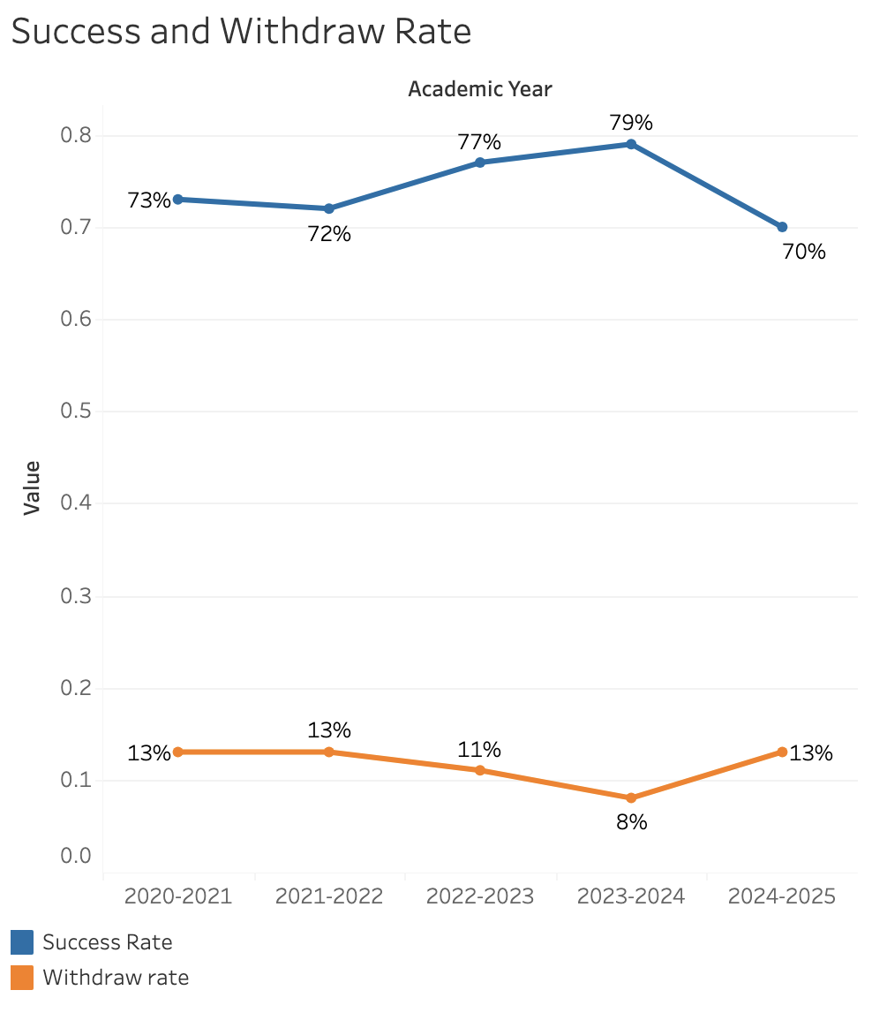

Success and withdraw rates remain stable around the college averages.

**Course Success Rates: Equity Gaps**

|  |  |  |
| --- | --- | --- |
| **Student Sub-Population** | **Overall Course Success Rates Equity Gaps** | **Year of Gap** |
| Black-non-Hispanic | -20.1% | 2023-24 |
| Hispanic - Male | -8.2% | 2022-23 |
| -11.4% | 2021-22 |
| Face to Face (Modality) | -8.8% | 2020-21 |

**Course Retention Rates: Equity Gaps**

|  |  |  |
| --- | --- | --- |
| **Student Sub-Population** | **Overall Course Withdraw Rates Equity Gaps** | **Year of Gap** |
| 40-49 (Age Group) | 22.4% | 2024-25 |
| Hybrid (Modality) | 11.9% | 2024-25 |
| 18.3% | 2022-23 |
| 37.6% | 2021-22 |

Please check the [Equity & Disproportionate Impact Dashboard](https://canadacollege.edu/prie/dashboards/disproportionate-impact.php) on the PRIE website to look for equity gaps by specific course.

### 7B. Online Success

The college has a goal of improving success in online courses. Using the data provided by PRIE, what significant gaps do you see in success between different course modalities: asynchronous, synchronous, hybrid, and face-to-face courses? Analyze any disproportionate online course retention and success rates by modality.

Please consult the *Course Enrollment Report* posted for your discipline on the [PRIE website](https://canadacollege.edu/prie/data-dashboards.php) to review student success at the course level. For the discipline as a whole, the course success rates by modality are:

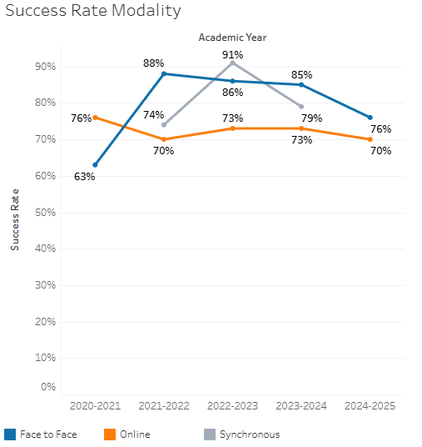

Online courses typically underperformed face to face courses, but were at satisfactory levels overall.

**Course Success Rates: Equity Gaps by modality**

As all of the program’s courses were offered in a face-to-face modality in 2024-25, the equity gap identified here is the same as that identified in the overall success rate calculation.

|  |  |  |  |  |  |  |
| --- | --- | --- | --- | --- | --- | --- |
| **Student Sub-Population** | **Overall** | **Online Courses (ASYNC)** | **Face-to-Face Courses** | **Hybrid Courses** | **Synchronous Courses (SYNC)** | **Year of Equity Gap** |
| 23-28 (Age Group) |  |  | -25.7% |  |  | 2022-23 |
| 29-39 (Age Group) |  |  | -30.7% |  |  | 2022-23 |
| Hispanic |  |  |  | -18.4% |  | 2022-23 |
| Hispanic-Female |  |  |  | -25.6% |  | 2022-23 |
| Male |  | -13.1% |  |  |  | 2022-23 |
| Hispanic-Male |  | -22.0% |  |  |  | 2023-24 |