EQUITY, SOCIAL JUSTICE, AND COMPLETION
A STRATEGIC PLAN OF THE SMCCCD

EXECUTIVE SUMMARY
The San Mateo County Community College District (SMCCCD), and its three colleges, Cañada College in Redwood City, College of San Mateo in San Mateo, and Skyline College in San Bruno provide access to higher education for the students and communities of San Mateo County, the Silicon Valley, the greater Bay Area, and beyond. The District is committed to the principles of social justice and equity with an intentional focus on ensuring students complete their educational goals, from certification in career education to associate degrees and transfer to four- year universities… on-time! This focus on completion comes from a recognition that the most important factor that contributes to upward social and economic mobility is the attainment of higher education.

This District Strategic Plan is organized around four Strategic Goals and attending Districtwide Initiatives that provide a blueprint and focus for the work of the District and its Colleges.

STRATEGIC GOAL 1: DEVELOP AND STRENGTHEN EDUCATIONAL OFFERINGS, INTERVENTIONS, AND SUPPORT PROGRAMS THAT INCREASE STUDENT ACCESS, SUCCESS, AND COMPLETION.

STRATEGIC GOAL 2: ESTABLISH AND EXPAND RELATIONSHIPS WITH SCHOOL DISTRICTS, 4-YEAR
COLLEGE PARTNERS, COMMUNITY-BASED ORGANIZATIONS AND EMPLOYERS TO INCREASE HIGHER EDUCATION ATTAINMENT AND ECONOMIC MOBILITY IN SAN MATEO COUNTY.

STRATEGIC GOAL 3: PROMOTE INNOVATION AND EXCELLENCE IN INSTRUCTION TO SUPPORT STUDENT LEARNING AND SUCCESS.

STRATEGIC GOAL 4: ENSURE NECESSARY RESOURCES ARE AVAILABLE TO IMPLEMENT THIS STRATEGIC PLAN THROUGH SOUND FISCAL PLANNING AND MANAGEMENT OF ALLOCATIONS. PROTECT
COMMUNITY-SUPPORTED STATUS, AND UNDERTAKE THE DEVELOPMENT OF ALTERNATIVE SOURCES OF REVENUE THAT SUPPORT EDUCATIONAL PROGRAMS BEYOND WHAT IS AVAILABLE FROM COMMUNITY AND STATE ALLOCATIONS.

Taken together, these Strategic Goals are intended to continue the work of the SMCCCD to be an innovative, effective, and equity focused institution of higher education. The District Strategic Plan will serve as a guide over the next five years as the District invests in the strategic development and allocation of resources in support of these goals.

A FOCUS ON EQUITY AND SOCIAL JUSTICE
The previous iteration of the District Strategic Plan also included a focus on equity and social justice, which is carried through to this update. Social justice is not a passive statement, but instead requires focused action to dismantle systemic barriers that have prevented, in particular, low-income communities and communities of color from accessing and succeeding in higher education. A true commitment to

equity means being willing to invest more in communities and students that have been historically marginalized and have experienced disproportionately negative impacts from systemic racism and other institutionalized systems of oppression. Through the implementation of the Strategic Plan, the SMCCCD demonstrates its commitment to dismantling barriers to access, success, and completion of higher education.

FREE COMMUNITY COLLEGE IN THE SMCCCD
The environmental scan data presented later in this Strategic Plan highlights the essential role that the SMCCCD plays by providing THE point of access to public higher education in San Mateo County. In support of the focus on Equity, Social Justice, and Completion, a strategic initiative of the District over the life of this Strategic Plan is to make Free Community College in the SMCCCD a reality. Some of the key components that combine to make Free Community College a possibility for San Mateo County that are also captured in the Goals and Districtwide Strategies of this plan include the accelerated expansion of Dual Enrollment, the Promise Scholars Program (PSP), and Open Educational Resources (OER) for Zero Textbook Cost (ZTC) degree programs, all within a Guided Pathways framework.

RESOURCE DEVELOPMENT AND STEWARDSHIP
San Mateo County is one of the wealthiest, and also one of the most expensive, counties in the state of California, reflected in a median home price of more than $1.8 million as of March 2021. This wealth is in large part generated by the robust economy of the Silicon Valley and greater Bay Area, from San Francisco through San Mateo and down to Santa Clara County. The SMCCCD is fortunate to benefit from this economy that causes it to be one of the handful of community supported (i.e., Basic Aid) districts in the California Community College System. As outlined in Strategic Goal 4, maintenance of this status is essential to the long-term stability of the District. However, just as important, is the strategic development of additional resources and the responsible stewardship of existing ones. The strategic development of partnerships with governmental agencies such as the San Mateo County Board of Supervisors and local city councils, expansion of philanthropic efforts through the San Mateo County Community College Foundation (SMCCCF), and the development of alternative revenue sources combined with legislative and policy changes, will all be necessary to implement the Districtwide Strategies outlined in this Strategic Plan. Responsible and effective stewardship of these resources, and the willingness to prioritize their allocation and expenditure, will be needed to fully realize the goals of the District.

THE COVID-19 PANDEMIC
It is important to note that during the update of the District Strategic Plan, the COVID-19 global pandemic disrupted not only the timeline for the revision of this plan, but the entire District, its colleges, and the lives of every student and employee. Emerging from this pandemic has led to a reexamination of what the implementation of the District Strategic Plan can look like, from what types of professional development are needed, to what does innovation in teaching and learning look like, and even to what does sustainability mean in the face of such a disruption?

THE DISTRICT STRATEGIC PLAN UPDATE PROCESS
The District Strategic Plan (DSP) follows a regular cycle of review and update as shown below. Beginning in the 2019-20 academic year, a District Strategic Plan Steering Committee (DSPSC) was formed in order to lead the update process. Originally scheduled to be completed by the beginning of the 2020-21 academic year, the COVID-19 global pandemic forced the timeline to be extended.

District Strategic Plan Review Cycle
 | 2015/16 | 2016/17 | 2017/18 | 2018/19 | 2019/20 | 2020/21 | 2021/22
SMCCCD | Plan | Implement | Implement | Implement | Plan | Plan | Comprehensive
Strategic | Completed | (Year 2) | (Year 3) | (Year 4) | Update | Update | Plan Update
Plan  2015-  2020 | (Year 1) | —  Review | —  Mid-Term | —  Review | (Year 5)  — | Continued  (Year 6 ) | Completed  (Year 1)
 |  | — | Review | — | Review
 |  | Assess | — | Assess | —
 |  |  | Assess | — | Assess
Table 1

STEERING COMMITTEE MEMBERSHIP
The District Strategic Plan Steering Committee (DSPSC) was formed to guide the process for update and revision of the District Strategic Plan. The DSPSC included representation from the Board of Trustees and appointees from each of the Colleges. The Deans of PRIE were key members that were included to promote alignment between the local college Strategic Plans and Educational Master Plans and the revised District Strategic Plan. The committee membership was as follows:

Name | Title
Aaron McVean (Chair) | Vice Chancellor, Educational Services and Planning
Dave Mandelkern Tom Nuris | Trustees
Jamillah Moore | President (Cañada College)
Jeramy Wallace | District Academic Senate President (CSM)
Golda Margate | CSEA Representative (Skyline College)
Jordan Chavez (2019-20)  Jade Shonette (2020-21) | Student Trustees

Karen Engel | Dean of PRIE (Cañada College)
Hilary Goodkind | Dean of PRIE (CSM)
Ingrid Vargas | Dean of PRIE (Skyline College)
Table 2

Over the course of the update period, the DSPSC met regularly to review relevant information that informed the current Strategic Goals and Districtwide Strategies. Once an updated set of Goals and Districtwide Strategies were developed, input was solicited from Academic and Classified Senates, as well as governance committees involved in local strategic planning and resource allocation at each of the three Colleges. From that input, additional changes were made to the final set of goals and strategies contained within this Strategic Plan.

Date | Activity | Location
 | 2019
October 15th | First meeting of the DSP Steering Committee | District
November 13th | DSPSC #2: District Mission and College Strategic Plans | District
December 9th | DSPSC #3: Environmental Scan and SWOT Analysis | District
 | 2020
January 28th | DSPSC #4: Strategic Goals and Districtwide Strategies Review | CSM
February 18th | DSPSC #4.5: Strategic Goals and Districtwide Strategies Review cont. | District
 | COVID-19
October 7th | DSPSC #5: District Strategic Plan Metrics Review | Zoom
October 14th | Board Study Session: District Strategic Plan Progress | Zoom
November | College Planning Council Presentations | Zoom
 | 2021
January - March | Academic Senate Presentations Classified Senate Presentations | Zoom
March 3rd | DSPSC #6: Final Review | Zoom
June 9th | Board Presentation | Zoom
July 23rd | Board Adoption | TBD
Table 3

STRATEGIC GOALS AND DISTRICTWIDE STRATEGIES
The following set of Strategic Goals and Districtwide Strategies was developed following the process outlined above. The first section of the District Strategic Plan focuses on Districtwide Strategies that cut across all Strategic Goals and provide a timely focus for District and College efforts. Reflecting emerging issues and priorities across the District, the following set of Districtwide Strategies were identified for the 2021-2026 District Strategic Plan.

Districtwide Strategies
- Continually explore and implement interventions that benefit all students and help them to achieve their specific educational goals.
- Measure the impact of new and existing Districtwide efforts to increase access, success, and completion while reducing equity gaps for disproportionately impacted student groups.
- Support the Colleges by providing resources for innovative teaching and learning that is designed to increase student success.
- Fully implement and optimize the Salesforce CRM and associated products in order to integrate technology systems for better communication to students, staff, and faculty.
- Support the implementation of the District’s sustainability initiatives to address its program goals as part of the District’s response to climate change.
- Support the work of the District Anti-Racism Council to radically reimagine how we commit
to anti-racism and how we can transform the educational experiences for all students, especially hyper-marginalized students.
- Expand the Promise Scholars Program to serve all students who are interested and qualify for this completion focused program.
- Increase enrollment of San Mateo County residents through coordinated efforts, including the implementation of the Free Community College initiative.
- Communicate information to the District and the public regarding enrollment and student success metrics in an accurate and transparent manner.

Strategic Goal #1 and the accompanying Districtwide Strategies focus on increasing student access, success, and completion. Although the District Strategic Plan is intended to set the strategic direction for the District for the next five years, it is impossible to not consider the current COVID-19 pandemic when reviewing the revised strategies below. The importance of continuing to develop and implement on-line support services and to provide professional development, for example, are both made more apparent in the current operating environment.

Strategic Goal #1
DEVELOP AND STRENGTHEN EDUCATIONAL OFFERINGS, INTERVENTIONS, AND SUPPORT PROGRAMS
THAT INCREASE STUDENT ACCESS, SUCCESS, AND COMPLETION
Districtwide Strategies

- Encourage the development of methodologies that increase the number of students who utilize support services that enable them to stay in school and succeed.
- Create on-line and web-based options for students to access advising and counseling services, interactive scheduling, and educational plans.
- Strengthen the alignment of career education programs with projected workforce needs.
- Provide professional development resources for faculty, staff, and administration to ensure program effectiveness and excellence in teaching and learning.
- Establish a dedicated budget for new program development in order to increase access, success, and completion, and eliminate equity gaps.
- Review student placement processes and incorporate multiple measures of assessing the preparedness of new students for college level work with the goal of decreasing time needed to achieve one’s goal.
- Use emerging practices to accelerate student progression of ESL sequences into transfer-level courses.
- Evaluate the implementation of revised placement processes for English, and math, ensuring students are successful in transfer-level coursework.
- Systematically evaluate the effectiveness of academic and student support programs in all areas and develop, strengthen, or eliminate programs to support student success.

Strategic Goal #2 and the accompanying Districtwide Strategies focuses on the continuum of strategic partnerships and pathways from feeder high schools through the District and onto four-year universities. The continued focus of the District and its colleges to implement Guided Pathways and increase Dual Enrollment opportunities is part of the intentional work to increase access to higher education for historically underserved communities and to increase their successful completion and transfer.

Strategic Goal #2
ESTABLISH AND EXPAND RELATIONSHIPS WITH SCHOOL DISTRICTS, 4-YEAR COLLEGE PARTNERS, COMMUNITY-BASED ORGANIZATIONS AND EMPLOYERS TO INCREASE HIGHER EDUCATION ATTAINMENT
AND ECONOMIC MOBILITY IN SAN MATEO COUNTY
Districtwide Strategies
- Increase collaboration, interaction, and alignment with high school partners to increase successful transitions from local high schools to ensure higher education is accessible for all San Mateo high school students.
- Increase outreach and recruitment efforts with San Mateo County high school partners, students, and parents to make the SMCCCD the “college of choice” for high school graduates.
- Continue to expand and support Middle College and Early College opportunities.
- Expand dual enrollment opportunities and make processes more efficient and accessible for secondary schools and their students.

- Create faculty-to-faculty collaboration as part of high school partnerships for Dual Enrollment and Guided Pathways to better align curricula and to create seamless transitions from
secondary to postsecondary education.
- Work with feeder high schools to streamline processes for sharing transcript information to facilitate placement of more students into the appropriate transfer-level credit courses.
- Create an active campus environment that creates a sense of belonging and engagement for students.
- Increase and articulate Guided Pathways, programs, and services to improve career development and job placement to help students meet their stated goals.
- Increase/expand partnerships with four-year colleges and universities to increase seamless curriculum alignment and direct program transfer, as well as develop opportunities to complete four-year degrees in San Mateo County.
- Share data and information, especially about student success, with community partners.

Strategic Goal #3 and the accompanying Districtwide Strategies focuses on the development of innovation in teaching and learning, including the use of emerging technologies. The need for this focus has again been highlighted by the COVID-19 pandemic, which has immediately shifted the operating environment of the District and has changed the future of higher education in ways that are not yet fully understood. Regardless, the continued investment in innovation is essential for the District to remain relevant and competitive for future generations of students.

Strategic Goal #3
PROMOTE INNOVATION AND EXCELLENCE IN INSTRUCTION TO SUPPORT STUDENT LEARNING AND
SUCCESS
Districtwide Strategies
- Expand program delivery options, including accelerated completion options, for all students including online students, e.g., College for Working Adults; short-term classes; intersession
classes; cohort classes; and continuing, corporate and community education.
- Promote strategic development of online education to increase the development and delivery of quality, fully online certificate and degree programs.
- Ensure instruction is delivered in multiple modalities, including in-person, hybrid, and hyflex, to increase access to higher education and meet the needs of different student populations.
- Support professional development for faculty and staff to incorporate advances in teaching, learning, and effective use of technology.
- Increase technology use in the classroom and develop the overall District technology infrastructure to support innovative practices in teaching and learning.
- Integrate technological systems to ensure a seamless and efficient experience for students, faculty, and staff.
- Ensure student and academic support services are accessible to all students in the online environment.

- Support innovation and excellence by increasing the availability of data and information to inform the effectiveness of programs and interventions designed to increase student success,
equity, and achievement.
- Foster an environment that continues to attract and retain highly qualified and dedicated faculty, staff, and administration that share the District’s values of equity and social justice.
- Accelerate the development and adoption of Open Educational Resources (OER) and expand Zero Textbook Cost (ZTC) course offerings for students across all modalities.

Finally, Strategic Goal #4 and the accompanying Districtwide Strategies focuses on the maintenance and development of resources to support the innovation, programs, and services identified in the previous strategic goals.

Strategic Goal #4
ENSURE NECESSARY RESOURCES ARE AVAILABLE TO IMPLEMENT THIS STRATEGIC PLAN THROUGH SOUND FISCAL PLANNING AND MANAGEMENT OF ALLOCATIONS AND PROTECTION OF COMMUNITY-
SUPPORTED STATUS.
Districtwide Strategies
- Protect and solidify District funding, predominately in the form of property taxes, through interaction and advocacy with key county and state legislators and the State Chancellor’s Office. To ensure this is achieved, build coalitions among other community-supported districts and
statewide associations.
- Ensure strong fiscal stewardship and the efficient utilization of taxpayer resources in order to accomplish the strategic goals of the District.
- Support actions across the District to provide alternative revenue sources to promote programs that increase student success, equity, and completion.
- Develop and support legislation and Board policies that allow for greater flexibility and control over the use of District resources.
- Expand the development, management, and grant funding strategy and infrastructure for the Districts and its Colleges.
- Increase philanthropic development efforts in order to provide resources that can be used to support programs and efforts that increase student success, equity, and completion.
- Develop Community, Continuing and Corporate Education (CCCE), as a net revenue generating program through increased lifelong learning and focus on not-for-credit professional certifications and customized workforce training for public and private-sector organizations,
without infringement on established credit-based academic programs.
- Increase credit-based enrollments through new credit/non-credit hybrid programming.
- Contribute to the economic development of San Mateo County through collaborative partnerships with industry and workforce/economic development agencies.
- Partner with local, regional, and state level governmental and other agencies in order to achieve the strategic goals of the District.

- Review allocations and evaluate the investment of resources in order to align resource allocation with District goals and Districtwide strategies that increase student success, equity,
and completion.

ENVIRONMENTAL SCAN DATA
Informing the update and revision of the current District Strategic Plan is a robust set of environmental scanning data that was reviewed and considered in detail by the DSPSC and shared with the broader District community during discussion of the updated goals and strategies. Data from both the external and internal environment was reviewed and analyzed. The data presented below represent the most relevant information for the planning context that informed the update and revision of this District Strategic Plan.

EXTERNAL CONTEXT
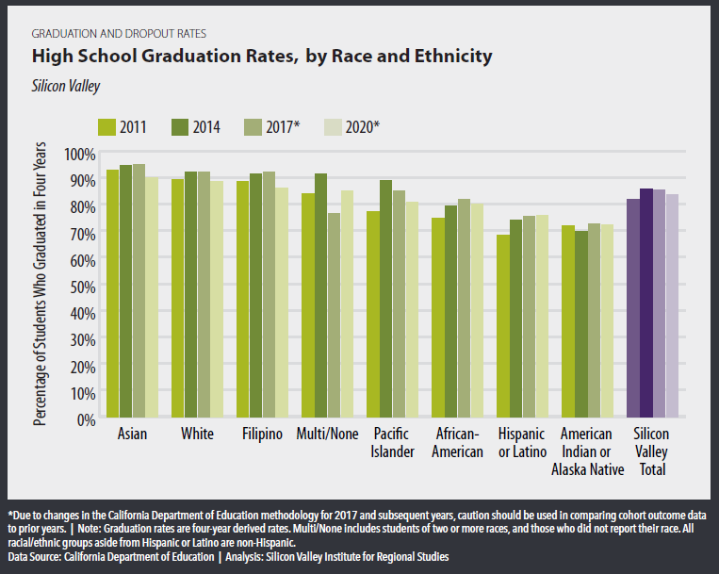
The relevant external context for the update and revision of the District Strategic Plan includes the broader trends in San Mateo County and the Silicon Valley, with particular focus on high schools and the economic conditions related to, and impacted by, higher education. Unless otherwise noted, environmental scanning data for the external context was pulled from the Silicon Valley Index 2021, an annual report published by Joint Venture Silicon Valley.

High school data included here highlight one of the major equity

Figure 1

issues that several of the Districtwide Strategies are intended to address. Beginning with high school graduation rates (Figure 1), though relatively high across all groups there are noted discrepancies based on the race and ethnicity of students. The largest equity gaps exist for Hispanic/Latinx, American Indian or Alaskan Native (AIAN), and African American students, when compared to White and Asian students. This

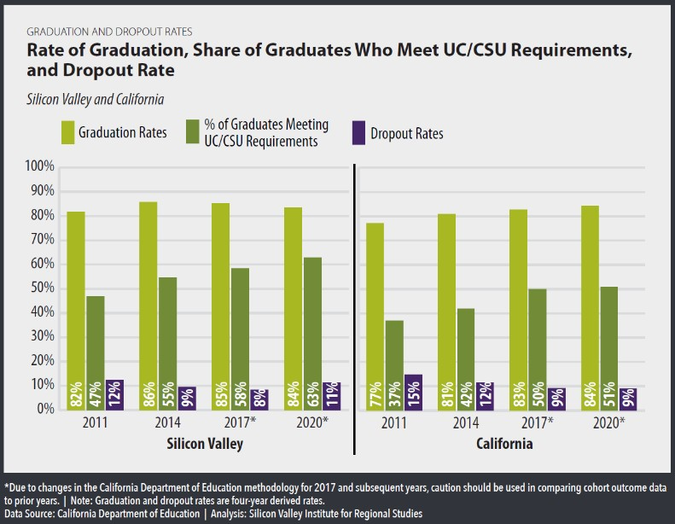
highlights a systemic issue that is resulting in institutions being less successful in serving these student populations. These data, when combined with data on the share of high school graduates who meet UC/CSU requirements (see Figures 2 and 3), also known as “a-g” requirements, reinforce the critical need to invest in strengthening and streamlining
pathways from local high schools to the Colleges of the SMCCCD. Again, while generally high when compared to the overall State rates, there are gross disparities based on the race and ethnicity of students with regard to the completion of UC/CSU requirements.

The lowest rates of completion of UC/CSU requirements are seen in the Hispanic/Latinx, Pacific Islander, African-American, and American Indian or Alaska Native student

Figure 2

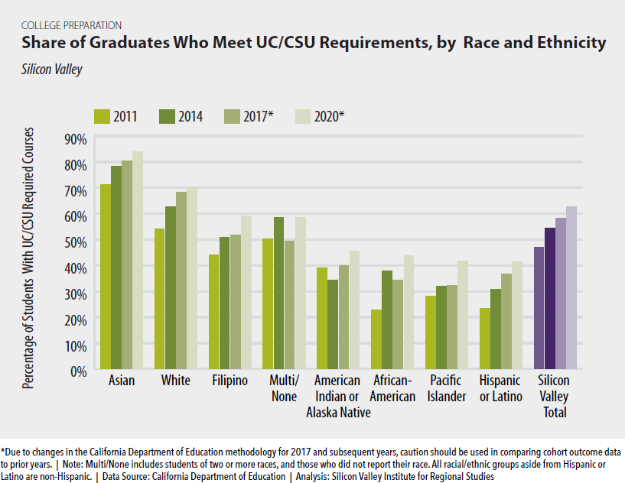
Figure 3

populations. Taken in totality, these three figures highlight a persistent systemic issue that this District Strategic Plan is focused on addressing. The expansion of Dual Enrollment, as part of Strategic Goal 2 and a key component of the Free Community College initiative is specifically intended to address this issue. If students do not complete the UC/CSU requirements in high school, the SMCCCD is likely the only point of access to higher education available. The other Districtwide Strategies under Goal 2 that identify engagement with high schools and streamlining of data and information sharing are all in recognition of the importance of increasing the successful transition of high school students, and specifically students of color, into higher education.

THE IMPORTANCE OF COMPLETION
Increasing access to higher education in the SMCCCD is only one component of the District Strategic Plan, but the overarching focus is on increasing completion of educational goals, and in particular completion of certificates, degrees, and eventual transfer to a four-year university. The next set of external environmental scanning data, taken together, highlight the importance of degree and transfer completion
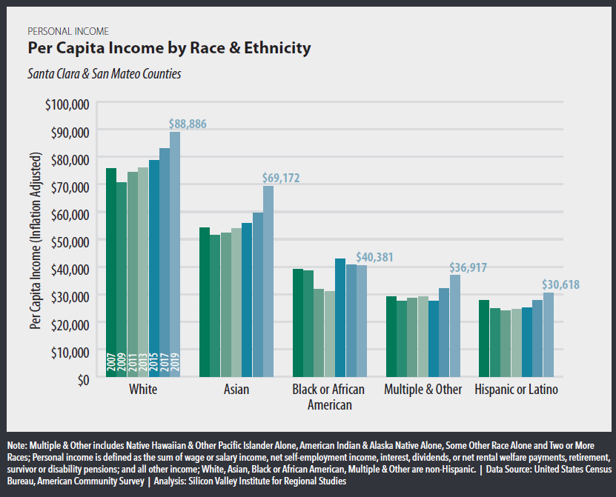
Figure 4

in particular for individuals in the Silicon Valley and San Mateo in order to gain access to the economies of the region. Beginning with Figure 4, there are wide disparities in per capita income between racial and ethnic groups in the Silicon Valley. African-American and Hispanic/Latinx communities earn substantially less than White and Asian communities. As shown in Figure 5 at right, these disparities have increased over the past decade, with communities of color not benefiting as much from the substantial growth in the overall incomes as a result of the growth in the economies of the Silicon Valley.

Although not the only reason for these disparities, a significant factor that prevents individuals from accessing the economy and reaching higher per capita income levels is educational attainment. As shown below, achieving a Bachelor’s Degree is essentially a minimum level of educational attainment in order to

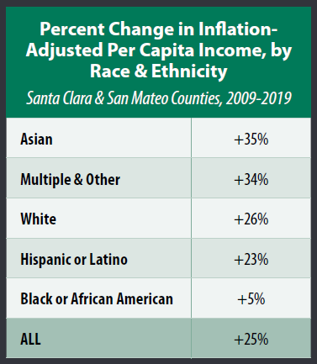

Figure 5

earn a median income level that is sustainable in the Silicon Valley. The Ratio presented also highlights that level of educational attainment has a greater impact on median income levels in the Silicon Valley, San Mateo, and San Francisco, than the state of California in general (see Figure 6).
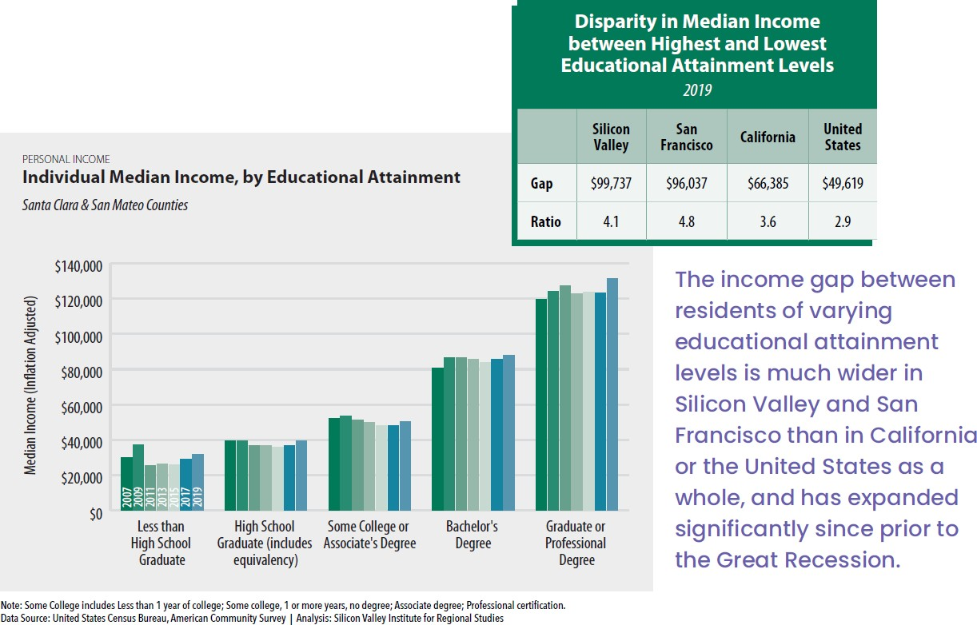

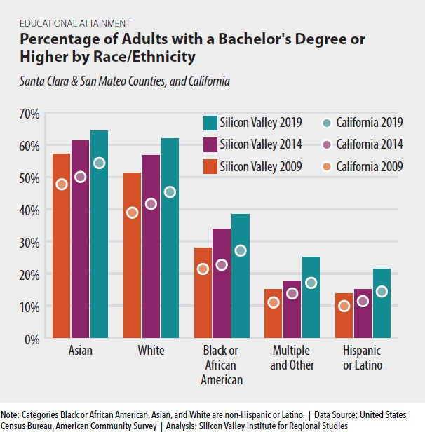
As suggested in the high school data presented earlier, the culmination of systemic barriers has led to disparities in educational attainment and therefore per capita and median income for communities of color. Bachelor’s Degree attainment, or higher, is lowest among Hispanic/Latinx communities, follow by those with Multiple racial identities, and the African American communities of the Silicon Valley (Figure 7). These factors directly result in far greater proportions of Hispanic/Latinx and African American Households living below the self- sufficiency standard for San
Mateo County (see Figure 8).
Figure 7
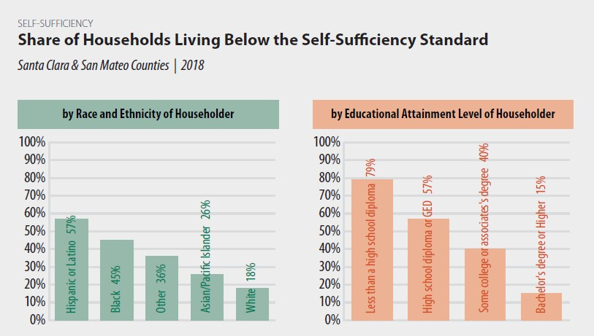

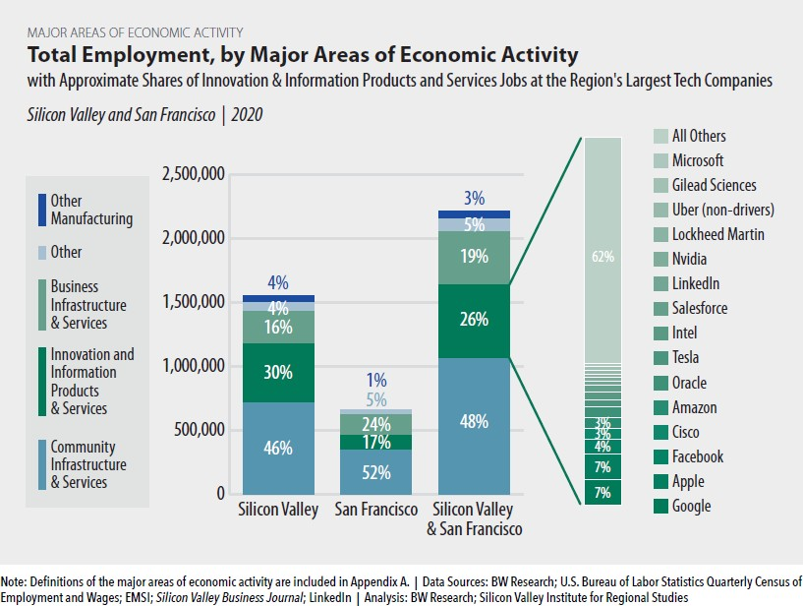
The set of environmental scanning data presented above highlights the need for educational attainment in order to access the economies of the Silicon Valley. Strategic Goals 2 and 3 both include Districtwide Strategies for more and better alignment with workforce needs and employment opportunities, whether through traditional credit-based programs or through the Districts Community, Continuing, and Corporate Education
(CCCE; CommEd).
Therefore, it was also worth examining areas of economic activity or employment sectors provide living, sustainable wages that allow individuals and households to achieve the self- sufficiency standard. The largest general employment sector for both San Mateo County and the Silicon Valley is Community

Infrastructure and Services, followed by
Figure 10

Innovation and Information Products and Services, with the latter area containing what is commonly referred to as the Tech Industry (see breakout in Figure 9). Within each area, however, there is a wide range of jobs that require various levels of training and education (i.e., Tiers), and as a result the median income varies within and across each area (see Figure 10). While the largest employment sector is in Community Infrastructure and Services, the proportion of those jobs that require

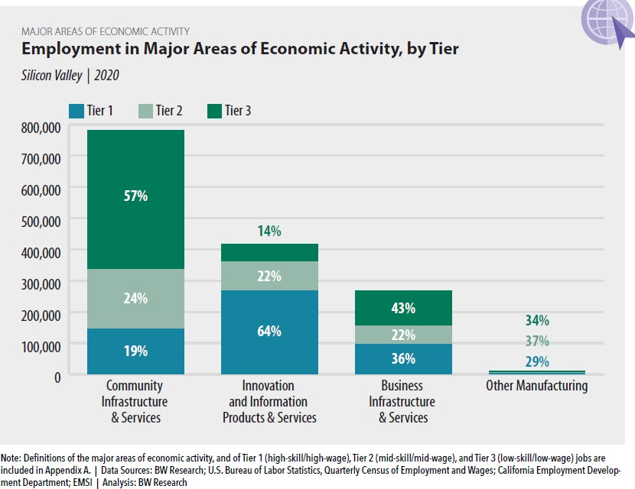
Figure 9

high-skilled workers with greater educational attainment is far less than what is available in the Innovation and Information Products and Services area (19% vs 64% of jobs). What this translates into is a focus on preparing the students served by the SMCCCD and its Colleges to access at least Tier 2, but ideally Tier 1 jobs, in order that they can achieve a median wage that provides for self-sufficiency in San Mateo County and the Silicon Valley (see Figure 11).
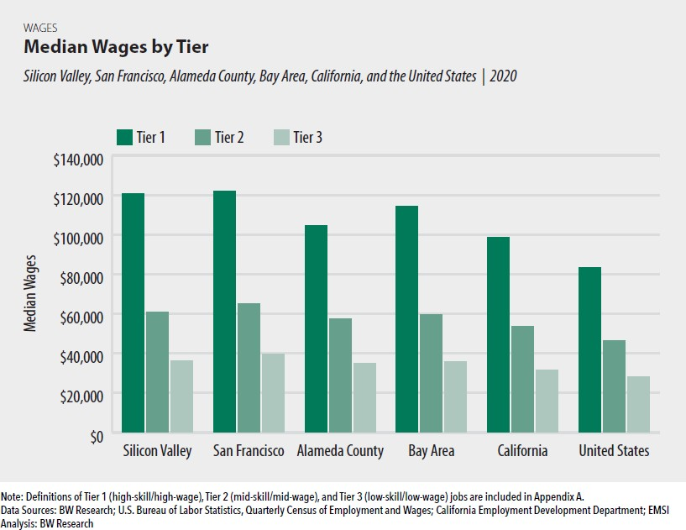

Figure 11

DISTRICT CONTEXT
As part of the process to update and revise this District Strategic Plan, environmental scan data from the internal District context was also reviewed and considered. The most prominent factor that was considered, and one that underlies the focus of the Strategic Goals, Districtwide Strategies, and Free Community College initiative, was the persistent decline in enrollment that the District has experienced over the past decade. As shown in Figure 12 below, the District has seen a decline of 23% in the number of unique students served each academic year. At the same time it has also experienced a decline of almost 28% of FTES, which means that students on average are also taking fewer units. While this decline was severely exacerbated by the COVID-19 global pandemic in the 2020-21 academic year, the overall trend is cause for concern.

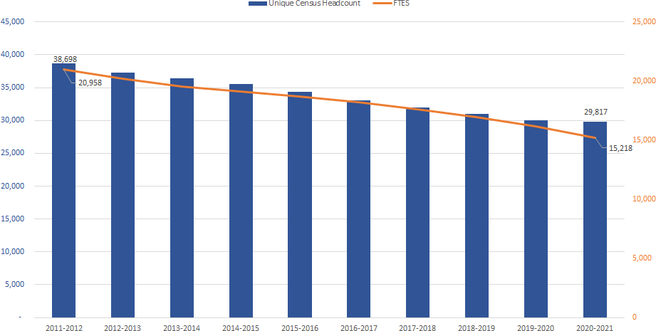

Figure 12

The only source of consistent growth in students and enrollment in the most recent academic years has been in concurrent and dual enrollment of high school students in the District (see Figure 13 below). As identified explicitly in Strategic Goal 2 and as a key component of the Free Community College initiative, the expansion of dual enrollment is a Districtwide Strategy and priority. Dual enrollment in particular is not only a promising source of new enrollment in the District, but as identified in the environmental scan data from the
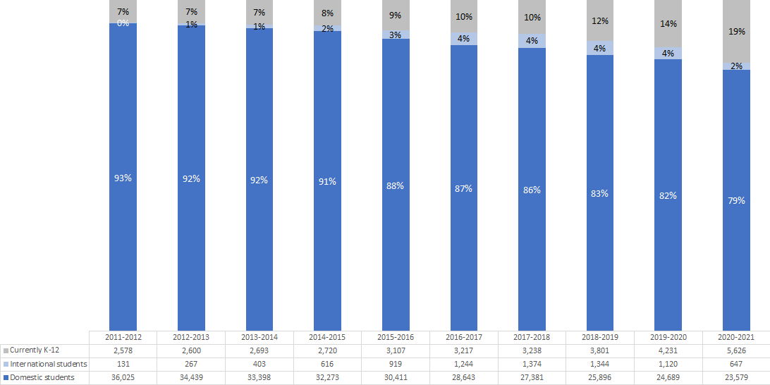
external context presented above, it is one way to address the equity gaps that exist in both higher education attainment and ultimately per capita income in particular for students and

communities of color.
Figure 13

Also shown in Figure 13 is both the growth and decline of the international student population in the SMCCCD over the past decade. Strategic Goal 3 also includes a Districtwide Strategy to support the expansion of international education recognizing its contribution to providing a global education and campus culture that benefits all students.

Over the same time period that the District has experienced enrollment declines, there has been a gradual shift in enrollment patterns with regard to the unit load carried by students. Although the number of students who are enrolled full-time (greater than or equal to 12 units), part-time (at least 6 units but less than 12 units) or less-than-part-time (less than 6 units) have all decreased over the past ten years, the balance has shifted toward proportionately more full-time students (see Figure 14).
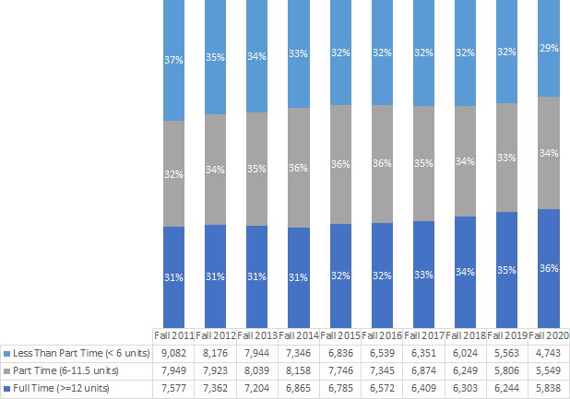
Figure 14 – NOTE: Excludes International students and K-12 High School students

As identified in Strategic Goal 3, this data taken together, and further highlighted by the COVID-19 global pandemic, puts a focus on the need to expand program delivery options such as greater online and hybrid course offerings. Furthermore, the Free Community College initiative is explicitly intended to engage students while they are still in high school, remove financial barriers to enrolling in the District, and provide the structure of the Promise Scholars Program to assist as many students as qualify to complete their educational goals. Through the combination of these efforts, and others identified in the Strategic Goals and Districtwide Strategies, that enrollment will begin to return to the Colleges of the SMCCCD.

The last piece of environmental scan data from the District context that is presented here reinforces the Districts intentional and explicit focus on promoting equity and social justice. The District and its Colleges

serve a majority of communities and students of color (Figure 15), and therefore have a responsibility to ensure that those students complete their educational goals in order to increase overall educational attainment and provide access to the economies of San Mateo County and the Silicon Valley. All three of the District’s Colleges are federally designated as Hispanic Serving Institutions (HSIs), with Skyline College and Cañada College having the additional designation of Minority Serving Institutions (MSIs).
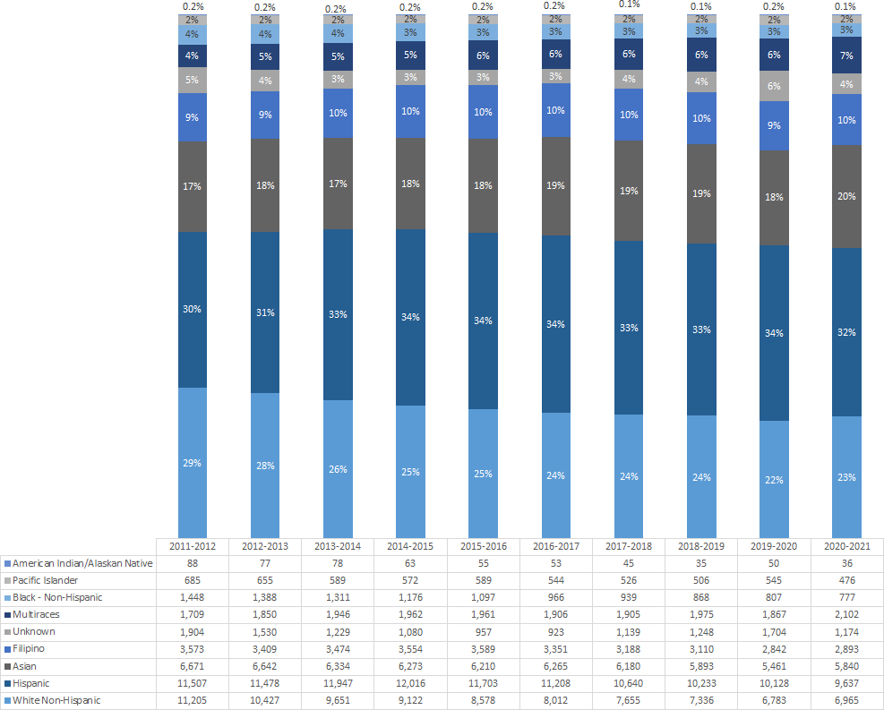

Figure 15 – Districtwide student demographics.

As identified in the overarching Districtwide Strategies, a specific focus of the District during this strategic plan cycle, for example, will be to support the work of the District Anti-Racism Council to radically reimagine how we commit to anti-racism as a District in order to transform the educational experiences for all students, especially hyper-marginalized students.

SUMMARY AND CONCLUSIONS
This District Strategic Plan is organized around four Strategic Goals and related Districtwide Initiatives that provide a blueprint and focus for the work of the District and its Colleges over the next five years. The principles of equity and social justice remain an intentional and unapologetic focus of the District and its

Colleges. A renewed focus on completion is evident throughout the Strategic Goals and Districtwide Strategies of this plan, and is highlighted by the Free Community College initiative that will be pursued as part of the implementation of this plan. The environmental scan of the external context reinforces that completion must be a focus if the students and communities served by the District and its Colleges are to be able to access the economies of San Mateo County, the Silicon Valley, and the greater Bay Area in order to obtain the per capita income and household wages that allow for self-sufficiency. The environmental scan of the internal District context puts a focus on the need to address enrollment decline through innovation to provide alternative access points to the District. Dual enrollment as a key component of the Free Community College initiative has been the sole consistent source of growth in recent years, and holds the promise to address equity gaps in higher education access and attainment shown in the high school data presented. The need to increase the number, type, and indeed quality of online, hybrid, and HyFlex courses was understood at the outset of the update and revision of this Strategic Plan, but the COVID-19 global pandemic has brought that need into sharper focus. As part of an overall effort to increase enrollment in the District, additional flexibility in scheduling will also need to be considered.

Though evidenced throughout the Strategic Goals and Districtwide Strategies included in this updated and revised District Strategic Plan, it is worth restating that the SMCCCD is committed to not only ensuring access to higher education, but to doing everything possible to help students complete their educational goals, with a particular focus on certificates, degrees, and eventual transfer to four-year colleges and universities. Completion is an equity issue. Social justice means working to dismantle systems that have resulted in the inequitable outcomes for students and communities of color served by the District and its Colleges. Free Community College is a key strategic initiative that can focus efforts to specifically dismantle and remove those systemic barriers. It is with that focus that this District Strategic Plan is presented.

APPENDIX A – DISTRICT STRATEGIC PLAN METRICS
Below are the metrics annually presented to and reviewed by the Board of Trustees to assess the progress and impact of the implementation of the District Strategic Plan.

Districtwide Strategic Metrics | First-Time Full-Time Cohort  Based | First Time Part-Time Cohort  Based | Non- Cohort Based
% of students completing SEP | ✓ | ✓
Fall-to-Spring persistence | ✓ | ✓
Fall-to-Spring-to-Fall persistence | ✓ | ✓
% of students earning 20+ units in first year (Fall and Spring) | ✓ | ✓
% completing transfer level MATH within first year | ✓ | ✓
% completing transfer level ENGLISH within first year | ✓ | ✓
% of students completing a degree within two years. | ✓ | ✓
% of students transferring, with a degree, to a 4-year University within two years. | ✓ | ✓
% of students transferring, without a degree, to a 4-year University within two years. | ✓ | ✓
% of students transferring, with or without a degree, to a 4-year University within two years. | ✓ | ✓
% of students completing a degree and/or transferring to a 4-year University within two years. | ✓ | ✓
% of students completing a degree within three years. | ✓ | ✓
% of students transferring, with a degree, to a 4-year University within three years. | ✓ | ✓
% of students transferring, without a degree, to a 4-year University within three years. | ✓ | ✓
% of students transferring, with or without a degree, to a 4-year University within three years. | ✓ | ✓
% of students completing a degree and/or transferring to a 4-year University within three years. | ✓ | ✓
% of students completing a degree within four years. |  | ✓
% of students transferring, with a degree, to a 4-year University within four years. |  | ✓
% of students transferring, without a degree, to a 4-year University within four years. |  | ✓

 | First-Time Full-Time Cohort  Based | First Time Part-Time Cohort  Based | Non- Cohort Based
% of students transferring, with or without a degree, to a 4-year University within four years. |  | ✓
% of students completing a degree and/or transferring to a 4-year University within four years. |  | ✓
% of students completing a degree within five years. |  | ✓
% of students transferring, with a degree, to a 4-year University within five years. |  | ✓
% of students transferring, without a degree, to a 4-year University within five years. |  | ✓
% of students transferring, with or without a degree, to a 4-year University within five years. |  | ✓
% of students completing a degree and/or transferring to a 4-year University within five years. |  | ✓
Average time to completion of Associate (semesters*)  * Summer = 0.5 semesters | ✓ | ✓
Districtwide Strategic Metrics
Associate Degree Completers |  |  | ✓
Median number of Units Attempted by Associate Degree Completers |  |  | ✓
Median number of Units Earned by Associate Degree Completers |  |  | ✓
Baccalaureate Degree Completers |  |  | ✓
Certificate Completers |  |  | ✓
CSU transfers |  |  | ✓
UC transfers |  |  | ✓
San Mateo County High School Take Rate
Districtwide Strategic Metrics
100% Online Associate Degree Completers |  |  | ✓
100% Online Certificate Completers |  |  | ✓

