Humanities and Social Sciences Division
AGENDA
Friday, February 7, 2025
12:00 pm to 2:00 pm
Location: 3-104
Zoom, if necessary:
https://smccd.zoom.us/j/89201611666?pwd=ZU4zRDNHMEhISWt4OXdGanUzZnZsUT09
(Meeting ID: 892 0161 1666 Passcode: 440051)

12:00 Humans and Teachers (Connect and Reflect): Facilitators: Kiran Malavade (English), Faculty Equity Coordinator, and Doniella Maher (English), Faculty Teaching and Learning Coordinator

12:30 General Announcements

12:35 Approval of Minutes and Agenda

Need a Volunteer: Chat and Hands Monitor
12:45 Participatory Governance Committees, Representatives

- Academic Senate, HSS rep, David Eck (SP 2025) 2nd and 4th Thursday, 1:00 to 3:00 or 2:10 to 4:00 pm. In-person, Brown Act.

- Curriculum Committee, HSS reps, Lisa Palmer (Spring 2026) and Maureen Wiley (Fall 2026)—1st and 3rd, Thursday, 1:00 to 2:30. In-person, Brown act.

- Distance Education Advisory Committee, HSS rep, Julie Carey, (SP 2026)

- Technology Committee, Julie Carey for Ami Smith, (SP 2026) 2nd Wednesdays, 12:30-2:00

- Equity and Antiracism Planning Council, HSS rep, Yolanda Valenzuela (SP 2025)

- Planning and Budget Council, HSS rep, Alicia Aguirre (SP 2026) 1st and 3rd Wednesdays, 2:10 to 4:00

- Spring 2025, Faculty Evaluation Committee (Tenured Faculty): Alicia Aguirre, Katie Schertle, Doniella Maher

Regular Division Updates
- AFT
- Honors

Please post to HSS Division Reports and Updates:
https://docs.google.com/document/d/1d5mKJSECncn7OPeZLzRftka_anvYK3k7DNPvdR5zOz0/edit?usp=sharing

(Agenda Items: Information, Discussion, Action)

1:15 Division Information and Discussion

- (1:15) Faculty Teaching and Learning Events: Doniella Maher (English), Faculty Teaching and Learning Coordinator

- (1:30) Cañada College Brave Space Collective: Dr. Michiko Kealoha, Director of Equity

- INFORMATION: We are committed to supporting our undocumented community.

If you become aware of immigration enforcement activities on campus:

- NOTIFY the President’s Office immediately. No employee outside of the President’s Office is authorized to accept legal documents from immigration enforcement officers.
- DOCUMENT and provide the President’s Office with all details of immigration enforcement activities as soon as possible. Include time, location, officer name/credential, and details of officer’s request, if known.
- ESCORT officers to the President’s Office. If you do not feel comfortable escorting officers, contact Public Safety at (650) 738-7000 to assist. You are prohibited from giving consent for an immigration officer to enter any non-public area of campus (e.g. classrooms, office areas, etc.). If an officer arrives in the evening when the President’s Office is closed, please contact Public Safety.
Please bookmark smccd.edu/undocu to connect with campus, community, and legal resources. Additional information will continue to be added to the website over time.
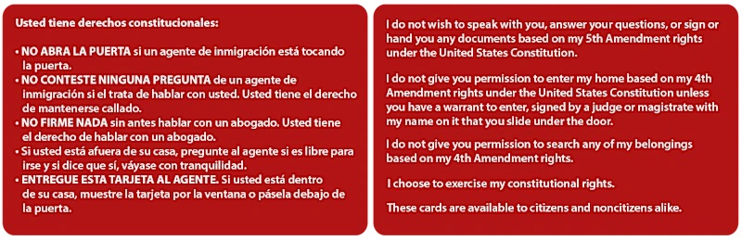
Pick Up Free Red Cards in the Division Office
Red Cards from the Immigrant Legal Resource Center outline key constitutional rights for everyone, regardless of immigration status. Red Cards are available in both English and Spanish. Please encourage students and colleagues to pick up a free card at:

Building 5
- Outreach (Building 5, Room 108)
- Cañada Market (Building 5, Room, 202)
Building 8
- President’s Office (Building 8, Room 206)
- Office of VPSS (Building 8, Room 209)
Building 9
- Admissions & Records (Building 9, First Floor)
- Welcome Center (Building 9, First Floor)
- COLTS-U Transfer Center (Building 9, Room 106)
- Undocumented Community Center (Building 9, Room 118)
- EOPS (Building 9, Room 133)
- VROC (Building 9, Room 151)
- Learning Center (Building 9, Second Floor)
- Library (Building 9, Third Floor)
Building 17
- Cultural Center (Building 17, Room 107)
Building 18
- Middle College office (Building 18, Room 111)
- SparkPoint office (Building 18, Rooms 106/115)

Spring 2025 Division Meetings: Please mark your calendars
Division meetings are scheduled on the first Friday of every month. Full-time faculty are to attend all meetings. Part-time faculty attendance is appreciated but not required.
- TBD, Flex Days, Thursday, 9, TBD
- Friday, February 7, 12:00-2:00, 3-104
- Friday, March 7, 12:00-2:00, 3-104
- Friday, April 4, 12:00-2:00, 3-104
- Friday, May 2, 12:00-2:00, 3-104

Reminders:
- Recurring Zoom Meeting:
https://smccd.zoom.us/j/89201611666?pwd=ZU4zRDNHMEhISWt4OXdGanUzZnZsUT09
Meeting ID: 892 0161 1666. Passcode: 440051

