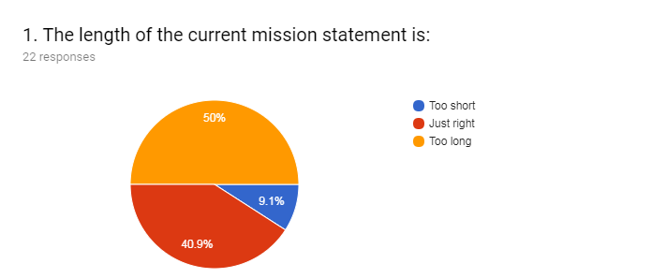
Standard I.A.1. Mission
The mission describes the institution’s broad educational purposes, its intended student population, the types of degrees and other credentials it offers, and its commitment to student learning and student achievement. (ER 6)
Evaluation Criteria:
- The institution’s mission statement addresses the institution’s educational purpose.
- The mission defines the student population the institution serves.
- The institution’s educational purpose is appropriate to an institution of higher learning.
- The mission statement addresses the types of degrees, credentials, and certificates the institution offers.
- The mission statement demonstrates the institution’s commitment to student learning and student achievement.
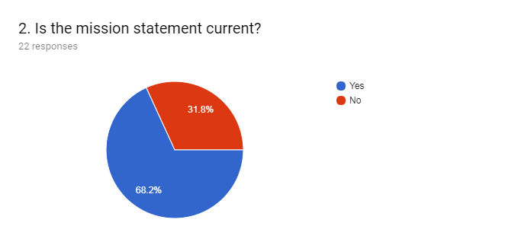
No, the mission statement is not current because:
- “it hasn't been validated or reviewed since the last
comprehensive accreditation visit 6 years ago.”
- “we don’t value life-long learning; there is too much push
to get certificates or transfer.”
- “it should include reference distance learning.”
- “we should add the term “academic” as we are an academic
institution.”
- “we could reconsider the term “modern workplace.”
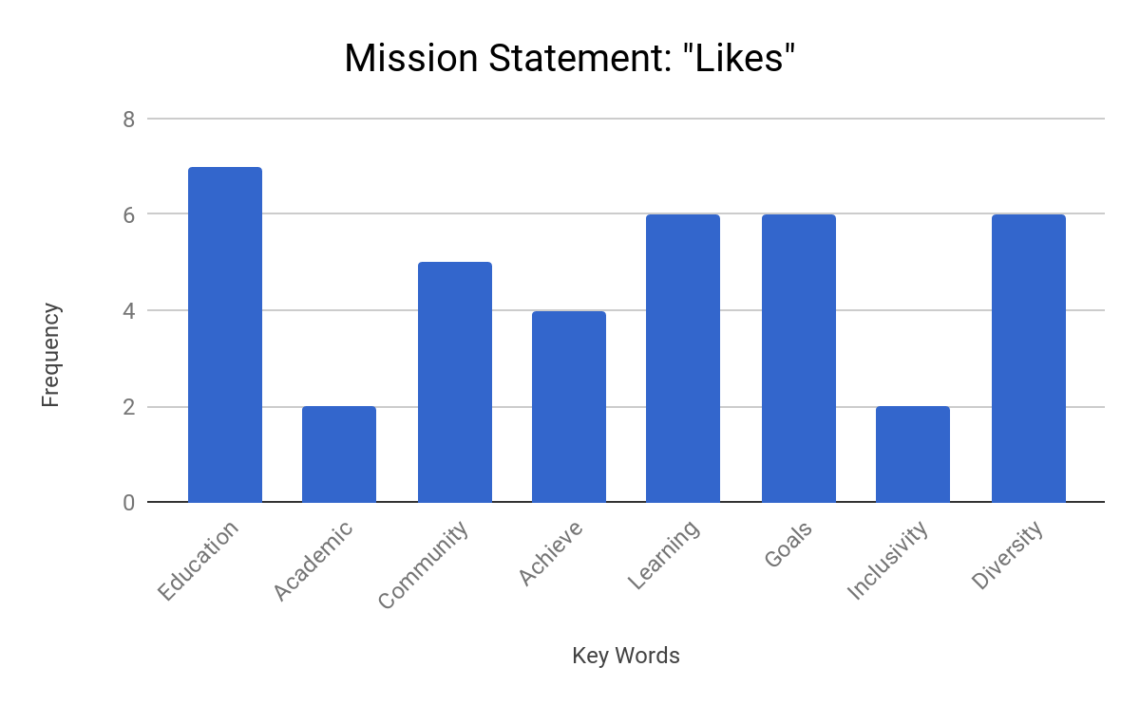
I.A.1. Evaluation Criteria Alignment with Mission Statement “Likes”

The institution’s mission statement addresses the institution’s educational purpose. → Education (7), Learning (6), Community (5), Academic (2)

The mission defines the student population the institution serves.
→ Diversity (6), Community (5), Inclusivity (2)

The institution’s educational purpose is appropriate to an institution of higher learning. → Education (7), Academic (2)

The mission statement demonstrates the institution’s commitment to student learning and student achievement. → Learning (6), Goals (6), Achieve (4)

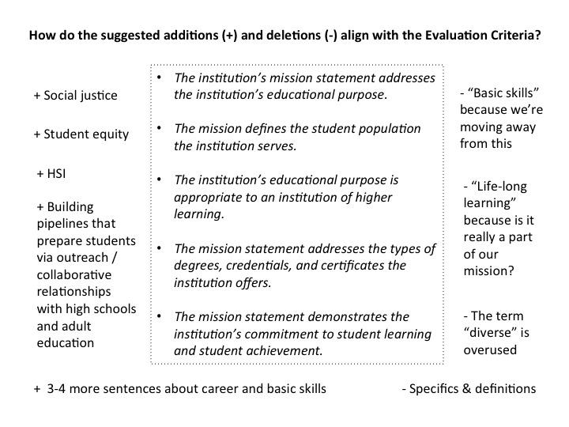

Next Steps: Standard 1 A committee recommends a broader review of the mission statement by the college community. The words in the statement, “basic skills,” “lifelong learning,” and “diverse” need to be reconsidered; and words not included in the mission statement, “social justice,” “student equity,” “HSI,” “building pipelines that prepare students…” and more words around career and basic skills.

