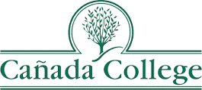
Educational Master Plan

2022-2027
(with a possible one-year extension to align with SKY and CSM EMPs)

Draft

as of April 21, 2022

Contents
Purpose of the Educational Master Plan 4
President’s Message 5
Tri-Chairs Message 5
Cañada College 7
Mission, Vision and Values 8
Mission Statement 8
Vision Statement 8
College Values 8
College Goals 11
Student Access, Success and Completion 11
Equity-Minded and Antiracist College Culture 11
Community Connections 11
Accessible Infrastructure and Innovation 11
College Goal #1 12
Student Access, Success and Completion 12
Strategic Initiatives to Accomplish Goal 1: 12
College Goal #2 15
Equity-Minded and Antiracist College Culture 15
Strategic Initiatives to Accomplish Goal 2: 15
College Goal #3 17
Community Connections 17
Strategic Initiatives to Accomplish Goal 3: 17
College Goal #4 19
Accessible Infrastructure and Innovation 19
Strategic Initiatives to Accomplish Goal 4: 19
Cañada College Service Area 21
APPENDICES 22
EMP Planning Process 22
Cañada College Goals and San Mateo District Goals 25
Partial Inventory of Resources Reviewed 26
College Internal and External Scans 26
Other College and District Documents 26
Other Resources 26
C. Baseline Metrics 27

Purpose of the Educational Master Plan

The 2022-27 Cañada College Educational Master Plan (EMP) serves as a foundational document and statement of the College’s commitment to education in our community and a framework to ensure the implementation of our mission and achievement of our vision according to clearly stated values. The EMP provides the framework for setting college priorities and for making decisions and resource allocations on campus. It serves as a guide for developing goals and initiatives of the College’s other college-wide plans. All other college plans are developed in support of achieving the goals and strategic initiatives laid out in the EMP.

The EMP is informed by analysis of internal and external data, as well as feedback from the College’s students, employees, industry partners, educational partners, and members of the surrounding community. It aligns with and supports the achievement of the San Mateo County Community College District (SMCCCD) Board of Trustees’ 2021 Strategic Plan as well as the College’s efforts to achieve the California Community College Chancellor’s Vision for Success.

President’s Message

On behalf of the entire Cañada College community, I would like to thank the members of the Educational Master Planning Task Force (see Appendix A). These students, faculty, staff and administrators gave generously of their time to ensure our planning process was thoughtful, rigorous and inclusive. The Task Force made a commitment to consider and hear all voices and consider all significant sources of information about the current and future direction of the College. With their guidance, along with input from our entire campus community, this Plan provides the College with inspirational new mission, vision, and values statements that speak to our community’s aspirations for Cañada’s role as a leading institution of higher education in San Mateo County. This Plan also articulates goals and strategies that will help ensure that Cañada College rises to meet the challenges facing public educators everywhere as we seek to prepare our current and prospective students to adapt to and succeed in an ever-changing world.

Thank you to all who helped create this critically important document.

Sincerely,

Kim Lopez
President

Tri-Chairs Message
Developing an Educational Master Plan during the 2021-2022 academic years and the COVID-19 pandemic was both very relevant and very challenging. The strategic initiatives included in this plan are those the college community will undertake - over and above our normal operations - to continuously improve how we serve our students and larger community. The core of Cañada College remains teaching and learning, while these initiatives focus on new and ongoing projects that strengthen Cañada College’s educational mission.
This Educational Master Plan reflects the urgent need to eliminate equity and racial barriers in higher education, as we better serve our current students and expand our reach to future students. All of our community members should feel welcome at Cañada College, and we think this plan will help many more of them make use of what we have to offer.
We would like to second our President’s thanks to everyone who contributed to the Educational Master Plan. We believe the collective effort will make Cañada better for both our students and our fellow colleagues.
David Eck, Academic Senate President, EMP Task Force Tri-Chair
Roz Young, Classified Senate President, EMP Task Force Tri-Chair
Karen Engel, Dean of Planning, Research, Innovation & Effectiveness, EMP Task Force Tri-Chair

Cañada College

Cañada College is one of three public community colleges serving San Mateo County and the greater Bay Area region. Each year, more than 10,000 students enroll at Cañada to pursue a broad range of educational and life goals. Since 1968, the College has been dedicated to fulfilling its educational mission as well as adapting that mission as needed to better address the changing needs of the community it serves.

Mission, Vision and Values

Mission Statement

Cañada College engages and empowers students in transforming their lives and communities through quality education.

Vision Statement

Cañada College provides quality, equitable education that inspires and empowers students to achieve their goals and benefit the world.

College Values

Social Justice and Racial Equity

Cañada College is dedicated to social justice and racial equity:
- Antiracism: commit to actively combat individual racism and to interrogate racist structures and policies.
- Equity: provide equitable access and resources to students, staff and faculty, in consideration of all their identities to ensure a community of support and successful educational outcomes.
- Inclusion: a campus where everyone feels a sense of community and has a voice.
- Diversity: a community where different cultures are represented, recognized and celebrated.
- Access: a community where all students have access to academic tools and student support resources to help them succeed.
- Liberation: building an equitable and antiracist community where members, especially students, are valued as whole human beings and are empowered to express themselves fully in pursuit of their goals.

Transforming Lives

Cañada College is dedicated to transforming lives:
- Students’ Feelings – Students move forward from Cañada feeling proud, accomplished and prepared for what is next for them.
- Being Supportive - Meeting Students’ Needs & Providing Opportunities – Provide a supportive environment where we work to meet students’ needs and provide opportunities to all students, so that they can continue the work of transforming their own lives.
- Evolving Ourselves to Continue to Be Able to Transform Lives – In order for Cañada to be a place where students can transform their lives, we need to continually listen to our students’ needs and grow and adapt as an institution to stay relevant and meaningful to our students.

Community Partnerships

As a community college, Cañada College recognizes the utmost importance of cultivating and fostering strong relationships and partnerships with our community, including high schools, businesses, organizations and individuals. These partnerships allow our college to successfully:
- Reach out to, recruit and retain students
- Provide access to a college education for members of the community
- Enrich academic programs and create pipelines for students to explore and enter careers
- Reflect the culture of the community we serve
- Use our campus and resources to address the needs of our community

Academic Excellence

Cañada College values fostering curious, self-directed, and responsible adult learners. Academic excellence occurs both within, and beyond, the classroom, equipping students with skills that serve them in all domains of their lives. Individualized learning experiences are essential to the success of all our students, ensuring that they recognize and develop their unique selves in the process of completing their academic work. Facilitating meaningful learning experiences is also essential for maintaining a culture of academic honesty and trust. Learning at Cañada College involves transformative life experiences that benefit both individuals and their communities.

Sustainability

Cañada College works to sustain the health of the planet to promote social justice and robust economies for all, in perpetuity. As stewards of a college campus, Cañada College endeavors to minimize our negative impact on the environment (for example, limit carbon footprint, decrease production of waste and greenhouse gasses), while promoting a culture of environmental awareness.

Transparency and Authenticity

Cañada College values transparency and authenticity in all aspects of the college:
- Speak in plain and understandable language, rather than in educational jargon.
- Take personal responsibility for addressing problems that arise, rather than placing blame on official policies, administrative procedures, or other people.
- Promote awareness among students that they are allowed to attend meetings and give input.
- Be honest and follow through to the end on promises made.
- Articulate solutions, not slogans.

Adaptability and Resilience

Cañada College values a culture of adaptability and resilience. As a critical part of our region’s socio-economic infrastructure, the College is adaptable and willing to change in order to suit the dynamic, changing needs of our region. Our culture of resilience supports all of our college community members in being able to recover quickly from adversity and unexpected challenges.

Student Centered

As a student-centered institution, Cañada College puts the needs of students first and recognizes our duty to address the Obligation Gap - our responsibility as an institution to address the most pressing equity gaps in student outcomes. Proactive in understanding the changing needs of individuals and groups of students, the College seeks to align its teaching, curriculum, services, policies and goals to best support students. The College values norms of behavior that help ensure that students feel their voices are heard and not being undermined or silenced.

Cultural Empathy

Recognizing that members of its community come from many different cultures, Cañada College values empathy, understanding and respect for cultural differences and similarities within, among and between groups. Cañada College seeks to honor diversity, mitigate implicit bias, and promote empathy in a manner that acknowledges power imbalances and supports all community members in achieving their educational and professional goals.

College Goals

The Cañada College community developed four goal statements that are meant to establish a broad, strategic direction.

Student Access, Success and Completion
Cañada College ensures student access to relevant and transformative student services and instructional programs that are inclusive, diverse, equitable, and antiracist. As an institution, Cañada contributes to the financial stability of students to empower them to pursue personal, academic, professional, and civic goals. Cañada College continuously assesses processes and removes barriers to student access, success, and completion.

Equity-Minded and Antiracist College Culture
Cañada College transforms its culture to be equity-minded and antiracist. Our teaching, learning, and services create a sense of belonging among all community members so they are able to recognize that their unique selves are valued, express themselves fully, and thrive. Our educational practices reflect the fundamental importance of individualized learning experiences, the shared building of knowledge, and promoting social justice at Cañada College.

Community Connections
Cañada College establishes equity-minded partnerships with other educational institutions, employers, governments, and community-based organizations that result in seamless pathways for high school students transitioning to college, college students transitioning to university, and all community members pursuing career, and lifelong educational opportunities.

Accessible Infrastructure and Innovation
College financial resources are well managed in support of the College’s values and to provide accessible physical and virtual spaces that promote continuous innovation and excellence in teaching and learning. Cañada’s investments in physical, technological and transportation infrastructure create sustainable, equitable access to the College and support equitable educational outcomes across the diverse members of the community we serve.

College Goal #1

Student Access, Success and Completion
Cañada College ensures student access to relevant and transformative student services and instructional programs that are inclusive, diverse, equitable, and anti-racist. As an institution, Cañada contributes to the financial stability of students to empower them to pursue personal, academic, professional, and civic goals. Cañada College continuously assesses processes and removes barriers to student access, success, and completion.

Strategic Initiatives to Accomplish Goal 1:
Initiatives may be added or revised as conditions change and their completion is contingent upon availability of resources.

Make registration easier

  - Assess and streamline outreach, application, matriculation, and registration processes to ensure more applicants, particularly low-income, first generation, and Black, Indigenous, and People of Color (BIPOC) applicants, enroll in at least one course the same year they apply. Ensure that the programs that support students through these processes have enough resources to manage the workload.

Connect students to the academic program(s) and classes they need

1.2 Prioritize serving part-time, working students by building on the model of College for Working Adults, adding more degrees and certificates obtainable within 3 years via evening, weekend and online classes, ensuring services are available in the evenings, to support at least 1,000 part-time working students, particularly low income, BIPOC students, per term by 2027.
1.3 Create a student-first course schedule that reduces scheduling conflicts and maximizes course-taking opportunities (e.g., offer courses in multiple modalities, better align with the District Block Schedule, offer short courses, offer selective courses during non-prime hours) for students given their educational goals.
1.4 Create new degree and certificate programs (especially career education programs not yet available in the District) that support the evolving short and long-term needs of prospective students and regional employers.
1.5 Develop new Kinesiology, Athletics, & Dance programs and certifications in collaboration with the Community Fitness operations in Building 1 such that students have access to on-site job training and workforce development opportunities that effectively prepare them for health and fitness-related employment in the region.
1.6 Create more short-term, stackable certificate programs that result in gainful employment in the near term, so students can work in their field while continuing their education. Align these programs with ESL instruction.
1.7 Continue to increase the number of degree and certificate programs and general education courses at the Menlo Park site and/or other off-campus locations (East Palo Alto) to help students access needed courses and support services closer to home.
1.8 Continuously improve the Program Review process to ensure all academic degree and certificate programs remain viable and strong and that they adapt to the changing needs of students and employers in Cañada’s service area.
1.9 Strengthen participation in the California Virtual Campus to help Cañada students’ access courses not offered in our District and to gain enrollments in Cañada’s online courses by completing all of the college-specific steps needed to participate in the Course Exchange and providing robust support to online instruction.
1.10 Improve WebSchedule descriptions of course offerings.

Ensure students (particularly part-time students) experience a sense of belonging and connection to the College that helps them persist and complete

1.11 Complete the college redesign process according to the essential practices of Guided Pathways and ensure that all students are connected to and feel supported by their Interest Area and Success Team and, if applicable, their special program (e.g., Promise, EOPS, TRIO SSS, Puente, Umoja, etc.) by committing funding, marketing and other resources for at least 3-5 years before assessing the impact.
1.12 Increase peer mentoring availability in Interest Area Success Teams and special programs.
1.13 Scale the Promise Scholars Program to include part-time students.
1.14 Strengthen and scale student affinity programs and other student support programs such as Umoja, Puente, EOPS, and TRIO SSS and create strong ties and coordination between them and the Interest Area Success Teams such that BIPOC and LGBTQ+ students are well supported to complete their educational journeys at Cañada within 3 years.
1.15 Create (by 2023) and scale (by 2025) the First Year Experience program for all incoming students, including default course schedules for some first-time cohorts.
1.16 Create a campus culture that expects and supports students’ completion of their educational goals within three years by: (1) scheduling classes according to student interest and demand (informed by Student Education Plan (SEP) data; (2) offering more course-taking opportunities during the summer; (3) monitoring student progress more closely (via Success Teams, the Retention Specialist Community of Practice, and the Transfer Dashboard); and (4) focusing communications and outreach to students accordingly.
1.17 Implement the provisions of California Assembly Bills 1111 and 928.

Improve financial stability of students

1.18 Design and include financial literacy and college financial planning workshops in our First Year Experience program, among others.
1.19 Increase the proportion of students who complete and submit financial aid applications.
1.20 Reduce or eliminate the cost of textbooks and course materials by ensuring 75% of all course sections utilize Open Educational Resources and so have zero or low cost by 2030.

College Goal #2

Equity-Minded and Antiracist College Culture

Cañada College transforms its culture to be equity-minded and antiracist. Our teaching, learning, and services create a sense of belonging among all community members so they are able to recognize that their unique selves are valued, express themselves fully, and thrive. Our educational practices reflect the fundamental importance of individualized learning experiences, the shared building of knowledge, and promoting social justice at Cañada College.

Strategic Initiatives to Accomplish Goal 2:
Initiatives may be added or revised as conditions change and their completion is contingent upon availability of resources.

Support innovative teaching that creates more equitable and antiracist learning environments

2.1 Support for faculty to provide more timely, individualized attention for students in their classes, such as smaller class sizes in key courses, more embedded tutors, and teaching assistants (e.g., Umoja practices).
2.2 Support faculty development of culturally relevant curriculum and equity-minded (race conscious) learning outcomes.
2.3 Dedicate resources for faculty professional development in experimenting with new teaching modalities and learning experiences, especially those that reach underserved current and prospective students.
2.4 Sustain and expand the Faculty Learning Program community of practice to support evolving teaching methods, innovation in teaching, and antiracism in teaching and learning.
2.5 Increase use of Open Educational Resources that address diversity, equity, inclusion and antiracism in the course material content.

Create and sustain an inclusive, antiracist, and equity-minded campus culture

2.6 Revise and improve faculty and staff hiring practices that recognize both traditional and nontraditional experiences and qualifications to ensure the hiring of a diverse pool of faculty and staff applicants.
2.7 Provide a comprehensive orientation and on-boarding for all newly hired faculty, staff and administrators each term that includes module(s) in antiracism shared language, resources for equitable pedagogy and practices, and how to connect with a mentor or personal support via the Cultural Center and/or Offices of Instruction, Student Services, and Administrative Services.
2.8 Provide regular, accessible, planned and intentional professional development opportunities (including implicit bias and antiracism training every two years) to all employees that sustains their personal growth and professional development over the course of employees’ careers.
2.9 Implement a campus-wide bias incident reporting system with safeguards for victims and transparent methods for addressing all reports effectively. Ensure that privacy-protected data on incidents are disseminated for analysis, policy improvements, and prevention.
2.10 Reimagine and transform college participatory governance processes and structures to: (1) address equity and antiracism in all integrated planning and resource allocation decisions; (2) increase student voice in college processes, including program review; and (3) ensure classified staff have adequate time to contribute to the committees and councils on which they serve.
2.11 Develop the College Cultural Center (Multicultural Center) to provide timely, relevant, and intentional programming that serves the needs of the campus community in a manner that supports antiracist work at the College and more effective support for and representation of diverse racial, ethnic, and LGBTQ+ groups in the community.
2.12 Empower student voices on an ongoing basis to ensure the Cultural Center meets the needs of the community and fosters leadership development opportunities that support understanding and interpreting various points of view that emerge from a diverse world of peoples and cultures.

Strengthen the college culture of continuous assessment and improvement in order to ensure all programs effectively serve students and close equity gaps

2.13 Ensure the Program Review process effectively identifies equity gaps in both academic and student services programs and provides program leads with the professional development and resources to address them. Ensure that online programs are evaluated separately from those provided in person and address any bias or discrepancies as soon as possible.
2.14 Support all student support services in evaluating their programs and practices regularly to ensure they are effective in closing equity gaps in access, student success and completion. These include but are not limited to: Interest Area Success Teams, Special Programs (Promise, EOPS, TRIO SSS, Puente, Umoja, ESL, and Middle College).
2.15 Support all academic support services in evaluating their programs and practices regularly to ensure they are effective in closing equity gaps in access, student success and completion. These include but are not limited to: Interest Area Success Teams, the Learning Center, Tutoring (online and in person), the Writing Center, and Peer Mentoring, Library, Math, Word and all other JAMS.
2.16 Ensure all aspects of the college redesign process to embed the essential practices of Guided Pathways in College programs and structures are regularly evaluated to ensure they are effective in closing equity gaps in access, student success and completion. These include but are not limited to: Interest Areas, First Year Experience, Dual Enrollment, Career Exploration and faculty efforts to ensure students are learning.

College Goal #3

Community Connections
Cañada College establishes equity-minded partnerships with other educational institutions, employers, governments, and community-based organizations that result in seamless pathways for high school students transitioning to college, college students transitioning to university, and all community members pursuing career, and lifelong educational opportunities.

Strategic Initiatives to Accomplish Goal 3:
Initiatives may be added or revised as conditions change and their completion is contingent upon availability of resources.

Better share what Cañada offers

3.1 Transform how we share the story of Cañada College as both a Hispanic serving and Asian American, Native American, and Pacific Islander serving institution through updated marketing and outreach in multiple languages with flexible, dynamic and culturally-informed branding and logos.
3.2 Transform where we share what Cañada has to offer by identifying new outreach audiences that help strengthen our ties to BIPOC communities and recruit more BIPOC students, including more students who identify as Black / African American.
3.3 Utilize relevant social media and other marketing platforms to reach community members in the formats and virtual environments in which they exist. Ensure College websites are up-to-date, accurate, informative, and speak to community members in language that is welcoming and inclusive.

Be the best college choice for local high school students

3.4 Increase the number of high school students participating in dual enrollment course-taking opportunities - particularly low-income, minoritized students (as specified in the College Dual Enrollment Implementation Plan) - by 300% by 2024 and by 600% by 2027.
3.5 Double the size of the Middle College program in 5 years, with particular focus on expanding access to the program for first generation, low income, BIPOC students who may not yet be on track to attend college or complete high school.
3.7 Collaborate with community organizations to host summer camps, events, and other activities and programs that help triple the number of high school students on campus during the summer and year-round (Saturdays), particularly students who may not be college aware or on track to be college ready.

Strengthen K-16 pathways and transfer

3.8 Fulfill the purposes of the Memorandum of Understanding (MOU) between Cañada and San Francisco State University, California State University East Bay, and the Sequoia Union High School District created in 2022.
3.9 Strengthen transfer support services by, (1) building University pathways and expanding the University Center, (2) increasing by 35% the number of Cañada College transfer-seeking students who achieve transfer readiness and the number of students who apply to a 4-year University ­­­between 2022 and 2027 (adjusted for enrollment fluctuations) and, (3) reduce the transfer equity gap for low-income, first generation, and Black, Indigenous, and People of Color (BIPOC) students.

Help students explore and find employment in fields of their choice

3.10 Centralize and coordinate College relationships with community and employer partners in order to expand and improve college partnerships with employers, community organizations, high schools, and 4-year transfer universities in a manner that scales opportunities for students and improves the community-serving brand of the College and supports our educational mission.
3.11 Create career exploration experiences (such as work-based learning, internships, and job shadow opportunities) for students during their time at Cañada, particularly during their First Year (in each Interest Area), as they choose a program of study and refine their education goals. Close racial equity gaps in access to career development and job placement opportunities.
3.12 Strengthen the emerging Cañada College alumni organization by doubling the number of alumni connected to it by 2027, as well as involving more of them in campus activities that strengthen the campus as a center of community life, provide career exploration for existing students, and develop new resources and connections for the College.

Help meet the basic needs of Cañada students and other community members

3.12 Collaborate with community partners to address food insecurities of our students and their families (Food Pantry, Drive thru Food Distribution, and Community Markets).
3.13 Collaborate with community partners to increase access to housing resources for Cañada students.
3.14 Reduce or eliminate the cost of textbooks and course materials by ensuring 75% of all course sections utilize Open Educational Resources and so have zero or low cost by 2030.

College Goal #4

Accessible Infrastructure and Innovation
College financial resources are well managed in support of the College’s values and to provide accessible physical and virtual spaces that promote continuous innovation and excellence in teaching and learning. Cañada’s investments in physical, technological and transportation infrastructure create sustainable, equitable access to the College and support equitable educational outcomes across the diverse members of the community we serve.

Strategic Initiatives to Accomplish Goal 4:
Initiatives may be added or revised as conditions change and their completion is contingent upon availability of resources.

Ensure the physical campus is accessible

  - Improve access to campus via public transit, shuttles, and additional partners such as Lyft and Cruise.
  - Include in our Facilities Master Plan a plan to build student housing on campus, as well as Childcare Center to serve students with families.
  - Create a hub for evening and weekend students to support their social connections, access to nutritional food and beverages, as well as learning support services (an Evening One Stop).
  - Make the campus more visually welcoming and inviting to the diverse community through murals and activities that represent and appreciate the cultures of the student body.
  - Enhance wayfinding and the pedestrian experience on campus for all, including those who are differently abled.
  - Improve pedestrian and bike access to the campus by extending sidewalks, and create a clearly marked perimeter trail.
  - Modernize the Performing Arts Center to better support Creative Arts programs.
  - Reimagine the Library and Learning Center to best connect students to services and resources.
  - Update and implement the College and District sustainability initiatives in response to climate change to reduce the environmental impact of campus-based activities while ensuring uninterrupted, quality instruction at all times.

Provide adequate access to technology

  - Ensure all faculty, staff and students have access to the hardware and software technology resources needed to provide instruction in multiple modalities.
  - Provide trainings needed to ensure new technology resources facilitate quality teaching and learning.
  - Offer key courses (e.g., popular, commonly needed General Education courses) in multiple instructional modalities.

Manage resources effectively

  - Advocate for the District to allocate sufficient resources needed to grow innovations in new as well as existing academic and support programs.
  - Develop the College budget to invest in the College’s commitment to equity and antiracism.
  - Fundraise $1 million dollars over the next 5 years to spur innovation and supplement our current resources.

Cañada College Service Area

Overlooking the San Francisco Bay, Cañada College is situated in the western part of Redwood City, in the center of the Silicon Valley. The College is one of three accredited colleges in the San Mateo County Community College District (SMCCCD). The District serves the entire County of San Mateo with an estimated population of 737,888, as of 2021. The primary service area for Cañada College is the southern part of the County, including Atherton, East Palo Alto, La Honda, Ladera, Menlo Park, North Fair Oaks, Pescadero, Portola Valley, Redwood City, San Carlos, San Gregorio, and Woodside.

The College takes its name from Cañada Road, which winds its way through the valley to the west of the campus. In Spanish, the word cañada means ravine. The College first opened its doors at its current location to 2,000 students in the fall of 1968.
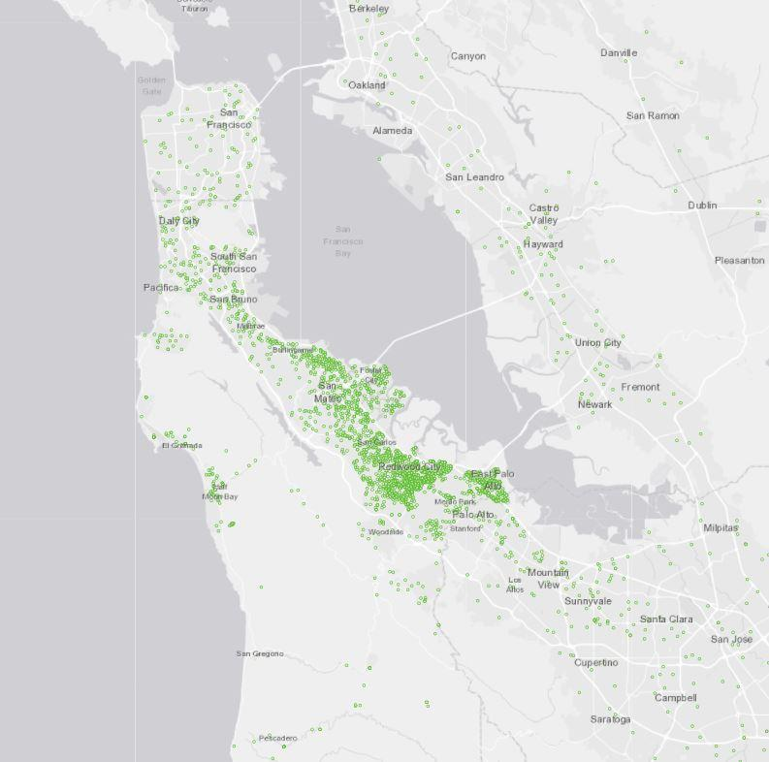
Figure 1 Cañada College Students Fall 2021

APPENDICES

EMP Planning Process

The 2022-27 Educational Master Plan was developed through an inclusive, broad-based, participatory process. A Task Force of members appointed by the Academic, Student and Classified Senates, as well as College Cabinet, and approved by the Planning and Budgeting Council in spring 2021, led the effort. This Task Force included:

Task Force Tri-Chairs:
- David Eck, Academic Senate President
- Roslind Young, Classified Senate President
- Karen Engel, Dean of Planning, Research, Innovation & Effectiveness and Accreditation Liaison Officer

Faculty Members:
- Humanities and Social Sciences Division Rep: Alicia Aguirre
- Business, Design and Workforce Division Rep: Leonor Cabrera
- Science and Technology Division Rep: Not Identified
- Kinesiology, Athletics and Dance Division Rep: Eddy Harris
- Counseling Division Rep: Jenna French

Classified Staff Representatives:
- Outreach & Welcome Center Rep: Jeanne Stalker
- Classified Rep At Large (and GP Success Teams): Nimsi Garcia
- Transfer Services Rep: Mary Ho
- Instructional Division Rep: Krystal Martinez
- Instructional Technologist: Allison Hughes

Student Representatives:
- Mira Rubio
- Brittney Samora-Delgadillo

Administrators:
- Dean of Business, Design & Workforce: Hyla Lacefield
- Dean of Enrollment Services and Student Support: Wissem Bennani
Staff Support: The Office of Planning, Research & Institutional Effectiveness will provide staff support, research, analysis and writing throughout the process.
The EMP Task Force met 24 times over the course of a calendar year. It led a number of important opportunities for the entire college community to come together to understand and collaborate on elements of the new EMP, including:

- a session focused on crafting a new mission, vision and values statements during the October 13, 2021 Flex Day;
- several sessions to review the results of the Internal Equity Scan during the January 13, 2022 Flex Day;
- a Community Forum on February 11, 2022, during which the Task Force led discussions to help refine the challenges and opportunities facing the College as well as to begin to craft strategies for addressing them; (
- a college-wide Retreat on March 11, 2022 during which the new, proposed goal and strategy statements for the EMP were developed and refined; and
- a college-wide session on the April 20, 2022 Flex Day to review the new draft EMP in its entirety.

Each of these all-college workdays as well as the processes the EMP Task Force completed over the course of a year are depicted here:

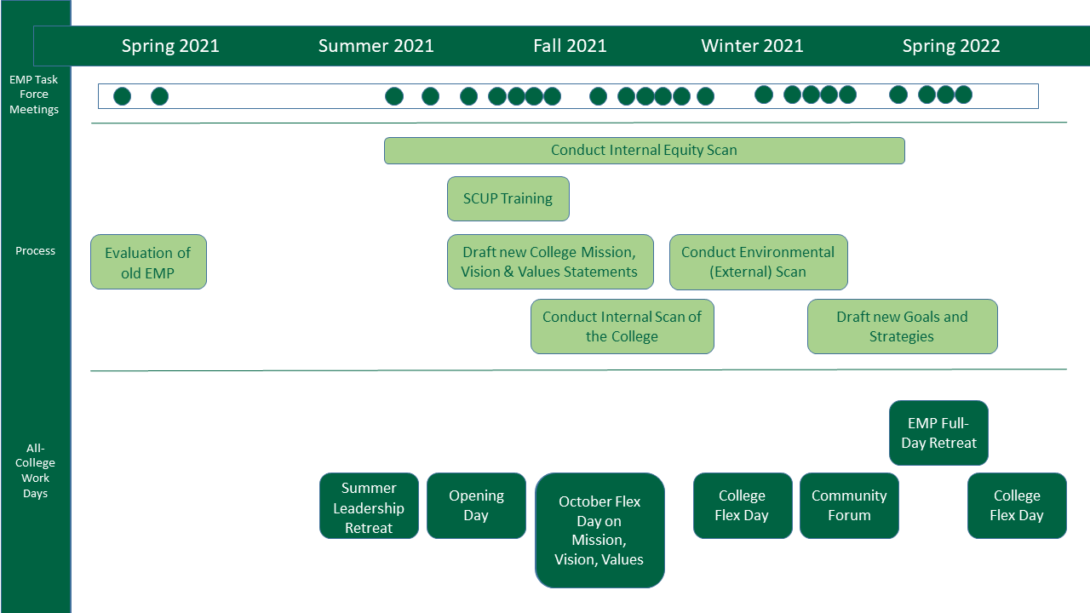

EMP Task Force Tri Chairs and Members also regularly updated their Divisions, Senates, and Planning Councils with information about the planning process and important milestones and choices the Task Force made.

The overall timeline to which the EMP Task Force adhered was:

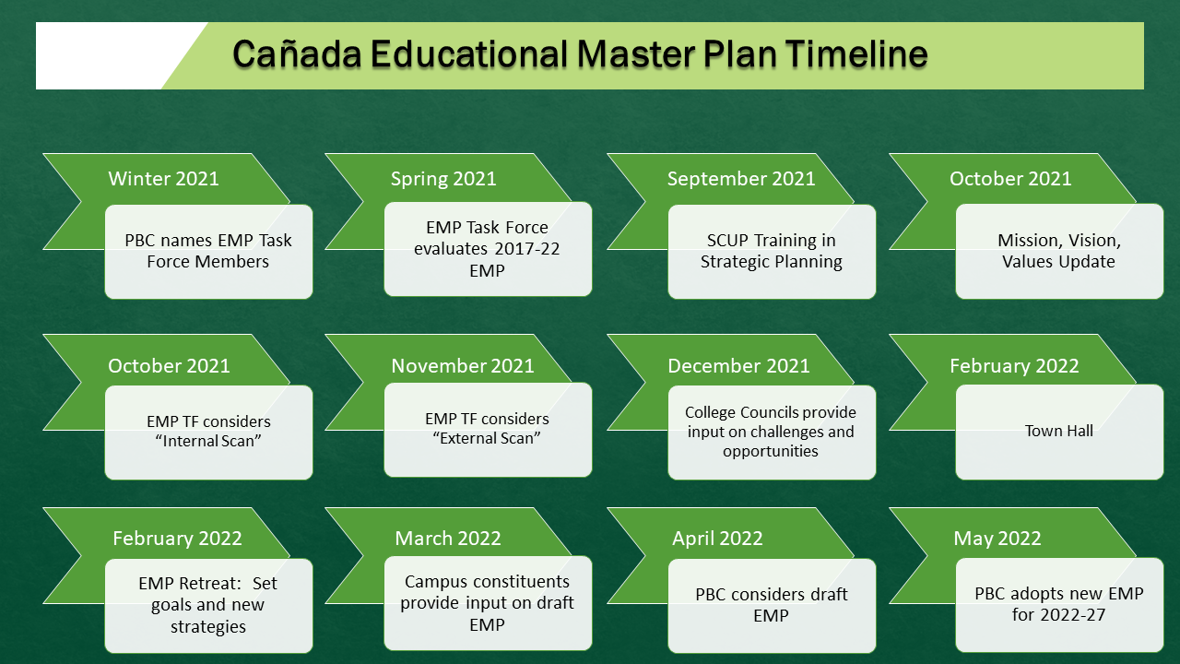

Cañada College Goals and San Mateo District Goals

Cañada College Goals (as of 2022) | SMCCC District Goals (as of 2021)
Cañada College ensures student access to relevant and transformative student services and instructional programs that are inclusive, diverse, equitable, and antiracist. As an institution, Cañada contributes to the financial stability of students to empower them to pursue personal, academic, professional, and civic goals. Cañada College continuously assesses processes and removes barriers to student access, success, and completion. | Develop and strengthen educational offerings, interventions, and support programs that increase student access, success, and completion.
Cañada College establishes equity-minded partnerships with other educational institutions, employers, governments, and community-based organizations that result in seamless pathways for high school students transitioning to college, college students transitioning to university, and all community members pursuing career, and lifelong educational opportunities. | Establish and expand relationships with School Districts, 4-year college partners, community-based organizations and employers to increase higher education attainment and economic mobility in San Mateo County.
Cañada College transforms its culture to be equity-minded and antiracist. Our teaching, learning, and services create a sense of belonging among all community members so they are able to recognize that their unique selves are valued, express themselves fully, and thrive. Our educational practices reflect the fundamental importance of individualized learning experiences, the shared building of knowledge, and promoting social justice at Cañada College. | Promote innovation and excellence in instruction to support student learning and success
College financial resources are well managed in support of the College’s values and to provide accessible physical and virtual spaces that promote continuous innovation and excellence in teaching and learning. Cañada’s investments in physical, technological and transportation infrastructure create sustainable, equitable access to the College and support equitable educational outcomes across the diverse members of the community we serve. | Ensure necessary resources are available to implement this strategic plan through sound fiscal planning and management of allocations. Protect community-supported status, and undertake the development of alternative sources of revenue that support educational programs beyond what is available from community and state allocations.

Partial Inventory of Resources Reviewed

College Internal and External Scans
- Cañada College Internal Scan
- Community Perceptions Questionnaire Results and External Scan Slides
- San Mateo County Community College District External Scan
- Cañada College Internal Equity Report Snapshot by Áse Power Consult

Other College and District Documents

Cañada College Educational Master Plan 2017-22
San Mateo County Community College District Strategic Plan 2021-26
California Community College Chancellor’s Office Vision for Success
Cañada College Institutional Self Evaluation Report, October 2019
Cañada College Strategic Enrollment Management Plan, 2021-23
Cañada College Student Equity and Achievement Plan, 2019-22
Center for Urban Education feedback on Cañada College’s Student Equity & Achievement Plan of 2019-22.
Cañada College Antiracism Task Force Recommendations, Spring 2021
Cañada College Cultural Center Focus Groups and Career Ladders Recommendations, Spring 2021
Cañada College Internal Equity Scan prepared by Áse Power Consult, Spring 2022

Other Resources

https://canadacollege.edu/emp/emp-data.php

Redesigning America’s Community Colleges: A Clearer Path to Student Success, by Thomas Baily, Shanna Smith Jaggars & Davis Kenkins. Columbia University Community College Research Center, 2015.

C. Baseline Metrics

