Educational Master Planning Task Force
Second Meeting
April 28, 2021

MEETING MINUTES

Meeting Participants: Jeanne Stalker, Diana Tedone-Goldstone, Karen Engel, Jamillah Moore, Joshua Foreman-Ortiz, Nimsi Garcia, Allison Hughes, Max Hartman, Matt Lee, Hyla Lacefield, Alicia Aguirre, Rebekah Taveau-Sidman, Jessica Kaven, Sarita Santos, Mary Ho, Roslind Young, David Reed, Ameer Thompson

Task Force Members were welcomed by the Tri-Chairs of the Task Force (Stalker, Tedone, Engel).

Tri Chairs presented the minutes of the kick-off meeting and confirmed satisfactoriness.

Tri Chairs opened the discussion about the 2017-2021 EMP Strategic Initiatives. The following poll results and opinions were expressed during the discussion.

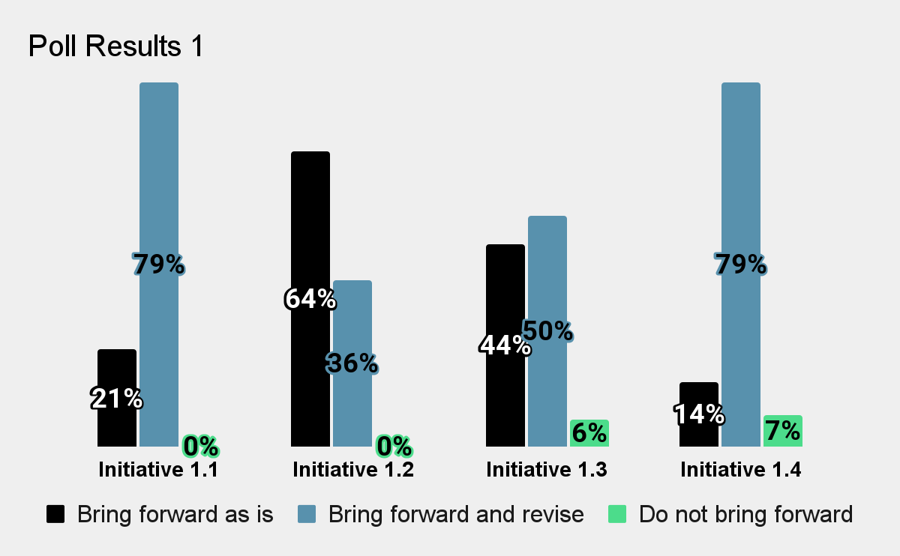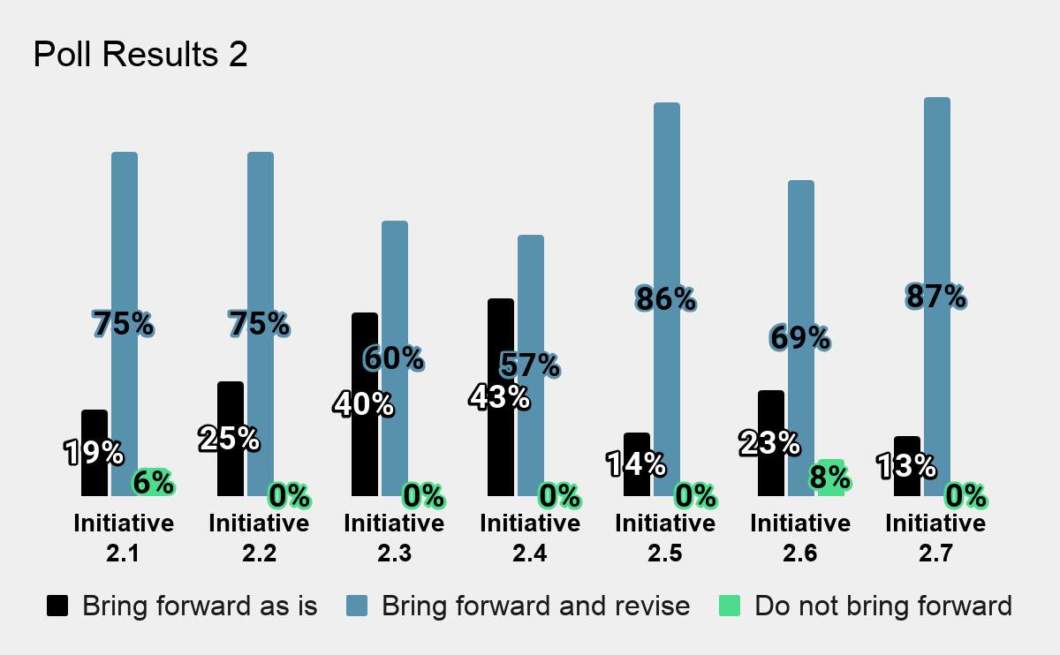

Initiative 1.1: There has been significant progress made in developing academic pathways for students. The early exposure to Cañada of elementary and middle school children should be explored. A possible benefit of an outreach effort is the enrollment of some parents.

Initiative 1.2: The comprehensive college-wide approach to enhance completion is valuable, but there remains a lot of room for improvement. There is a need to adapt to the challenge of nationwide declines in enrollment. Initiative improvements should eliminate impediments to the educational goals of students by flexible scheduling, for example. Students should be 'met where they are.' There should also be accommodation for students with non-degree goals.

Initiative 1.3: The college program Promise is regarded as very helpful to students. The value of Promise lies in its utility to ongoing efforts to attain equitable outcomes. Part-time students stand to benefit from inclusion in the program. The single dissenting view on Promise continuation was raised due to concern that a focus on a specific program is unnecessary because an EMP should deal with broad overarching goals.

Initiative 1.4: The idea of expanding bridge cohort programs remains in its infancy. Bridge and cohort programs are possibly different but conflated concepts. It is thus essential to get clarification on initiative 1.4.

Initiative 2.1: A higher than expected drop in enrollments highlights the need for improvements in collaboration with Pre-K and Adult School partners. Non-traditional students' enrollments should be explored too. ESL students are a potential source of growth in enrollments. There could also be a role for dual enrollment goal-setting.

Initiative 2.2: Efforts to connect students to local employers remain between the phases of design and implementation. Lessons can be drawn from ongoing programs connecting STEM students to employers. There should be attention paid to the preparation, staffing, and budgeting because the initiative is a significant undertaking. Disproportionately impacted groups like undocumented students and males should be specifically assisted with internships, fellowships, and other professional opportunities.

Initiative 2.3: There remains a need to attract the community to the college using high-profile events. There is evidence of the viability of attendance at online events. Any expenditure on community events should be prudent with a cost-benefit analysis taken into consideration. The Latino Thought Makers, Dr. Cornell West talks, soccer games, and the Mexican Folklorico dance are possible community-attracting events. Some ideas for a welcoming climate at events are free parking, uncomplicated contracts, etc. A center for community engagement with possible grant funding will be valuable to realize initiative.

Initiative 2.4: Efforts remain in the design phase. Some work with alumni is presently done by The District Foundation. A library-organized book club targeting alumni is also being developed. Having dedicated staff for alumni-related programs will be beneficial. Inspiration can be drawn from the STEM speaker series.

Initiative 2.5: The goals of this initiative appear to overlap with others.

Initiative 2.6: This initiative is worth expanding.

Initiative 2.7: Paused due to the COVID-19 pandemic. Intentional strategies, innovation, and explicitness are viewed as necessary for the initiative.

Regarding the EMP reference to student populations, the need to adopt an anti-racist framework by avoiding race-neutral language was highlighted.

Due to a lack of time, further review of the Strategic Initiatives was postponed until the next Task Force meeting.

Input on external scan for EMP was solicited.

Plans for a return to in-class lectures and vaccination requirements were discussed.

