Technology Committee
4/12/10
Attendees: Robert Haick, David Meckler, Nathan Staples, Jim Petromelli, Linda Hayes, & VPI, Sarah Perkins
Absent: Mike Sinkewitsch, Greg Stoup, & Mike Tyler
The Technology Committee discussed the following items:
- All computer inventory (hardware) is housed in the District database and the ITS personnel are able to generate reports by campus and by District. All computers purchased come with either a three or four year warranty.
- When the college needs to replace computer hardware that is outdated, it is the college responsibility not the District responsibility.
- There was discussion on what should be installed on laptops for employees and it was agreed upon that any software an employee uses for work and has a site license should be loaded onto the laptop. Note: all software needs to have a specific district site license for that particular desktop/laptop computer in order for it to be installed.
- The Technology Committee should meet quarterly.
- All future decisions on technology needs to go through the Technology Committee for input.
- Processes need to be defined and developed and taken to the Administrative Council and then to the College Planning Council.
- Process/Policy on software, hardware, prioritizing, decision making for grants, new construction with a sustainable plan needs to be developed.
- ITS needs a minimum of two-three weeks in advance and everyone needs to go to the Portal page and click on the section ITS Services Request form and complete the request form and click submit:
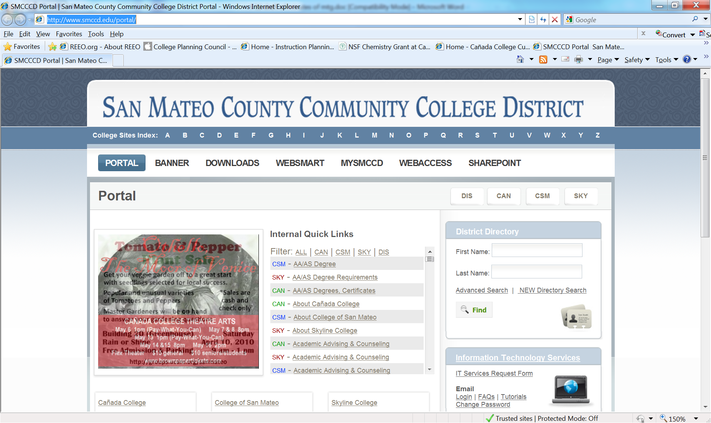

- The Technology Committee needs to work on the following:
  - Define the role and mission of the Technology committee
  - Integrate in the college strategic planning process
  - Develop and implement processes for policies
- The Technology committee needs to play an active role in giving advice to the District ITS on college issues.
- The Technology committee needs to plan for the future and work closely with CEITL on where do we want to be in five years from now:
  - Trends and Issues in technology
  - Technology used for Teaching & Learning
  - How to back up individual hard drives to secure data

