**Evaluating Parameter Estimation of Accuracy and Stability of Structural Property-Dependent Integration Algorithms**

**Manuel Ramirez1, Nathan Carlson1, Oskar Granados1, Madoka Oyama1, Maryam Khan2, Cheng Chen2**

**1Cañada College / 2San Francisco State University**

**Abstract**

Real Time Hybrid Simulation (RTHS) is a viable alternative to using shake tables for testing a structure’s response to seismic loading. RTHS analyzes both physical and numerical substructures to predict the behavior of the entire structure; it is impossible to know the exact mass, damping, and stiffness of the complete structure. The CR and KR-𝛼 Integration algorithms have been widely used to integrate the physical model and analytical model during RTHS. Due to the nature of these algorithms, certain parameters can cause the simulation to be unstable and inaccurate. To effectively use RTHS the structural properties must be estimated. In this research MATLAB and Simulink were used to investigate the structure's response upon seismic loading and explore how varying the parameters affected the stability and accuracy of using these integration algorithms for RTHS. It was found that error in the mass, damping, and stiffness estimations minimally affected the accuracy and stability of RTHS. Using the results from this research, engineers are able to better predict a structure's response to seismic loading.

**I. Introduction**

Real Time Hybrid Simulation (RTHS) consists of two components, a physical substructure and a numerical model. RTHS tests these components simultaneously in real time to predict how the entire structure will respond to seismic loading.1The combination of physical testing and computational modeling gives a more thorough examination of the response on civil structures due to seismic loading while reducing the costs and means of an entirely physical structure. The physical component consists of a segment of the structure including the servo hydraulic actuators, while the rest of the structure is modeled mathematically through a computational system. Because a physical model and numerical model are being tested to predict the behavior of the complete structure, there is no way to know the exact structural properties of the complete structure; to run RTHS the structural properties must be estimated. The purpose of this study was to discover how error in these estimations affected the results of RTHS. To carry out this research, RTHS will be emulated using Simulink and analyzed using MATLAB2.

**II. Approach**

RTHS has been increasingly recognized as a powerful methodology to evaluate structural systems. The comparison with numerical simulation results demonstrates that the real time hybrid simulation system produces accurate and reliable experimental results; thus, proving great potential for structural performance evaluation in earthquake engineering. However, testing different substructures to predict the response of the whole structural system involves key factors. These include the boundary conditions of the space surrounding the substructure, the dynamics of the actuators that impose lateral excitations, and the stability of the integration algorithms. The boundary conditions are crucial to ensure communication between the computational model and the physical substructure. Also, due to inherency of the dynamics of servo hydraulic actuators, a time delay is introduced in the simulations which may lead to accuracy degradation as well as instability. The computational process is based on integration algorithm methods that require estimation of parameters, which will affect the stability and accuracy of the output. The error, between command and measured response of the structural system, can be minimized if another method of analysis was explored.

**A. Integration Algorithms**

The algorithm methods used are the core of the seismic response data. Each algorithm has a different computational model in which the delay is taken into account. These algorithms are explicit, making it computationally efficient by avoiding iterations. The algorithm methods change the domain to a continuous s-domain using the Laplace-transform function and to a discrete z-domain using the z-transform function5. The discrete z-transform function is a more convenient process of gathering information; however, the use of Laplace is still useful to test small estimation range of the structural properties.

**1. Laplace Simulation Model**

A single degree of freedom (SDOF) structure can be simply modelled as a mass attached to stiffening and damping elements (i.e. a harmonic oscillator), such as the case of a Single Degree of Freedom (SDOF) for an ideal mass-spring-damper system as shown in Fig. 1. Using a SDOF, the Equation of Motion (EOM) considers all forces acting on the rigid body (Eqn 1.)

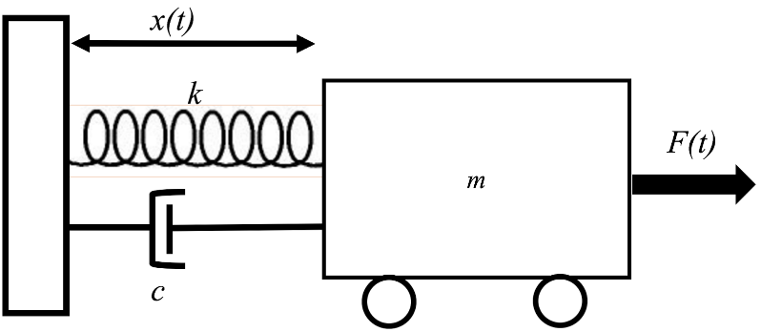

***Figure 1.*** *Illustration of oscillating mass spring damper system used to represent the SDOF structure used in RTHS.*

$m\ddot{x}+c\dot{x}+r\left(t\right)=F(t)$ (Eqn 1)

In Eqn 1, $m$, $c$, and $r(t)$ represent the mass, damping, and restoring force of the structure respectively; $F(t)$ represents the external excitation force. The restoring force for a linear elastic structure is defined by stiffness coefficient, $k$, and the displacement response $x(t)$ of the structure, per Eqn 2. The system is now displayed as the second degree ordinary differential equation; the Laplace Transform in Eqn 3 changes the system’s domain from $(t)$ to $(s)$ and with some simplification, is seen in Eqn 4.

$m\frac{d^{2}x(t)}{{dt}^{2}}+c\frac{dx(t)}{dt}+kx\left(t\right)=F(t)$ (Eqn 2)

$mX\left(s\right){ s}^{2}+cX\left(s\right) s+kX=F(s)$ (Eqn3)

$X\left(s\right) \left(ms^{2}+cs++k\right)=F(s)$ (Eqn 4)

$\frac{F(s)}{X(s)}=\frac{1}{ms^{2}+cs+k}$ (Eqn 5)

The transfer function (Eqn 5) relates the response, $X(s)$, of a system to its input, $F(s)$. For a given structure, the response includes the displacement of the structure as it undergoes an external excitation force, such as ground motion or an earthquake. Eqn 5 is used when finding a structure's response to a specific ground motion. This will be added into the Simulink2 file, a graphical block model that simulates dynamic systems within MATLAB2.

Figure 2 shows the block model that was used to replicate the effect of the system under seismic loading. External ground motion data, downloaded from the Peers database3, was sent into the control diagram. Notice that the Laplace transfer function has been added under the “Transfer Fcn” block. Out of the transfer function comes the command response, *‘ $xc$’*; to get the measured response, *‘ $xm$’*, the transfer function values go through a delay block. If there is no delay effect from the servo-hydraulic actuator, the measured response is equal to the command response. The restoring force, $r(t)$, is being expressed under the block “gain”. This dynamic simulation is convenient when working with small range of values due to the nature of the S-domain function. The discrete Z-transform function5 would demand some changes in the Simulink model.  By analyzing the stiffness, damping and mass of the system it could then be evaluated that the displacement of the system is due to the given excitation force.

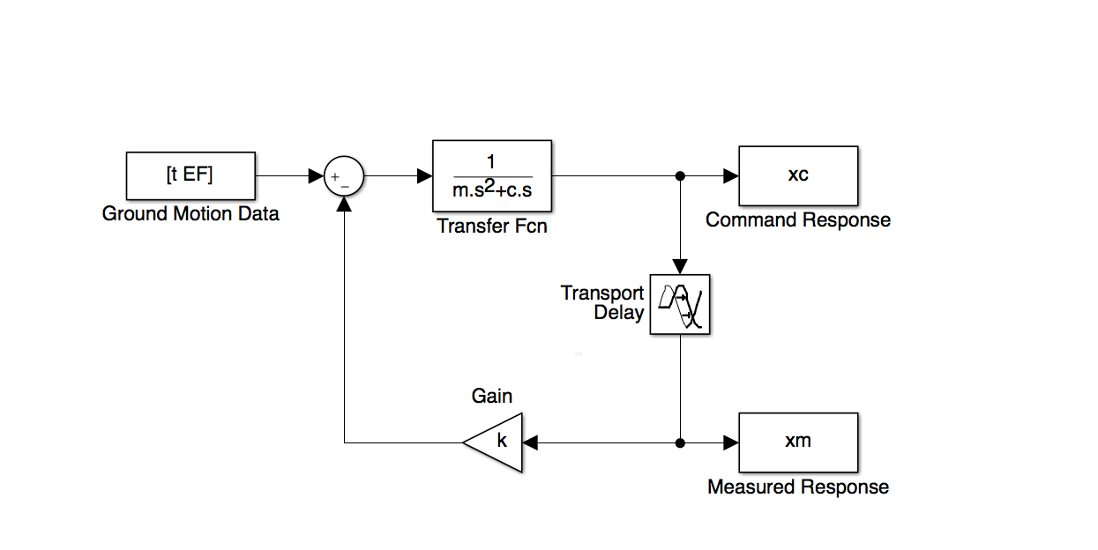

***Figure 2.*** *SIMULINK Block Diagram for the error quantification of RTHS*

**2. CR-Integration Algorithm**

The unconditionally stable explicit CR Integration algorithm was derived using discrete control theory. The z-transfer function converts a discrete time signal5, a sequence of real or complex numbers, into a complex frequency domain representation. This discrete z-transfer function (Eqn 6) compares the discrete input to the output for the system. It can be considered as a discrete time equivalent of the Laplace transform. Integration algorithms are used in RTHS1 to determine the structural response of a system based on the feedback of restoring forces. Explicitly conditional integration algorithms are preferred over implicit algorithms since they don't require iterations between time-steps. The explicit conditional integration algorithm works best with systems of higher natural periods and is greater computational efficient when compared to alternate methods.

While other algorithms have proved reliability for structural testing, the CR integration algorithm is explicit for both displacement and velocity, and is therefore more advantageous for real-time testing. The equation of motion and the formulas from acceleration and velocity which have been added the factor $α$ results in the CR algorithm expression. The output over input will look like Equation 6 where the transfer function, $G(z)$, relates the structure’s displacement, $X(z)$, while the excitation force relates to $F\left(z\right).$

$G\left(z\right)=\frac{X(z)}{F(z)}=\frac{n_{2}z^{2}+n_{1}z+n_{0}}{d_{2}z^{2}+d_{1}z+d_{0}}$ (Eqn 6)

**Table 1.** Coefficients for CR integration algorithm including estimated parameters

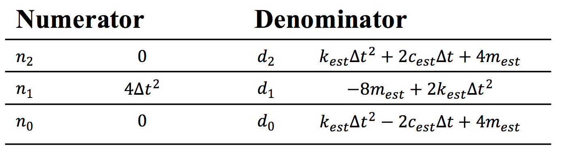

Integration parameters have been defined for a linear elastic structure in Equation 7, where in order to have unconditional stability a factor is added known as α. This is defined as $m_{est}$, $c_{est}$ and $k_{est}$ for the estimated mass, damping and stiffness, respectively and $Δt$ the time-step.

$α_{1}=α_{2}=\frac{4m_{est}}{{4m}_{est}+2Δtc_{est}+{Δt}^{2}k_{est}}$ (Eqn 7)

To find the structure’s stability the numerator is set equal to zero to then solve for $z$; the solutions will be known as “poles”. Correspondingly, the denominator is set to zero to find the “zeros” which determine the magnitude in the unit circle by using the Euler’s method.

The CR-algorithm is represented in the Simulink, similarly as the continuous Laplace method. Although the CR-algorithm is estimating several structural properties; there could still be a factor to take into account, the energy dissipation of a building under seismic loading.

**3.         KR-𝛼 Integration Algorithm**

The KR-𝛼 integration algorithm is very similar to the CR algorithm. The only difference is the presence of the ρ∞ variable which accounts for energy dissipation in the system being tested.

**B.        Computational Tools**

In this paper there has been a few computational tools. These tools were all found online and it certainly made this research possible in a more practical manner.

**1. MathWorks**

The research has used two major products from the MathWorks software company, MATLAB2 and Simulink. All the scripts for the RTHS have been written in MATLAB and the dynamic simulation on Simulink. This last one comes in the MATLAB version.

**2. Maple 18**

Maple 184 has been useful to solve all major calculations. From the Equation of motion (Eq 1) to the “poles” and “zeros” Maple 18 has been the equation solver for this research. In particular,   the z-transform function would have been a considerable challenge to find respective domains from the ground-motions data3.

**3. Ground-motion Data**

The ground-motions (GM) data were available from The Pacific Earthquake Engineering Research Center (PEER) website3. These files contain recorded accelerations from many different earthquakes. The data are called by GM followed by numbers from 1 to 99.

**III. Analysis and Results for Estimating Parameters**

In every test done the starting parameters have been mass = 1kg, damping ratio = 2%, and natural periods from 0.25s to 3s in intervals of .25s. Therefore, after solving for c and k, starting values of 0.68 Ns/m and 295.84 N/m respectively.

**A. Error Quantification for the Effect of Actuator Delay**

When delay is introduced in RTHS, the measured displacement tends to be different than the command displacement. Figure 3 shows the $xc$ and $xm$ with no delay in the system, Figure 4 shows the effect delay has on RTHS. The measured displacement, including the delay, is expressed in orange and the command displacement, simulating lateral excitation forces (i.e. seismic forces), in blue. The values of the command displacement are the same in both Figure 3 and Figure 4.

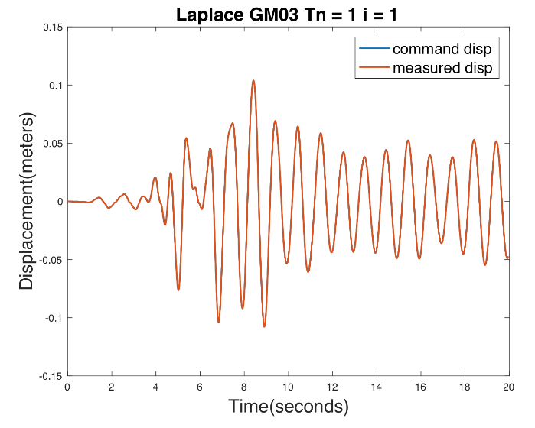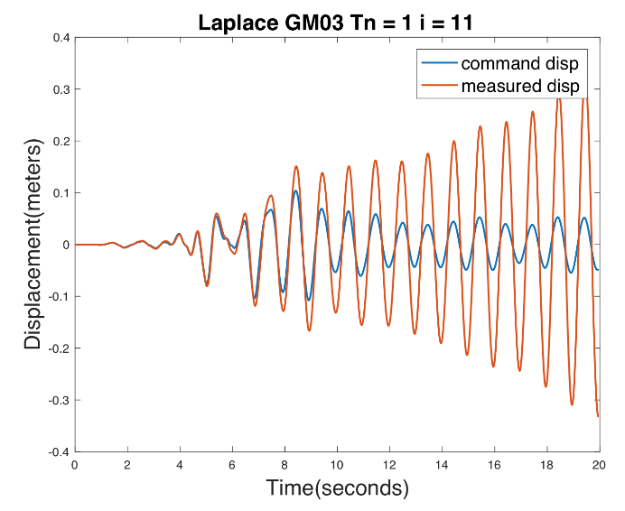

***Figure 3.*** *Displacement with no-delay****Figure 4.*** *Displacement with delay factor (i=11)*

In Figure 3 there was no delay, making this case an ideal scenario. As soon as the delay factor is taken into account, the measured response gets larger while the intended command displacement tends to disappear as a real earthquake would. It is important to quantify this error to know what delay values are allowable when running RTHS.

A Root Mean Square (RMS) error was calculated to evaluate the delay effect (Eqn 8). The response is graphically represented using variables $xm$ and $xc$.

$RMS=100\%× \sqrt{\frac{\sum_{i}^{n}{{(x_{m}-x_{c})}^{2}}}{n}}$ (Eqn 8)



***Figure 5.*** *Laplace RMS error for different natural periods*

Figure 5 shows the Laplace RMS percentage error for different natural periods as delay increases.  All of these curves were tested under GM01, they show 21 different periods, $Tn$, from $Tn$ =1s to $Tn$ = 5s in increments of 0.25s. Starting from the top blue curve to the rainbow formed in the bottom, the RMS percentage error decreases when as the natural period increases.

**B. CR-algorithm Method Error Quantification for Stability and Accuracy**

**1. Accuracy Error Calculation**

After applying the same concept of RMS error to quantify the error between $xc$ and $xm$ from the CR-algorithm, Figure 6 is obtained.



***Figure 6.*** *CR-RMS percentage error for different natural periods*

In Figure 6, GM01 was tested and different curve lines express the natural periods versus the delay factor, which is equivalent to 125 $×{10}^{-5}sec.$ per one delay factor. In addition to the illustration of error caused by the delay, the CR-algorithm allows estimation of parameters such as mass, damping and stiffness.

**i.) CR-algorithm Percentage Error Estimating the Mass**

Figures 7 and 8 show the RMS percentage error between $xc$ and $xm$ along the estimation of mass for different natural periods for two different ground motions.

 

***Figure 7.****RMS error for estimation of mass (GM12)* ***Figure 8.****RMS error for estimation of mass (GM33)*

Figure 7 and 8 shows the RMS error estimating a 1kg mass. Notice that the difference in mass does not significantly affect the measured response, the root mean square error is less than 1%.

**ii.) CR-Algorithm Percentage Error Estimating the Damping Coefficient**

Figures 9 and 10 show the RMS percentage error when varying the damping coefficient with two different ground motions.

 

***Figure 9.****RMS error for estimation of damping coef.* ***Figure 10.****RMS error for the estimation for damping coef.*

Evaluating the damping coefficient shows no major percentage errors even for different natural periods for both GM12 and Gm33.

**iii.) CR-algorithm Percentage Error Estimating Stiffness**

For Figures 11 and 12 the stiffness has been varied and analyzed with different natural periods for different ground motions.



***Figure 11.*** *RMS error for estimation of stiffness* ***Figure 12.*** *RMS error for estimation of stiffness*

Figures 11 and 12 show that the RMS percent error is minuscule, and will not significantly affect the accuracy of RTHS.

**2. Stability Error Calculation**

As mentioned in the CR-algorithm method, the results of finding $z$ in the numerator are the “poles” and “zeros” from the denominator. The stability of the system can be evaluated by looking at the roots of the transfer function and mapping them on a unit circle. The plane of Real vs Imaginary numbers is shown in Figure 13 along with the unit circle. The poles and zeros of a transfer function are the magnitudes for which the values of denominator and numerator of the transfer function becomes zero. The poles of $G\left(z\right)$ are used to determine the integration parameters that express the variation in the displacement and velocity over the time-step. If proper stable poles are used, the integration algorithm will be accurate and unconditionally stable.

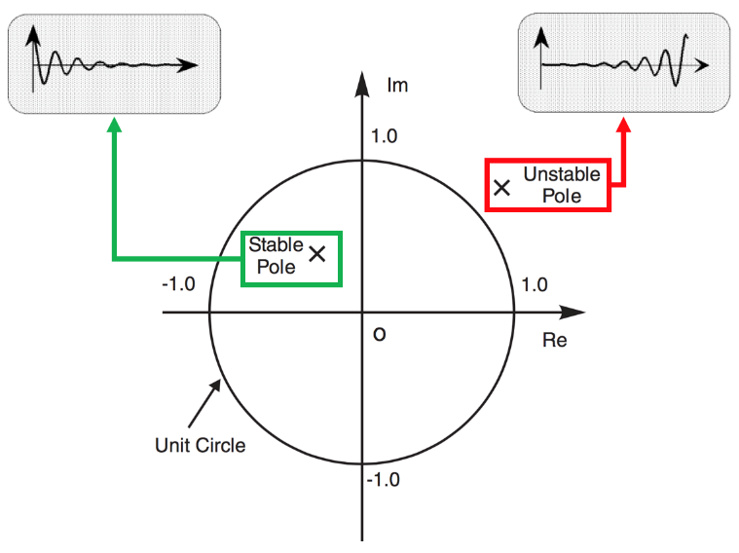

***Figure 13.*** *Pole-zero map for the z-domain.  Poles located outside of the unit circle are considered unstable while poles located within the unit circle are stable.*

**i.) Stability for the Mass Estimation**

In Figures 14 and 15 there is an underestimation and overestimation respectively of 50% of the initial mass.

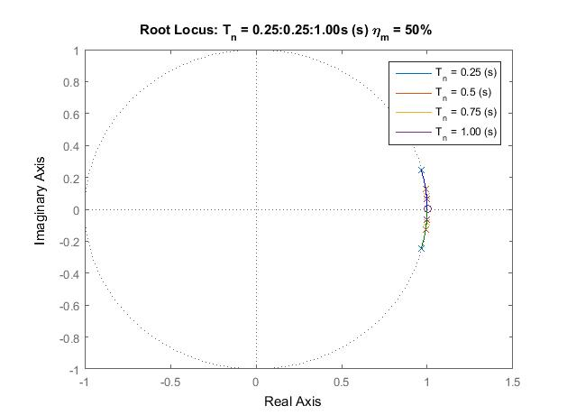

***Figure 14.*** *Root locus analysis stability for different periods for and underestimation of mass.*

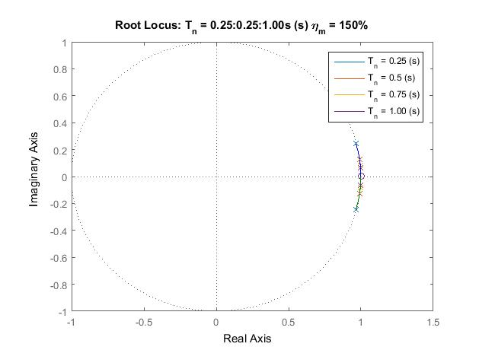

***Figure 15.*** *Root locus analysis stability for different periods for and overestimation of mass.*

The root locus allows to visually determine if the underestimation will result inside the unit circle. For the periods of .25s to 1s in intervals of 0.25s the test appears stable. When the mass is being overestimated by 50% of the starting value the model keeps having the range of “poles” than the previous estimation. The root locus analysis shows the stability of the mass estimation.

**ii.) Stability for the Damping Coefficient Estimation**

In Figures 16 and 17 there is an underestimation and overestimation of 50% for both of the initial damping coefficient.

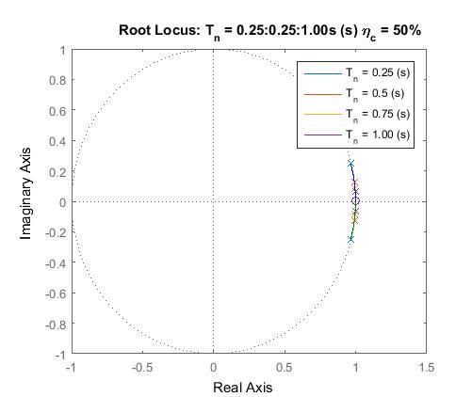

***Figure 16.*** *Root locus analysis stability for different periods for an underestimation of damping.*

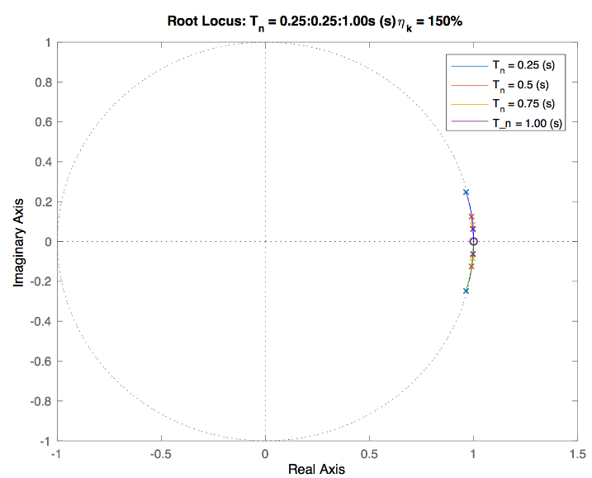

***Figure 17.*** *Root locus analysis stability for different periods for an overestimation of damping.*

The root locus analysis also shows the stability when the damping coefficient is overestimated and underestimated. The “poles” result to be inside the unit circle, being stable as well as when there is an overestimation of 50%.

**iii.) Stability for the Stiffness Coefficient Estimation**

In Figures 18 and 19 there is an underestimation and overestimation respectively of 50% of the initial stiffness.

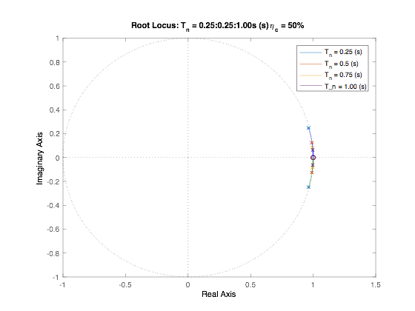

***Figure 18.*** *Root locus analysis stability for different periods for an underestimation of stiffness.*

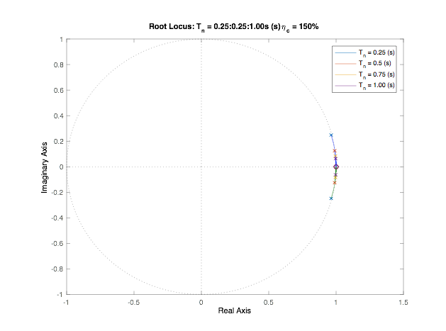

***Figure 19.*** *Root locus analysis stability for different periods for an underestimation of stiffness.*

The root locus analysis also shows a stable system when the stiffness coefficient is overestimated as well as underestimated.

**C. KR-α Error Quantification**

The KR-α algorithm is very similar to the CR-algorithm, but with an added factor, ρ, that accounts for energy dissipated during RTHS. This required different *n* and *d* coefficients in our Z-domain transfer function than those found in the CR-algorithm method. This step was carried out using Maple 184. It is important to emphasize that the KR-α is very similar to the CR-algorithm method as long as the energy dissipation factor does not increase rapidly. The CR-algorithm is the same as the KR- α when ρ equals 1. After analyzing the stability and accuracy of RTHS when estimating the parameters, the next step was to consider ρ. The data was performed using small increments of ρ.

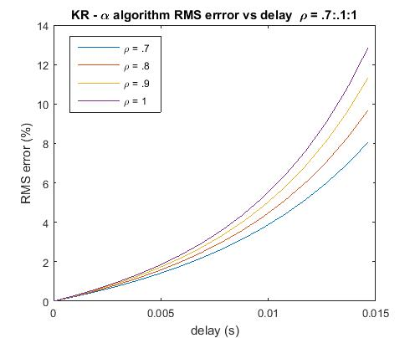  
***Figure 20.*** *Graph comparing how different values of rho affects the RMS error as delay increases*

Testing the KR-α method using ground motion GM01 to then compare several increments of a low, unitless factor ρ has been valuable. The inaccuracy from $xm$ and $xc$ is illustrated in Figure 20.

**IV. Conclusions**

The structural property-dependent parameters have been greatly examined in this research paper. Under the explicit algorithm methods used through this research, the accuracy is not significantly affected by low measures of natural periods while estimating mass, damping and stiffness. However, based on Figure 8 and Figure 9, significantly higher errors are expected for higher periods as the damping estimation increases. Although the tests involve small parameters, the lines expressing different periods signify the rapid increase in error estimations for larger values of $m$, $c$ and $k$.

The stability found through the “poles” and “zeros” show that the system is stable for small estimation limits on 1kg of mass. Nonetheless, it is necessary the further investigation to determine an exact boundary for estimations on stiffness and damping, in order to remain between the stable region.

The studies done in this research demonstrates the significance of the mass, damping and stiffness of a structural system and that it is not necessary to be extremely precise in estimating these errors to get accurate and stable results when predicting a structure's response to seismic loading using RTHS.

**V. Acknowledgments**

This project was partly supported by the US Department of Education through Minority Science and Engineering Improvement Program (MSEIP, Award No. P120A15014), and the Hispanic-Serving Institution Science, Technology, Engineering, and Mathematics (HSI STEM) Program, Award No. P031C110159.

**VI. Bibliography**

[1] Chen, C. and Ricles, J. M. (2008), Stability analysis of SDOF real-time hybrid testing systems with explicit integration algorithms and actuator delay. Earthquake Engng. Struct. Dyn., 37: no. doi: 10.1002/eqe.795

[2] MATLAB & Simulink, Natick, MA: MathWorks, 2016. Computer Software.

[3] http://peer.berkeley.edu/

[4] Maple 18. Waterloo, ON Canada: Maplesoft, 2012. Computer software.  
[5] Finn Haugen, TechTeach: Discrete-time signals and systems (2005)