Radiologic Technology
Comprehensive Program Review Data Packet
7A. Enrollment Trends
Use the data provided by PRIE to examine your enrollments by department or courses. Describe trends in headcount, FTES, and load. If applicable, describe any other enrollment data that is relevant to your program
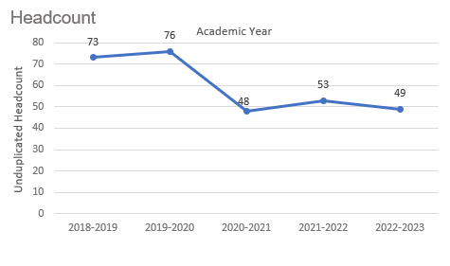
Headcount in Radiologic Technology was down 32.9% in 2022-2023 (49 students) compared to 2018-2019 (73 students). Headcount increase slightly before it declined dramatically in 2020-2021 and remained around that level through the most recent academic year.

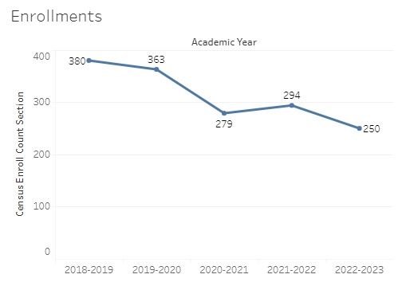
Enrollment in Radiologic Technology was down 34.2% in 2022-2023 compared to five years ago in 2018-2019. Radiologic Technology enrollment started at a five-year high in 2018-2019 with 380 enrollments and decreased to a five-year low of 250 enrollments in 2022-2023.

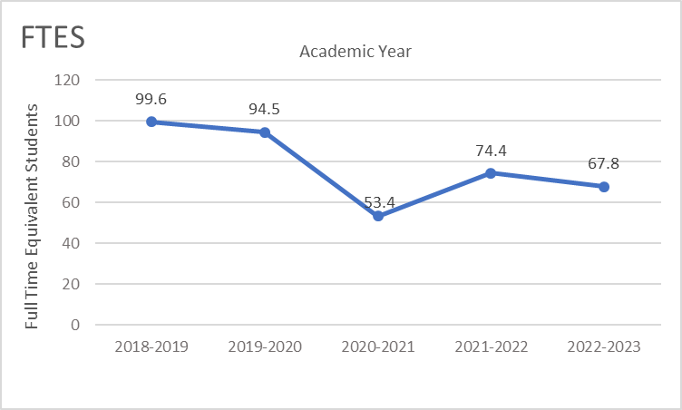
Full-time equivalent students (FTES) in Radiologic Technology was down 31.9% in the most recent academic year (2022-2023) compared to five years ago (2018-2019), a decrease of 31.8 FTES.

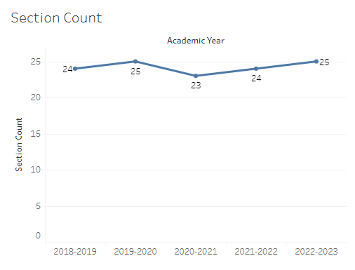
The number of sections offered in Radiologic Technology ranged from 23 sections to 25 sections, remaining fairly stable over the last five academic years.

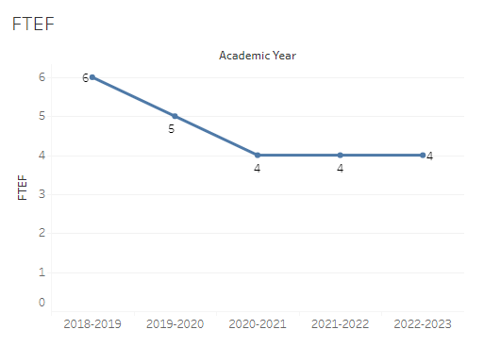
The number of full-time equivalent faculty (FTEF) in Radiologic Technology went from 6 in 2018-2019, down to 5 FTEF the following year, and then 4 FTEF for the next three academic years.

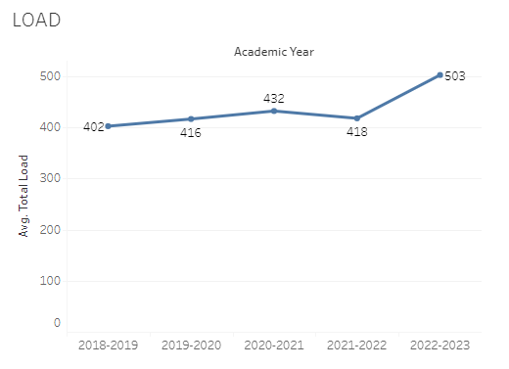
Load in Radiologic Technology fluctuated slightly over the last five academic years with a low of 402 in 2018-2019 and a high of 503 in 2022-2023.

8A. Access & Completion
Describe the student completion and success rate in your courses and/or program using the data provided by PRIE. Look at your course offerings, in the last program review cycle was it possible for a student to complete your certificates or degrees while only completing courses at Cañada College? How can the college help you improve student completion and success? What changes could be made?

Note: See the Course Enrollment & Success Detail Report for additional course-level data. This report can be found on PRIE’s Data Dashboards & Packets page under the program name.

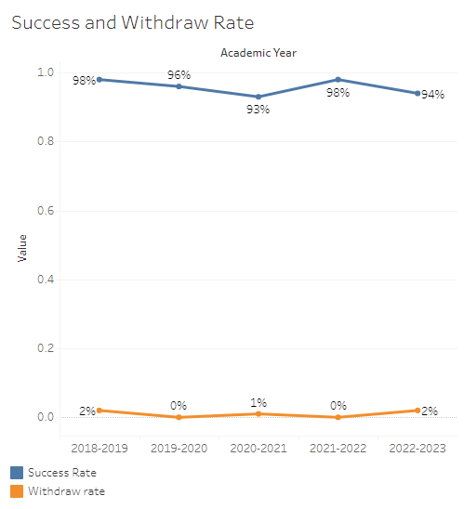
The overall success rate in Radiologic Technology remained fairly stable over the last five academic years, with a low of 93% and a high of 98%. Overall withdraw rates in Radiologic Technology were very low, ranging from 0% to 2%.
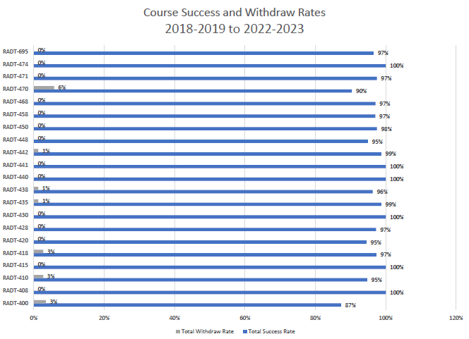
Course success rates in Radiologic Technology ranged from a minimum of 87% in RADT 400 to a maximum of 100% in multiple RADT courses. Course withdraw rates in Radiologic Technology ranged from a max of 6% in RADT 470 to a minimum of 0% for the majority of the other RADT classes offered in the last five academic years.

8B. Student Equity
One of the goals of the College’s Student Equity plan is to close the performance gaps for disproportionately impacted students. Use the data provided by PRIE that indicates which groups are experiencing a disproportionate impact in your program. Which gaps are most important for improving outcomes in your program? How can the college help you address these gaps? What changes could be made?

The Equity and Disproportionate Impact (DI) dashboard was used to identify subgroups that may have been disproportionately impacted in Radiologic Technology in the most recent academic year (2022-2023). The three metrics used to examine potential disproportionate impact were enrollment rates (referred as access), success rates, and withdraw rates. The rate for each subgroup was compared to either the college-wide rate (access) or the overall program-level rate (success and withdraws). The difference between the two rates is known as the ‘gap’ and may be referred to as a performance gap or equity gap. Student subgroups that may have been disproportionately impacted in Radiologic Technology appear below.
Access
Access is an indicator of what student subgroups are enrolling in courses, based on unique student counts. Enrollment data revealed one student subgroup was underrepresented in Radiologic Technology classes compared to the college-wide population (see Table 1). The proportion of students in Radiologic Technology with a unit load considered ‘less than part-time’ (fewer than 6 units) was 42.7 percentage points lower than the proportion of ‘less than part-time’ students enrolled college-wide.
Table 1.
Student Subgroup | Gap
Unit load - Less than part-time (less than 6 units) | -42.7

Success
Success is the rate at which different student subgroups pass courses and is based on enrollments. The success rate for different subgroups in Radiologic Technology was compared to the overall success rate in Radiologic Technology. No disproportionate impact was found for success in Radiologic Technology.

Withdraws
Withdraws is the rate at which a student withdraws from a course, with higher numbers being worse, as they indicate greater withdraw rates. The withdraw rates for subgroups in Radiologic Technology was compared to the overall withdraw rate for the program. No disproportionate impact was found for withdraws in Radiologic Technology.
8C. Completion – Success Online
The college has a goal of improving success in online courses. Using the data provided by PRIE, what significant gaps do you see in success between online/hybrid and non-online courses? What changes could be made to reduce these gaps? If your program does not offer online/hybrid courses, please write “not applicable”.
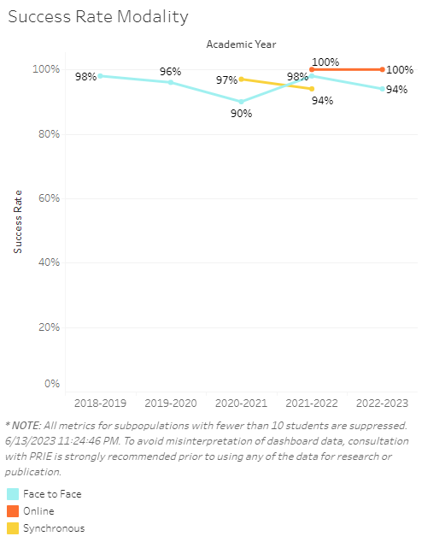

Source: https://canadacollege.edu/prie/dashboards/disproportionate-impact.php

