Library Science
Comprehensive Program Review Data Packet
7A. Enrollment Trends
Use the data provided by PRIE to examine your enrollments by department or courses. Describe trends in headcount, FTES, and load. If applicable, describe any other enrollment data that is relevant to your program
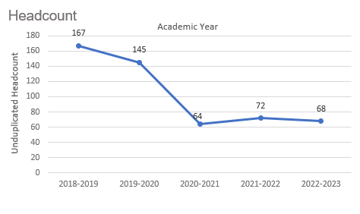
Headcount in Library Science was down 59.3% in 2022-2023 (68 students) compared to 2018-2019 (167 students). Headcount declined steadily for two academic years then flattened out.

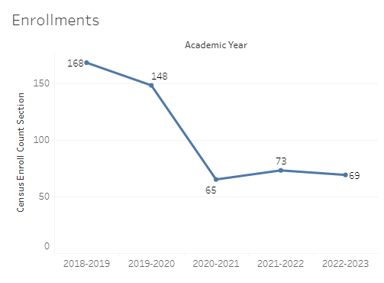
Enrollment in Library Science was down 58.9% in 2022-2023 compared to five years ago in 2018-2019. Library Science enrollment was at a five-year high in 2018-2019 with 168 enrollments and a five-year low of 65 enrollments in 2020-2021.

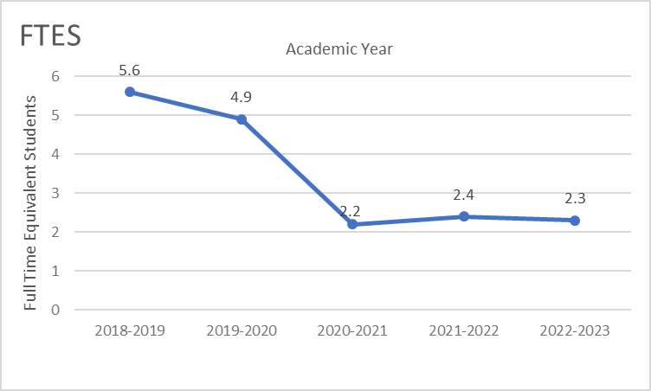
Full-time equivalent students (FTES) in Library Science was down 58.9% in the most recent academic year (2022-2023) compared to five years ago (2018-2019), a decrease of 3.3 FTES.

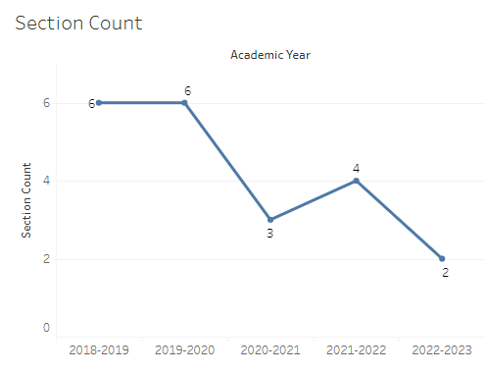
Overall the number of sections offered in Library Science decreased over the last five academic years, going from six sections in 2018-2019 down to two sections in 2022-2023.

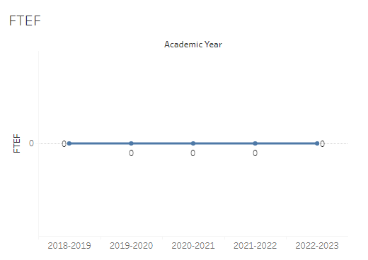
The number of full-time equivalent faculty (FTEF) in Library Science was zero for the last five academic years.

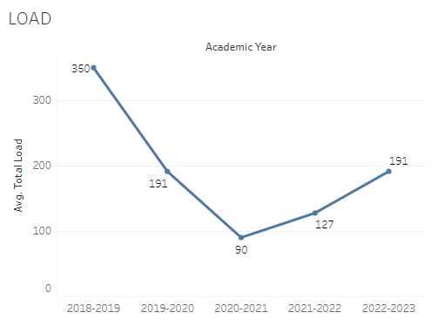
Load in Library Science dropped dramatically over the last five academic years, with a high of 350 in 2018-2019 to a low of 90 in 2020-2021. The load was 191 in the most recent academic year (2022-2023).

8A. Access & Completion
Describe the student completion and success rate in your courses and/or program using the data provided by PRIE. Look at your course offerings, in the last program review cycle was it possible for a student to complete your certificates or degrees while only completing courses at Cañada College? How can the college help you improve student completion and success? What changes could be made?

Note: See the Course Enrollment & Success Detail Report for additional course-level data. This report can be found on PRIE’s Data Dashboards & Packets page under the program name.

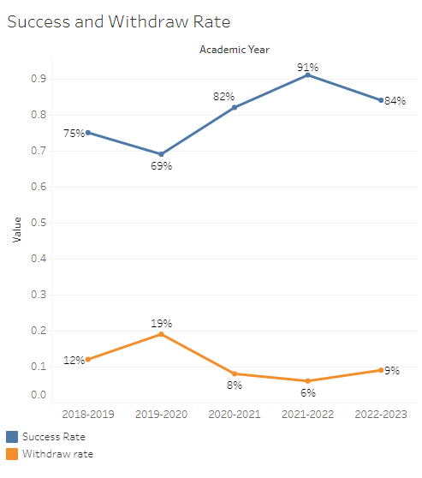
The overall success rate in Library Science increased over the last five academic years, with the exception of one year. The success rate was 75% in 2018-2019, peaked at 91% in 2021-2022, and ended at 84% in the most recent academic year (2022-2023). Overall, withdraw rates have decreased over the last five years, with a maximum withdraw rate of 19% in 2019-2020 and a minimum withdraw rate in 2021-2022 of 6%.
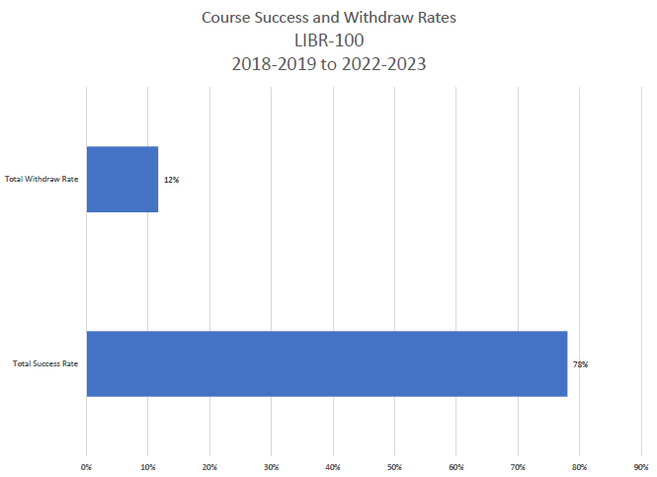

8B. Student Equity
One of the goals of the College’s Student Equity plan is to close the performance gaps for disproportionately impacted students. Use the data provided by PRIE that indicates which groups are experiencing a disproportionate impact in your program. Which gaps are most important for improving outcomes in your program? How can the college help you address these gaps? What changes could be made?

The Equity and Disproportionate Impact (DI) dashboard was used to identify subgroups that may have been disproportionately impacted in Library Science in the most recent academic year (2022-2023). The three metrics used to examine potential disproportionate impact were enrollment rates (referred as access), success rates, and withdraw rates. The rate for each subgroup was compared to either the college-wide rate (access) or the overall program-level rate (success and withdraws). The difference between the two rates is known as the ‘gap’ and may be referred to as a performance gap or equity gap. Student subgroups that may have been disproportionately impacted in Library Science appear below.
Access
Access is an indicator of what student subgroups are enrolling in courses, based on unique student counts. Enrollment data revealed two student subgroups were underrepresented in Library Science classes compared to the college-wide population (see Table 1). The proportion of students in Library Science with a unit load considered ‘less than part-time’ (fewer than 6 units) was 36.7 percentage points lower than the proportion of ‘less than part-time’ students enrolled college-wide. The proportion of students who were not considered low income in Library Science was 25.2 percentage points lower than the proportion of ‘not low income’ students enrolled college-wide. These findings lead to the conclusion there was a greater proportion of students enrolled in six or more units and a greater proportion of low-income students in Library Science classes compared to campus-wide.

Table 1.
Student Subgroup | Gap
Unit load - Less than part-time (less than 6 units) | -36.7
Not Low Income | -25.2

Success
Success is the rate at which different student subgroups pass courses and is based on enrollments. The success rate for different subgroups in Library Science was compared to the overall success rate in Library Science. No disproportionate impact was found for success in Library Science.

Withdraws
Withdraws is the rate at which a student withdraws from a course, with higher numbers being worse, as they indicate greater withdraw rates. The withdraw rates for subgroups in Library Science were compared to the overall withdraw rate for the program. No disproportionate impact was found for withdraws in Library Science.

8C. Completion – Success Online
The college has a goal of improving success in online courses. Using the data provided by PRIE, what significant gaps do you see in success between online/hybrid and non-online courses? What changes could be made to reduce these gaps? If your program does not offer online/hybrid courses, please write “not applicable”.
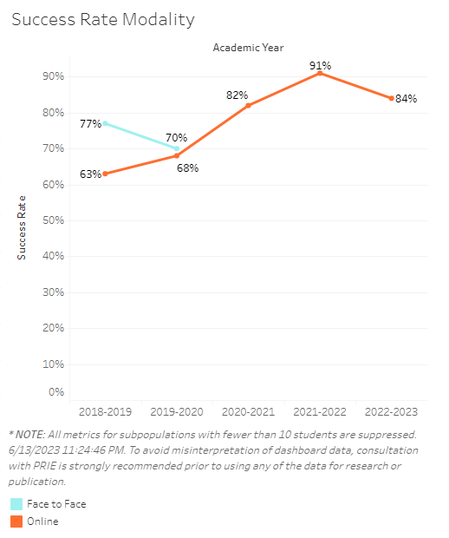
Library Science classes have been primarily offered online for the last five academic years. When face-to-face sections were offered, the success rate was slightly higher than online success. However, the most recent success rates in online Library Science sections surpassed the face-to-face success rates by five or more percentage points.

Source: https://canadacollege.edu/prie/dashboards/disproportionate-impact.php

