Human Services
Comprehensive Program Review Data Packet
7A. Enrollment Trends
Use the data provided by PRIE to examine your enrollments by department or courses. Describe trends in headcount, FTES, and load. If applicable, describe any other enrollment data that is relevant to your program
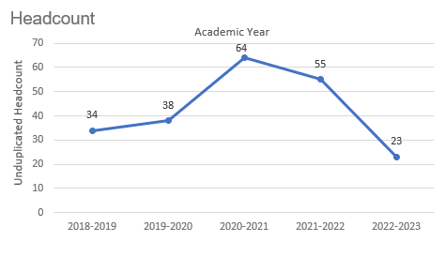
Headcount in Human Services was down 32.4% in 2022-2023 (23 students) compared to 2018-2019 (34 students). Headcount spiked in 2020-2021 (64 students) then dropped over the next two academic years.

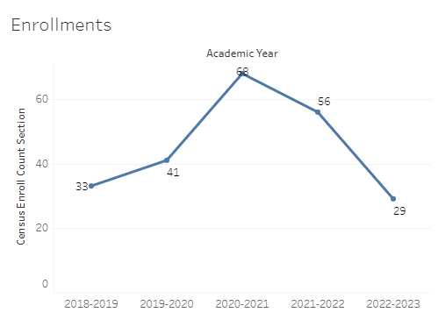
Enrollment in Human Services was down 12% in 2022-2023 compared to five years ago in 2018-2019. Human Services enrollment reached a five-year high in 2020-2021 (68 enrollments) and a five-year low in the most recent academic year (2022-2023 = 29 enrollments).

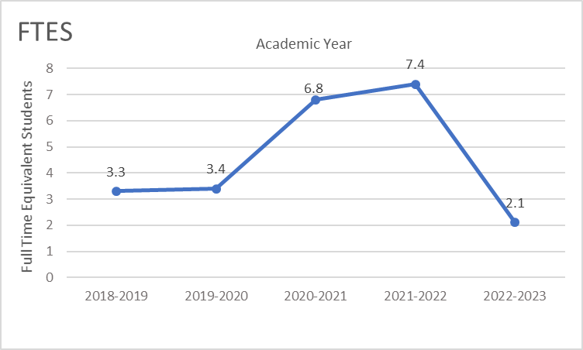
Full-time equivalent students (FTES) in Human Services was down 36.4% in the most recent academic year (2022-2023) compared to five years ago (2018-2019), a decrease of 1.2 FTES.

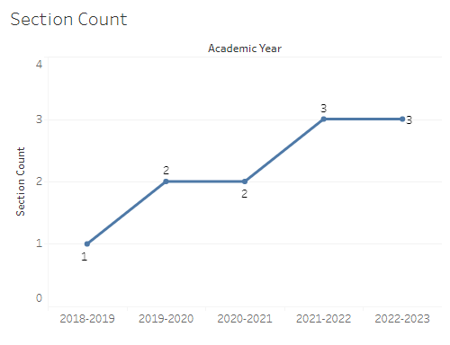
The number of sections offered in Human Services increased from one section in 2018-2019 to two sections for the next two academic years. In 2021-2022 the number of sections in Human Services increased to three and remained at three sections through the most recent academic year.

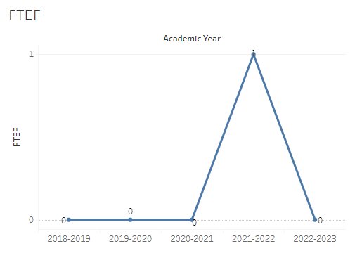
The number of full-time equivalent faculty (FTEF) in Human Services was zero each academic year except 2021-2022 when there was one FTEF.

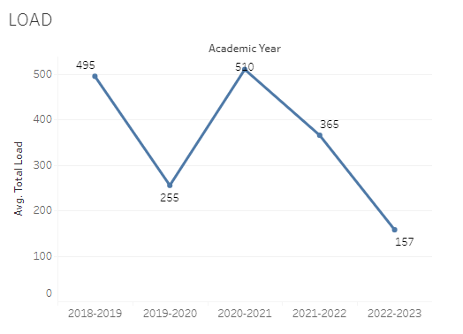
Load in Human Services fluctuated a lot over the last five academic years with a high of 510 in 2020-2021 and a low of 157 in 2022-2023.

8A. Access & Completion
Describe the student completion and success rate in your courses and/or program using the data provided by PRIE. Look at your course offerings, in the last program review cycle was it possible for a student to complete your certificates or degrees while only completing courses at Cañada College? How can the college help you improve student completion and success? What changes could be made?

Note: See the Course Enrollment & Success Detail Report for additional course-level data. This report can be found on PRIE’s Data Dashboards & Packets page under the program name.

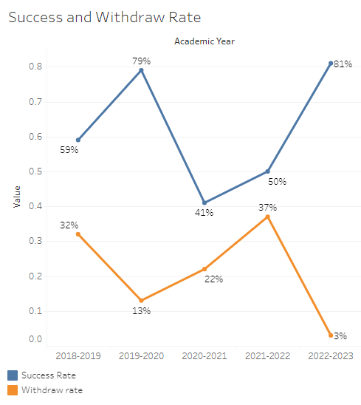
The overall success rate in Human Services has been inconsistent over the last five academic years, likely due to the small number of enrollments. The success rate in Human Services went from 59% in 2018-2019 to 79% in 2019-2020, followed by a dramatic drop to 41% the next year. In 2021-2022 the success rate increased to 50% and then up to 81% in the most recent academic year. Withdraw rates in Human Services were as unstable as success rates with a maximum of 37% in 2021-2022 and a minimum of 3% in 2022-2023.
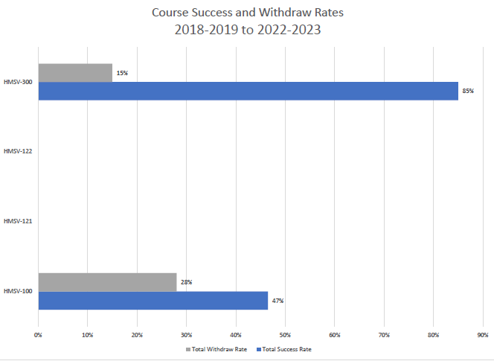

8B. Student Equity
One of the goals of the College’s Student Equity plan is to close the performance gaps for disproportionately impacted students. Use the data provided by PRIE that indicates which groups are experiencing a disproportionate impact in your program. Which gaps are most important for improving outcomes in your program? How can the college help you address these gaps? What changes could be made?

The Equity and Disproportionate Impact (DI) dashboard was used to identify subgroups that may have been disproportionately impacted in Human Services in the most recent academic year (2022-2023). The three metrics used to examine potential disproportionate impact were enrollment rates (referred as access), success rates, and withdraw rates. The rate for each subgroup was compared to either the college-wide rate (access) or the overall program-level rate (success and withdraws). The difference between the two rates is known as the ‘gap’ and may be referred to as a performance gap or equity gap.
Note: The number of enrollments in Human Services failed to meet the minimum requirements to conduct the analysis for disproportionate impact.

8C. Completion – Success Online
The college has a goal of improving success in online courses. Using the data provided by PRIE, what significant gaps do you see in success between online/hybrid and non-online courses? What changes could be made to reduce these gaps? If your program does not offer online/hybrid courses, please write “not applicable”.
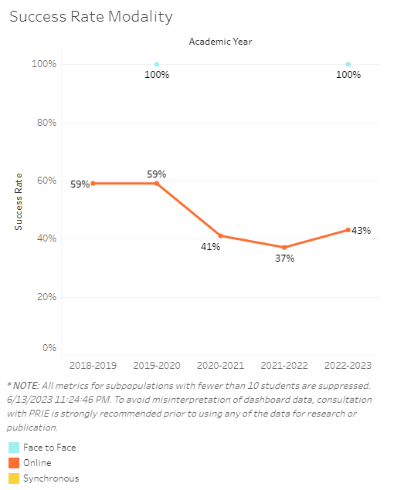

Source: https://canadacollege.edu/prie/dashboards/disproportionate-impact.php

