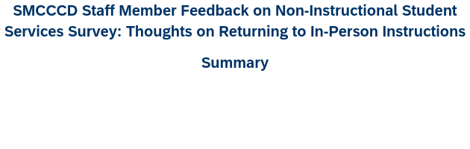
Response by College
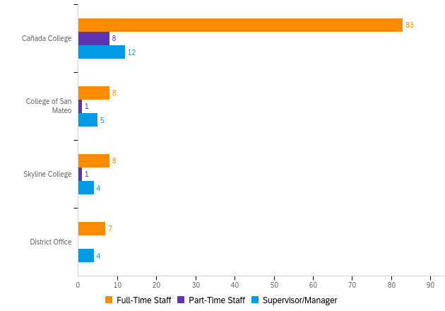

# | Question | Full-Time Staff |  | Part-Time Staff |  | Supervisor/Manager |  | Total
2 | Cañada College | 80.58% | 83 | 7.77% | 8 | 11.65% | 12 | 103
3 | College of San Mateo | 57.14% | 8 | 7.14% | 1 | 35.71% | 5 | 14
4 | Skyline College | 61.54% | 8 | 7.69% | 1 | 30.77% | 4 | 13
5 | District Office | 63.64% | 7 | 0.00% | 0 | 36.36% | 4 | 11

Staff respondents report of percent of time working directly with students
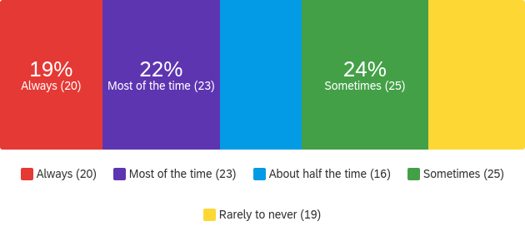

Comfort level of staff members if the District returned to pre-COVID in-person student services or work in Fall 2021
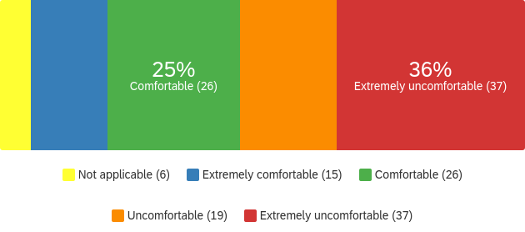
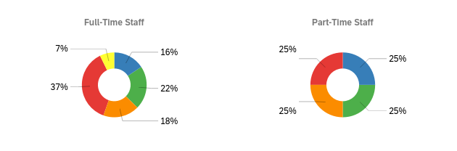
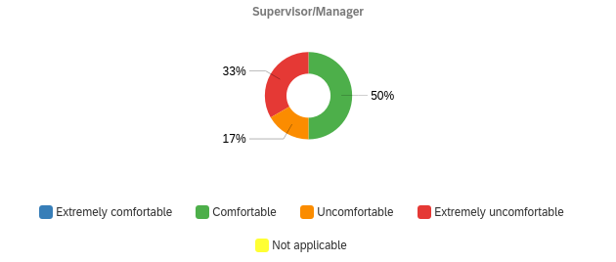

Of staff members who indicated "uncomfortable" or "extremely uncomfortable", top choices that would help staff member feel more comfortable to return for in-person services in Fall 2021

# | Question | Full-Time Staff | Part-Time Staff | Supervisor/Manager
2 | Knowing that students and colleagues have been vaccinated. | 37.00 | 4.00 | 6.00
2 | Being provided personal protective equipment | 31.00 | 4.00 | 5.00
2 | Knowing that public health regulations (issued by the government) are being followed by SMCCCD. | 30.00 | 4.00 | 6.00
2 | Knowing that mandatory symptom checks are required before entering the workplace | 36.00 | 4.00 | 5.00
2 | Knowing the space we use are cleaned/sanitized daily | 33.00 | 4.00 | 6.00
2 | Cleaning/sanitizing supplies are made readily available to all staff and students | 33.00 | 4.00 | 6.00
2 | Maintaining social distancing protocols | 32.00 | 4.00 | 6.00
2 | There is nothing that will make me feel more comfortable | 16.00 | 1.00 | 5.00
2 | Other (please specify) | 14.00 | 1.00 | null

Number of staff members with concerns about the possibility of returning to in-person student services or work for Fall 2021
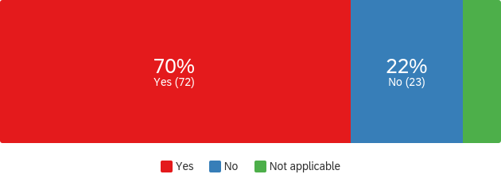
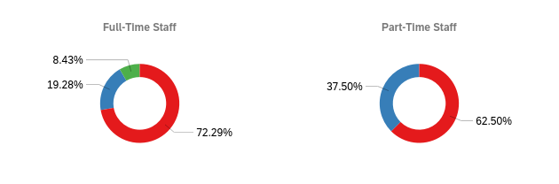
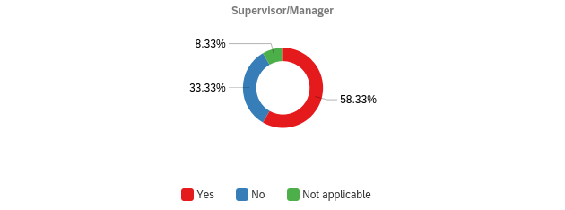

Of staff members who indicated "Yes" to concerns of returning for in-person student services or work, top concerns indicated

# | Question | Full-Time Staff | Part-Time Staff | Supervisor/Manager
2 | Uncertainty about the effectiveness of the vaccines | 36 | 3 | 5
2 | The space being not properly disinfected | 31 | 3 | 5
2 | SMCCCD COVID-19 Health and Safety Protocols are not being followed by students and colleagues | 39 | 3 | 7
2 | Readjustment to in-person work life | 20 | 2 | 6
2 | Other (please specify) | 13 | 1 | null
2 | My commute (e.g., using public transportation, different commute) | 16 | 1 | 5
2 | I have children in school and they may not be back to in-person schooling | 19 | 1 | 4
2 | I am in one of the groups identified by CDC as having increased risk for severe illness from COVID-19 (e.g., older adults and people who have certain underlying conditions like heart or lung disease or diabetes) | 24 | 2 | 4
2 | Having in-person interactions with others | 41 | 2 | 5
2 | Going back into group setting too early | 44 | 3 | 6
2 | Childcare/care for family members or friends | 18 | 2 | 6
2 | Availability of disinfecting materials or personal protective equipment | 24 | 3 | 5

