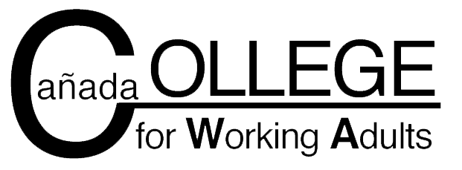

Student Code of Conduct

To ensure that the College for Working Adults maintains appropriate course requirements as established by Cañada College and CWA faculty and administration we have established the following guidelines for classroom comportment. Student misconduct may result in disciplinary action including (but not limited to): verbal or written warning; censure; disciplinary probation; suspension from a CWA class or classes; or expulsion from the College for Working Adults and/or Cañada College.

Students enrolled in CWA classes must adhere to the following guidelines:

- Student will treat classmates, faculty and administrators with consideration and respect at all times. Profanity, vulgarity, and racist/sexist/homophobic expression will not be tolerated under any circumstances.
- Students will not engage in lewd, indecent, aggressive, violent or obscene behavior toward another student, faculty member, staff person or administrator.
- Students will not consume or possess or be under the influence of alcohol or drugs on campus. Such behavior will be subject to disciplinary action by the college and may also be prosecuted by civil authorities.
- Students will demonstrate integrity in all academic endeavors. Violations or attempted violations of academic integrity will be subject to a failing grade, academic sanction and/or dismissal.
- Students will not disrupt class by socializing when an instructor is lecturing or a classmate is speaking.
- Students should come to class on time, prepared, and willing to contribute. Chronic tardiness and/or absenteeism will be grounds for dismissal from the CWA program.

If you are unable or unwilling to abide by these guidelines, you should not enroll in a CWA course or continue in the program. By signing below you affirm that you have read and understand the CWA CODE OF CONDUCT, and are willing to adhere to it.

_________________________________ ________________________
Student Signature G #

_________________________________ _________________________
Student Name (printed) Date

